STORMWATER MANAGEMENT ORDINANCE

ORDINANCE NO. 02-2022

MUNICIPALITY OF

Marietta Borough

LANCASTER COUNTY, PENNSYLVANIA

Adopted at a Public Meeting Held on

, 2022

Article I – General Provisions

Section 101. | Short Title
Section 102. | Statement of Findings
Section 103. | Purpose
Section 104. | Statutory Authority
Section 105. | Applicability
Section 106. | Repealer
Section 107. | Severability
Section 108. | Compatibility with Other Requirements
Section 109. | Erroneous Permit
Section 110. | Waivers

Article II – Definitions

Article III – Stormwater Management Standards

Section 301. | General Requirements
Section 302. | Exemptions and Modified Requirements
Section 303. | Water Quality and Runoff Volume Requirements
Section 304. | Infiltration Requirements
Section 305. | Stream Channel Protection Requirements
Section 306. | Rate Controls
Section 307. | Calculation Methodology
Section 308. | Other Requirements
Section 309. | Riparian Buffers
Section 310. | Permit Requirements by Other Government Entities
Section 311. | Stormwater management facility design standards.

Article IV – Stormwater Management Site Plan Requirements

Section 401. | Plan Requirements
Section 402. | Plan Submission
Section 403. | Plan Review
Section 404. | Modification of Plans
Section 405. | Resubmission of Disapproved SWM Site Plans
Section 406. | Authorization to Construct and Term of Validity
Section 407. | As-Built Plans, Completion Certificate and Final Inspection

Article V – Operation and Maintenance

Section 501. Responsibilities of Developers and Landowners
Section 502. Operation and Maintenance Agreements
Section 503. Financial Security

Article VI – Fees and Expenses

Section 601. General

Article VII – Prohibitions

Section 701. Prohibited Discharges and Connections
Section 702. Roof Drains and Sump Pumps
Section 703. Alteration of SWM BMPs

Article VIII – Enforcement and Penalties

Section 801. | Right-of-Entry
Section 802. | Inspection
Section 803. | Enforcement
Section 804. | Suspension and Revocation
Section 805. | Penalties
Section 806. | Appeals

Article IX – References

Appendix A – Simplified Approach to Stormwater Management for Small Projects
Appendix B – Runoff Coefficients and Curve Numbers
Appendix C – Operation and Maintenance Agreement
Appendix D – Conservation Design and Low Impact Development Site Design ARTICLE I – GENERAL PROVISIONS

Section 101. Short Title

This Ordinance shall be known and may be cited as the “Marietta Borough Stormwater Management Ordinance.”

Section 102. Statement of Findings

The Borough Council of Marietta Borough, Lancaster County, Pennsylvania, finds that:

- Inadequate management of accelerated runoff of stormwater resulting from development throughout a watershed increases runoff volumes, flows and velocities, contributes to erosion and sedimentation, overtaxes the carrying capacity of streams and storm sewers, greatly increases the cost of public facilities to carry and control stormwater, undermines flood plain management and flood control efforts in downstream communities, reduces groundwater recharge, threatens public health and safety, and increases nonpoint source pollution of water resources.

- A comprehensive program of stormwater management (SWM), including reasonable regulation of development and activities causing accelerated runoff, is fundamental to the public health, safety, and welfare and the protection of people of the Commonwealth, their resources, and the environment.

- Stormwater is an important water resource that provides groundwater recharge for water supplies and supports the base flow of streams.

- The use of green infrastructure and low impact development (LID) are intended to address the root cause of water quality impairment by using systems and practices which use or mimic natural processes to: 1) infiltrate and recharge, 2) evapotranspire, and/or 3) harvest and use precipitation near where it falls to earth. Green infrastructure practices and LID contribute to the restoration or maintenance of pre-development hydrology.

- Federal and state regulations require certain municipalities to implement a program of stormwater controls. These municipalities are required to obtain a permit for stormwater discharges from their separate storm sewer systems under the National Pollutant Discharge Elimination System (NPDES) program.

Section 103. Purpose

The purpose of this Ordinance is to promote health, safety, and welfare within the Borough and its watershed by minimizing the harms and maximizing the benefits described in Section 102 of this Ordinance, through provisions designed to:

- Meet legal water quality requirements under state law, including regulations at 25 Pa. Code 93 to protect, maintain, reclaim, and restore the existing and designated uses of the waters of this Commonwealth.

- Preserve natural drainage systems.

- Manage stormwater runoff close to the source, reduce runoff volumes and mimic predevelopment hydrology.

- Provide procedures and performance standards for stormwater planning and management.

- Maintain groundwater recharge to prevent degradation of surface and groundwater quality and to otherwise protect water resources.

- Prevent scour and erosion of stream banks and streambeds.

- Provide proper operation and maintenance of all stormwater best management practices (BMPs) that are implemented within the Municipality.

- Provide standards to meet NPDES permit requirements.

Section 104. Statutory Authority

The Borough of Marietta is empowered to regulate land use activities that affect runoff by the authority of the Act of July 31, 1968, P.L. 805, No. 247, The Pennsylvania Municipalities Planning Code, as amended, and/or the Act of October 4, 1978, P.L. 864 (Act 167), 32 P.S. Section 680.1, et seq., as amended, The Stormwater Management Act. The Borough Code, 8 Pa.C.S.A Section 101 et seq.

Section 105. Applicability

- All regulated activities and all activities that may affect stormwater runoff, including land development and earth disturbance activity, are subject to regulation by this Ordinance.

- Duty of Persons Engaged in a Regulated Activity

Notwithstanding any provision(s) of this Ordinance, including exemptions, any Landowner or any person engaged in a Regulated Activity, including but not limited to the alteration or development of land, which may affect stormwater runoff characteristics, shall implement such measures as are reasonably necessary to prevent injury to health, safety, or other property. Such measures also shall include actions as are required to manage the rate, volume, direction, and quality of resulting stormwater runoff in a manner which otherwise adequately protects health, property, and water quality of Waters of the Commonwealth.

- Phased and Incremental Project Requirements

  - Any Regulated Activity (including but not limited to New Development, Redevelopment, or Earth Disturbance) that is to take place incrementally or in phases, or occurs in sequential projects on the same parcel or property, shall be subject to regulation by this Ordinance if the cumulative Proposed Impervious Surface or Earth Disturbance exceeds the corresponding threshold for exemption (as presented in Table 302.1 ·'Thresholds for Regulated Activities that are Exempt from the Provisions of this Ordinance as Listed Below'').

  - The date of adoption of this Ordinance shall be the starting point from which to consider tracts as parent tracts relative to future subdivisions, and from which Impervious Surface and Earth Disturbance computations shall be cumulatively considered, unless such requirements have previously been adopted, then the earliest date of the applicable municipal ordinance adoption shall remain as the starting point.

For example:

If, after adoption of this Ordinance, an Applicant proposes construction of a two hundred (200) square foot shed, that project would be exempted from the requirements of this Ordinance as noted in Table 302.1. If, at a later date, an Applicant proposes to construct a nine hundred (900) square foot room addition on the same property, the Applicant would then be required to implement the stormwater management and plan submission requirements of this Ordinance for the cumulative total of one thousand one hundred (1,100) square feet of additional Impervious Surface added to the property since adoption of this Ordinance.

This Ordinance shall operate in coordination with those parallel requirements of federal, state, and local regulations. The requirements of this Ordinance shall be no less restrictive in meeting the requirements for environmentally-safe water quality and water patterns than the requirements of federal, state and other local regulations.

- All regulated conditions and activities require a Stormwater Management Permit as issued by the Borough or a Stormwater Management Exemption as issued by the Borough.

Section 106. Repealer

Any other ordinance provision(s), regulation or portion thereof, of the Borough of Marietta inconsistent with any of the provisions of this Ordinance is hereby repealed to the extent of the inconsistency only.

Section 107. Severability

In the event that a court of competent jurisdiction declares any word, sentence, phrase, section or provision of this Ordinance invalid, such decision shall not affect the validity of any of the remaining provisions of this Ordinance.

Section 108. Compatibility with Other Requirements

Approvals issued and actions taken under this Ordinance do not relieve the Applicant of the responsibility to secure required permits or approvals for activities regulated by any other code, law, regulation or ordinance.

Section 109. Erroneous Permit

Any permit or authorization issued or approved based on false, misleading or erroneous information provided by an Applicant is void without the necessity of any proceedings for revocation. Any work undertaken or use established pursuant to such permit or other authorization is unlawful. No action may be taken by a board, agency or employee of the Borough of Marietta purporting to validate such a violation.

Section 110. Waivers

- If the Borough of Marietta determines that any requirement under this Ordinance cannot be achieved for a particular regulated activity, it may, after an evaluation of alternatives, approve measures other than those in this Ordinance, subject to paragraphs B and C below.

- Waivers or modifications of the requirements of this Ordinance may be approved by the Borough of Marietta if strict enforcement will exact undue hardship because of peculiar conditions pertaining to the land in question, provided that the modifications will not be contrary to the public interest and that the purpose of the Ordinance is preserved. Cost or financial burden shall not be considered a hardship. Modification may be considered if an alternative standard or approach will provide equal or better achievement of the purpose of the Ordinance. A request for modifications shall be in writing and accompany the Stormwater Management Site Plan submission. The request shall provide the facts on which the request is based, the provision(s) of the Ordinance involved and the proposed modification.

- No waiver or modification of any regulated stormwater activity involving earth disturbance greater than or equal to one (1) acre may be granted by the Borough of Marietta unless that action is approved in advance by the Department of Environmental Protection (DEP) or the Lancaster County Conservation District.

ARTICLE II – DEFINITIONS

For the purposes of this Ordinance, certain terms and words used herein shall be interpreted as follows:

- Words used in the present tense include the future tense; the singular number includes the plural, and the plural number includes the singular; words of masculine gender include feminine gender; and words of feminine gender include masculine gender.

- The word “includes” or “including” shall not limit the term to the specific example but is intended to extend its meaning to all other instances of like kind and character.

- The words “shall” and “must” are mandatory; the words “may” and “should” are permissive.

These definitions do not necessarily reflect the definitions contained in pertinent regulations or statutes, and are intended for this Ordinance only.

100-Year Flood - A flood that, on the average, is likely to occur once every 100 years (i.e., that has a one-percent chance of occurring each year, although the flood may occur in any year).

100-Year Flood Boundary - The outer boundary of an area of land that is likely to be flooded once every 100 years (i.e., that has a one-percent chance of being flooded each year). A study by the Federal Insurance Administration, the United States Army Corps of Engineers, the United States Department of Agriculture's Natural Resources Conservation Service, the United States Geological Survey, the Susquehanna River Basin Commission, or a licensed surveyor or professional engineer, registered by the Commonwealth of Pennsylvania is necessary to define this boundary.

100-Year Flood Elevation - The water surface elevations of the one-hundred-year flood.

500-Year Flood - A flood that, on the average, is likely to occur once every 500 years.

500-Year Flood Boundary - The outer boundary of an area of land that is likely to be flooded once every 500 years (i.e., which has a 0.20% chance of being flooded each year), as determined by the Flood Insurance Study as may from time to time be promulgated by the Federal Emergency Management Association.

500-Year Flood Elevation - The water surface elevations of the five-hundred-year floodplain.

Accelerated Erosion - The removal of the surface of the land through the combined action of man's activity and the natural processes at a rate greater than would occur because of the natural process alone.

Access Easement - A right granted by a landowner to a grantee, allowing entry for the purpose of inspecting, maintaining and repairing SWM facilities.
Act 167 Plan - A plan prepared under the authority of Pennsylvania's Storm Water Management Act of October 4, 1978.

Agricultural Activity – Activities associated with agriculture such as agricultural cultivation, agricultural operation, and animal heavy use areas. This includes the work of producing crops including tillage, land clearing, plowing, disking, harrowing, planting, harvesting crops or pasturing and raising of livestock and installation of conservation measures. Construction of new buildings or impervious area is not considered an agricultural activity.

Alteration - As applied to land, a change in topography as a result of the moving of soil and rock from one location or position to another; the changing of surface conditions by causing the surface to be more or less impervious; earth disturbance activity. As applied to buildings or structures, any change in the supporting members of a building or structure such as bearing walls, columns, beams or girders, joists or rafters, or enclosing walls; any renovation to a building which would change its use.

Animal Heavy Use Areas - A barnyard, feedlot, loafing area, exercise lot, or other similar area on an agricultural operation where, due to the concentration of animals, it is not possible to establish and maintain vegetative cover of a density capable of minimizing accelerated erosion and sedimentation by usual planting methods. The term does not include entrances, pathways and walkways between areas where animals are housed or kept in concentration.

Applicant – A landowner, developer, or other person who has filed an application to the Municipality for approval to engage in any regulated activity at a project site in the Municipality.

Base Flood Elevation - The projected flood height of the base flood.

Best Management Practice (BMP) – Activities, facilities, designs, measures, or procedures used to manage stormwater impacts from regulated activities, to meet state water quality requirements, to promote groundwater recharge, and to otherwise meet the purposes of this Ordinance. Stormwater BMPs are commonly grouped into one of two broad categories or measures:
“structural” or “non-structural.” In this Ordinance, non-structural BMPs or measures refer to operational and/or behavior-related practices that attempt to minimize the contact of pollutants with stormwater runoff, whereas structural BMPs or measures are those that consist of a physical device or practice that is installed to capture and treat stormwater runoff. Structural BMPs include, but are not limited to, a wide variety of practices and devices, from large-scale retention ponds and constructed wetlands, to small-scale underground treatment systems, infiltration facilities, filter strips, low impact design, bioretention, wet ponds, permeable paving, grassed swales, riparian or forested buffers, sand filters, detention basins, and manufactured devices. Structural stormwater BMPs are permanent appurtenances to the project site.

BMP Manual - The Pennsylvania Stormwater Best Management Practices Manual of December 2006, or most recent version thereof.

Borough - The Borough of Marietta, Lancaster County, Pennsylvania.

Building - Any structure with a roof intended for shelter or enclosure of persons, animals or property.

- Detached - A building which has no party wall.
- Semidetached - A building which has only one party wall in common.
- Attached - A building which has two or more party walls in common.

Carbonate Geology (or carbonate rock formations) – See Karst.

Certificate Of Completion - Documentation verifying that all permanent SWM facilities have been constructed according to the plans and specifications and approved revisions thereto.

Channel – A natural or artificial open drainage feature that conveys, continuously or periodically, flowing water and through which stormwater flows. Channels include, but shall not be limited to, natural and man-made drainageways, swales, streams, ditches, canals, and pipes flowing partly full.

Channel Flow - That water which is flowing within the limits of a defined channel.

Chapter 102 - 25 Pa. Code Chapter 102, Erosion and Sediment Control.

Chapter 105 - 25 Pa. Code Chapter 105, Dam Safety and Waterway Management.

Chapter 106 - 25 Pa. Code Chapter 106, Floodplain Management.

Cistern - A reservoir or tank for storing rainwater.

CFS – Cubic Feet per Second

Clean Water Act - The 1972 amendments to the Federal Water Pollution Control Act, P.L. 92500 of 1972, 33 U.S.C. § 1251 et seq.

CN - Curve number.

Conservation District – A conservation district, as defined in Section 3(c) of the Conservation District Law (3 P. S. § 851(c)) that has the authority under a delegation agreement executed with DEP to administer and enforce all or a portion of the regulations promulgated under 25 Pa. Code 102.

Conservation Plan - A plan written by an NRCS certified planner that identifies conservation practices and includes site specific BMPs for agricultural plowing or tilling activities and animal heavy use areas.

Conservation Practices - Practices installed on agricultural lands to improve farmland, soil and/or water quality which have been identified in a current conservation plan.

Conveyance – A natural or manmade, existing or proposed Stormwater Management Facility, feature or channel used for the transportation or transmission of stormwater from one place to another. For the purposes of this Ordinance, Conveyance shall include pipes, drainage ditches, channels and swales (vegetated and other), gutters, stream channels, and like facilities or features.

Culvert - A structure with appurtenant works which can convey a stream under or through an embankment or fill.

Design Storm – The magnitude and temporal distribution of precipitation from a storm event measured in probability of occurrence (e.g., a 5-year storm) and duration (e.g., 24 hours) used in the design and evaluation of stormwater management systems. Also see Return Period.

Detention (or To Detain) – Capture and temporary storage of runoff in a Stormwater Management Facility for release at a controlled rate.

Detention Basin – An impoundment designed to collect and retard stormwater runoff by temporarily storing the runoff and releasing it at a predetermined rate. Detention basins are designed to drain completely shortly after any given rainfall event.

Detention Volume – The volume of runoff that is captured and released into the Waters of the Commonwealth at a controlled rate.

DEP – The Pennsylvania Department of Environmental Protection.

Developer – A person who seeks to undertake any Regulated Activities at a Site in the Municipality.

Development - Any man-made change to improved or unimproved real estate, including, but not limited to, buildings or other structures, mining, dredging, filling, grading, paving, excavation or drilling operations.

Development Site (Site) – See Project Site.

Diameter at Breast Height (DBH) - The outside bark diameter of a tree at breast height which is defined as four and one half (4.5’) feet (one and thirty-seven one-hundredths of a meter (1.37 m)) above the forest floor and/or ground on the uphill side of the tree.

Disappearing Stream - A stream in an area underlain by carbonate geology that flows underground for a portion of its length.

Disturbed Area – An unstabilized land area where an earth disturbance activity is occurring or has occurred.

Drainage Area - That land area contributing runoff to a single point (including but not limited to the point/line of interest used for hydrologic and hydraulic calculations) and that is enclosed by a natural or man-made ridge line.
E&S - Erosion and sediment.

Earth Disturbance (or Earth Disturbance Activity) – A construction or other human activity which disturbs the surface of the land, including, but not limited to: clearing and grubbing; grading; excavations; embankments; road maintenance; building construction; and the moving, depositing, stockpiling, or storing of soil, rock, or earth materials.

Easement - A right of use granted by a Landowner to allow a grantee the use of the designated portion of land for a specified purpose, such as for stormwater management or other drainage purposes.

Environmentally Sensitive Area - Slopes greater than 15%, shallow bedrock (located within six feet of ground surface), wetlands, natural heritage areas and other areas designated as conservation or preservation in Greenscapes, the Green Infrastructure Element of the County Comprehensive Plan, where encroachment by land development or land disturbance results in degradation of the natural resource.

Erosion – The natural process by which the surface of the land is worn away by water, wind, or chemical action.

Erosion and Sediment Control Plan - A plan required by the Conservation District or the Municipality to minimize accelerated erosion and sedimentation, and that must be prepared and approved per the applicable requirements.

Existing Condition – The dominant land cover during the five (5) year period immediately preceding a proposed regulated activity.

FEMA – Federal Emergency Management Agency.

Flood - A temporary condition of partial or complete inundation of land areas from the overflow of streams, rivers, and other waters of this Commonwealth.

Flood Elevation - The projected heights, in relation to the National Geodetic Vertical Datum of 1929 (NGVD), reached by floods of various magnitudes and frequencies in the floodplain areas.

Flood Fringe - That portion of the floodplain outside of the floodway.

Flood Of Record - The flood which has reached the highest flood elevation above mean sea level at a particular location.

Flood Plain Management Act - Act of October 4, 1978, P.L. 851, No. 166, as amended, 32 P.S. § 679.101 et seq.

Floodplain – Any land area susceptible to inundation by water from any natural source or delineated by applicable FEMA maps and studies as being a special flood hazard area. Also includes areas that comprise Group 13 Soils, as listed in Appendix A of the Pennsylvania DEP Technical Manual for Sewage Enforcement Officers (as amended or replaced from time to time by DEP).

Floodway – The channel of the watercourse and those portions of the adjoining floodplains that are reasonably required to carry and discharge the 100-year flood. Unless otherwise specified, the boundary of the floodway is as indicated on maps and flood insurance studies provided by FEMA. In an area where no FEMA maps or studies have defined the boundary of the 100-year floodway, it is presumed, absent evidence to the contrary, that the floodway extends from the stream to 50 feet from the top of the bank of the stream.

Forest Management/Timber Operations – Planning and activities necessary for the management of forestland. These include conducting a timber inventory, preparation of forest management plans, silvicultural treatment, cutting budgets, logging road design and construction, timber harvesting, site preparation, and reforestation.

Freeboard - A vertical distance between the design high-water elevation and the elevation of the top of a dam, levee, tank, basin, swale, or diversion berm. The space is required as a safety margin in a pond or basin.

Frequency - The probability or chance that a given storm event/flood will be equaled or exceeded in a given year.

Grade -
- (n) A slope, usually of a road, channel or natural ground specified in percent and shown on plans as specified herein.
- (v) To finish the surface of a roadbed, top of embankment or bottom of excavation.

Groundwater Recharge - The process by which water from above the ground surface is added to the saturated zone of an aquifer, either directly or indirectly.

Green Infrastructure – Systems and practices that use or mimic natural processes to infiltrate, evapotranspire, or reuse stormwater on the site where it is generated.

HEC-1 - The U.S. Army Corps of Engineers, Hydrologic Engineering Center (HEC) hydrologic runoff model.

HEC-HMS - The U.S. Army Corps of Engineers, Hydrologic Engineering Center (HEC) - Hydrologic Modeling System (HMS).

High Tunnel – A structure which meets the following:

- Is used for the production, processing, keeping, storing, sale or shelter of an agricultural commodity as defined in section 2 of the Act of December 19, 1974 (P.L. 973, No. 319), known as the “Pennsylvania Farmland and Forest Land Assessment Act of 1974,” or for the storage of agricultural equipment or supplies; and

- Is constructed with all the following:

  - Has a metal, wood or plastic frame;

  - When covered, has a plastic, woven textile or other flexible covering; and

  - Has a floor made of soil, crushed stone, matting, pavers or a floating concrete slab.

Hotspots - Areas where prior or existing land use or activities can potentially generate highly contaminated runoff with concentrations of pollutants in excess of those typically found in stormwater.

Hydrologic Soil Group (HSG) – Infiltration rates of soils vary widely and are affected by subsurface permeability as well as surface intake rates. Soils are classified into four HSGs (A, B, C, and D) according to their minimum infiltration rate, which is obtained for bare soil after prolonged wetting. The NRCS defines the four groups and provides a list of most of the soils in the United States and their group classification. The soils in the area of the development site may be identified from a soil survey report that can be obtained from local NRCS offices or conservation district offices. Soils become less pervious as the HSG varies from A to D (NRCS^{1,2}).

Impervious Surface (Impervious Area) – A surface that prevents the infiltration of water into the ground. Impervious surfaces (or areas) shall include, but not be limited to: roofs; additional indoor living spaces, patios, garages, storage sheds and similar structures; and any new streets or sidewalks. For the purposes of determining compliance with this Ordinance; decks, pools, and compacted soils or stone surfaces used for vehicle parking and movement shall be considered impervious.

Impoundment - A retention or detention facility designed to retain stormwater runoff and infiltrate it into the ground (in the case of a retention basin) or release it at a controlled rate (in the case of a detention basin).

Infiltration - Movement of surface water into the soil, where it is absorbed by plant roots, evaporated into the atmosphere, or percolated downward to recharge groundwater.

Infiltration Facility - A stormwater BMP designed to collect and discharge runoff into the subsurface in a manner that allows infiltration into underlying soils and groundwater (e.g., French drains, seepage pits, or seepage trenches, etc.).

Inlet - A surface connection to a closed drain. The upstream end of any structure through which water may flow.

Intermittent - A natural, transient body or conveyance of water that exists for a relatively long time, but for weeks or months of the year is below the local water table and obtains its flow from both surface runoff and groundwater discharges.

Intermittent Stream - A defined channel in which surface water is absent during a portion of the year, in response to seasonal variations in precipitation or groundwater discharge.

Invasive Vegetation (Invasives) - Plants which grow quickly and aggressively, spreading, and displacing other plants. Invasives typically are introduced into a region far from their native habitat. See "Invasive Plants in Pennsylvania" by the Department of Conservation and Natural Resources.

Invert - The lowest surface, the floor or bottom of a culvert, pipe, drain, sewer, channel, basin, BMP, or orifice.

Karst – A type of topography or landscape characterized by surface depressions, sinkholes, rock pinnacles/uneven bedrock surface, underground drainage, and caves. Karst is formed on carbonate rocks, such as limestone or dolomite.

Land Development (Development) – Any of the following activities:
- The improvement of one (1) lot or two (2) or more contiguous lots, tracts, or parcels of land for any purpose involving:

  - A group of two (2) or more residential or nonresidential buildings, whether proposed initially or cumulatively, or a single nonresidential building on a lot or lots regardless of the number of occupants or tenure, or

  - The division or allocation of land or space, whether initially or cumulatively, between or among two (2) or more existing or prospective occupants by means of, or for the purpose of, streets, common areas, leaseholds, condominiums, building groups, or other features;

- A subdivision of land;

- Development in accordance with Section 503(1.1) of the Pennsylvania Municipalities Planning Code (as amended).
Landowner - The legal or beneficial owner or owners of land including the holder of an option or contract to purchase (whether or not such option or contract is subject to any condition), a lessee if they are authorized under the lease to exercise the rights of the Landowner, or other person having a proprietary interest in the land.

Licensed Professional - A Pennsylvania Registered Professional Engineer, Registered Landscape Architect, Registered Professional Land Surveyor, or Registered Professional Geologist, or any person licensed by the Pennsylvania Department of State or qualified by law to perform the work required by the Ordinance within the Commonwealth of Pennsylvania.

Limiting Zone - A soil horizon or condition in the soil profile or underlying strata that includes one of the following:

- A seasonal high water table, whether perched or regional, determined by direct observation of the water table or indicated by other subsurface or soil conditions.

- A rock with open joints, fracture or solution channels, or masses of loose rock fragments, including gravel, with insufficient fine soil to fill the voids between the fragments.

- A rock formation, other stratum, or soil condition that is so slowly permeable that it effectively limits downward passage of water.

Lineament - A linear feature in a landscape which is an expression of an underlying geological structure such as a fault.

Low Impact Development (LID) – Site design approaches and small-scale stormwater management practices that promote the use of natural systems for infiltration, evapotranspiration, and reuse of rainwater. LID can be applied to new development, urban retrofits, and revitalization projects. LID utilizes design techniques that infiltrate, filter, evaporate, and store runoff close to its source. Rather than rely on costly large-scale conveyance and treatment systems, LID addresses stormwater through a variety of small, cost-effective landscape features located on-site.

Maintenance - The action taken to restore or preserve the as-built functional design of any Stormwater Management Facility or system.

Manning's Equation - An equation for calculation of velocity of flow (e.g., feet per second) and flow rate (e.g., cubic feet per second) in open channels based upon channel shape, roughness, depth of flow and slope. Manning's Equation assumes steady, gradually varied flow.

Maximum Extent Practicable (MEP) - Applies when the applicant demonstrates to the Borough of Marietta's satisfaction that the performance standard is not achievable. The applicant shall take into account the best available technology, cost effectiveness, geographic features, and other competing interests such as protection of human safety and welfare, protection of endangered and threatened resources, and preservation of historic properties in making the assertion that the performance standard cannot be met and that a different means of control is appropriate.

Maximum Flood Elevation - The water surface elevation of a flood which would completely fill the floodplain to the boundaries of the floodplain zone.

Mean Sea Level - The average height of the sea for all stages of the tide, using the National Geodetic Vertical Datum of 1929.

MPC - Act of July 31, 1968, P.L. 805, No. 247, 53 P.S. Section 10101, et seq., as amended, the Pennsylvania Municipalities Planning Code, Act 247.

Municipal Engineer - A professional engineer licensed as such in the Commonwealth of Pennsylvania, duly appointed as the engineer for the Municipality, planning agency, or joint planning commission.

Municipality – Marietta Borough, Lancaster County, Pennsylvania.

Municipal Separate Storm Sewer (MS3) — A conveyance or system of conveyances (including roads with drainage systems, municipal streets, catch basins, curbs, gutters, ditches, man-made channels, or storm drains) which is all of the following:

- Owned or operated by a state, city, town, borough, township, county, district, association or other public body (created under state law) having jurisdiction over disposal of sewage, industrial wastes, stormwater or other wastes;

- Designed or used for collecting or conveying stormwater;

- Not a combined sewer; and

- Not part of a publicly owned treatment works as defined at 40 CFR 122.2.

Municipal Separate Storm Sewer System (MS4) — All separate storm sewers that are defined as "large" or "medium" or "small" municipal separate storm sewer systems pursuant to 40 CFR 122.26(b)(18) or designated as regulated under 40 CFR 122.26(a)(1)(v). For the purposes of determining compliance with this ordinance; all Municipal Separate Storm Sewers shall be considered part of an MS4.

Native Vegetation - Plant species that have evolved or are indigenous to a specific geographical area. These plants are adapted to local soil and weather conditions as well as pests and diseases.

Natural Drainageway - An existing channel for water runoff that was formed by natural processes.

Natural Ground Cover - Ground cover which mimics the infiltration characteristics of predominant hydrologic soil group found at the site.

New Development - Any Regulated Activity involving placement or construction of new Impervious Surface or grading over existing pervious land areas not classified as Redevelopment as defined in this Ordinance.

Nonpoint Source Pollution - Pollution that enters a water body from diffuse origins in the watershed and does not result from discernible, confined, or discrete Conveyances.

Non-stormwater Discharges - Water flowing in stormwater collection facilities, such as pipes or swales, which is not the result of a rainfall event or snowmelt.

Nonstructural Best Management Practice (BMPs) - See Best Management Practice (BMP).

NOAA - National Oceanic and Atmospheric Administration.

NPDES - National Pollutant Discharge Elimination System, the Federal government’s system for issuance of permits under the Clean Water Act, which is delegated to DEP in Pennsylvania.

NRCS – USDA Natural Resources Conservation Service (previously SCS).

Open Channel - A drainage element in which stormwater flows with an open surface. Open channels include, but shall not be limited to, natural and man-made drainageways, swales, streams, ditches, canals, and pipes flowing partly full. Open channels may include closed conduits so long as the flow is not under pressure.

PADEP - Pennsylvania Department of Environmental Protection.

Parent Tract - The parcel of land from which a land development or subdivision originates, determined from the date of municipal adoption of this Ordinance.

Peak Discharge – The maximum rate of stormwater runoff from a specific storm event.

PennDOT - Pennsylvania Department of Transportation.

Pennsylvania Stormwater Best Management Practices Manual (PA BMP Manual) - Document Number 363-0300-002 (December 2006, and as subsequently amended).

Pervious Area (or Pervious Surface) – Any area not defined as impervious.

Pipe - A culvert, closed conduit, or similar structure (including appurtenances) that conveys stormwater.

Planning Commission - The Planning Commission of Marietta Borough.

Plans - The SWM and erosion and sediment control plans and narratives.

Point Source - Any discernible, confined, and discrete Conveyance including, but not limited to, any pipe, ditch, channel, tunnel, or conduit from which stormwater is or may be discharged, as defined in State regulations at 25 Pennsylvania Code § 92.1.

Post-construction (Postdevelopment) - Period after construction during which Disturbed Areas are stabilized, stormwater controls are in place and functioning, and all proposed improvements approved by the Municipality are completed.

Predevelopment (Pre-construction) -Ground cover conditions assumed to exist within the proposed Disturbed Area prior to commencement of the Regulated Activity for the purpose of calculating the Predevelopment water quality volume, infiltration volume, and peak flow rates as required in this Ordinance.

Pretreatment - Techniques employed in stormwater BMPs to provide storage or filtering, or other methods to trap or remove coarse materials and other pollutants before they enter the stormwater system, but may not necessarily be designed to meet the entire water quality volume requirements of this Ordinance.

Process Wastewater - Water that comes in contact with any raw material, product, by-product, or waste during any production or industrial process.

Project Site – The specific area of land where any regulated activities in the Municipality are planned, conducted, or maintained.

Proposed Impervious Surface – All new additional and replacement Impervious Surfaces.

Qualified Professional – Any person licensed by the Pennsylvania Department of State or otherwise qualified by law to perform the work required by this Ordinance. (See also, Licensed Professional)

Rainfall Intensity - The depth of accumulated rainfall per unit of time.

Rate Control - SWM controls used to manage the peak flows for the purposes of channel protection and flood mitigation.

Rational Formula (Rational Method) - A rainfall-runoff relation used to estimate peak flow.

Recharge - The replenishment of groundwater through the infiltration of rainfall, other surface waters, or land application of water or treated wastewater.

Redevelopment - Any Regulated Activity that involves demolition, removal, reconstruction, or replacement of existing Impervious Surface(s).

Regional Stormwater Management Plan - A plan to manage stormwater runoff from an area larger than a single development site. A regional stormwater management plan could include two adjacent parcels, an entire watershed, or some defined area in between. Regional stormwater management plans can be prepared for new development or as a retrofit to manage runoff from already developed areas.

Regulated Activities – Any earth disturbance activities or any activities that involve the alteration or development of land in a manner that may affect stormwater runoff.

Regulated Earth Disturbance Activity – Activity involving earth disturbance subject to regulation under 25 Pa. Code 92, 25 Pa. Code 102, or the Clean Streams Law.

Regulated Impervious Surface - Proposed impervious surface as part of a current proposed activity and all existing impervious surfaces installed after ___________________, 2022, as part of previous activity.

Release Rate - For a specific design storm or list of design storms, the percentage of peak flow rate for existing conditions which may not be exceeded for the proposed conditions.
Release Rate Map - A graphical representation of the release rates for a specific area.

Retention (or To Retain) - The prevention of direct discharge of stormwater runoff into surface waters or water bodies during or after a storm event by permanent containment in a pond or depression; examples include systems which discharge by percolation to groundwater, exfiltration, and/or evaporation processes and which generally have residence times of less than three (3) days.

Retention Basin - An impoundment that is designed to temporarily detain a certain amount of stormwater from a catchment area and which may be designed to permanently retain stormwater runoff from the catchment area; retention basins always contain water.

Retention Volume/Removed Runoff – The volume of runoff that is captured and not released directly into the surface waters of this Commonwealth during or after a storm event.

Return Period – The average interval, in years, within which a storm event of a given magnitude can be expected to occur one time. For example, the 25-year return period rainfall would be expected to occur on average once every 25 years; or stated in another way, the probability of a 25-year storm occurring in any one year is 0.04 (i.e., a 4% chance).

Riparian - Pertaining to anything connected with or immediately adjacent to the banks of a stream or other body of water.

Riparian Buffer – A permanent area of trees and shrubs located adjacent to streams, lakes, ponds and wetlands.

Riparian Corridor - A narrow strip of land, centered on a stream or river that includes the floodplain as well as related riparian habitats adjacent to the floodplain.

Runoff – Any part of precipitation that flows over the land.

SALDO - See Subdivision and Land Development Ordinance.

SCS - Soil Conservation Service, now known as the Natural Resources Conservation Service.

Sediment – Soils or other materials transported by surface water as a product of erosion.

Sediment Basin - A barrier, dam, retention or detention basin located and designed to retain rock, sand, gravel, silt, or other material transported by water.

Sediment Pollution - The placement, discharge or any other introduction of sediment into the waters of the commonwealth occurring from the failure to design, construct, implement or maintain control measures and control facilities in accordance with the requirements of this chapter.

Sedimentation - The action or process of forming or depositing sediment in waters of this commonwealth.
Seepage Pit/Seepage Trench - An area of excavated earth filled with loose stone or similar coarse material, into which surface water is directed for infiltration into the ground.

Semi-Impervious/Semipervious Surface - A surface which prevents some infiltration of water into the ground.

Separate Storm Sewer System – See Municipal Separate Storm Sewer and Municipal Separate Storm Sewer System.

Sheet Flow - A flow process associated with broad, shallow water movement on sloping ground surfaces that is not channelized or concentrated.

Site - Total area of land in the Municipality where any proposed Regulated Activity, as defined in this Ordinance, is planned, conducted, or maintained or that is otherwise impacted by the Regulated Activity.

Small Project - Regulated activities that, measured on a cumulative basis, create new impervious areas of more than 1,000 square feet and less than 5,000 square feet or involve earth disturbance activity of an area less than 5,000 square feet and do not involve the alteration of stormwater facilities or watercourses.

Small Storm Event - A storm having a frequency of recurrence of once every two years or smaller.

Soil Group, Hydrologic - See "hydrologic soil group."

Soil Cover Complex Method - A method of runoff computation developed by NRCS that is based on relating soil type and land use/cover to a runoff parameter called curve number (CN).

State Water Quality Requirements – The current regulatory requirements to protect, maintain, reclaim, and restore water quality under Title 25 of the Pennsylvania Code and the Clean Streams Law.

Storage - A volume above or below ground that is available to hold stormwater.

Storm Event - A storm of a specific duration, intensity, and frequency.

Storm Sewer - A system of pipes and/or open channels designed to convey stormwater.

Stormwater – Drainage runoff from the surface of the land resulting from precipitation or snow or ice melt.

Storm Frequency - (see Return Period).

Storm Water Management Act - Act of October 4, 1978, P.L. 864, No. 167, as amended 32 P.S. § 680.1 et seq.

Stormwater Management Facility – Any structure, natural or man-made, that, due to its condition, design, or construction, conveys, stores, or otherwise affects stormwater runoff. Typical stormwater management facilities include, but are not limited to: detention and retention basins; open channels; storm sewers; pipes; and infiltration facilities.

Stormwater Management (SWM) Site Plan – The plan prepared by the developer or his representative indicating how stormwater runoff will be managed at the development site in accordance with this Ordinance. Stormwater Management Site Plan will be designated as SWM Site Plan throughout this Ordinance.

Stream - A natural watercourse.

Structural BMPS - Physical devices and practices that capture and treat stormwater runoff. Structural stormwater BMPs are permanent appurtenances to the development site.

Structure - Any man-made object having an ascertainable stationary location on or in land or water, whether or not affixed to the land.

Subdivision – As defined in The Pennsylvania Municipalities Planning Code, Act of July 31, 1968, P.L. 805, No. 247.

Subdivision and Land Development Ordinance – the Subdivision and Land Development Ordinance of Marietta Borough, Lancaster County, PA, as amended. Also referred to as
“SALDO”.

Swale - An artificial or natural waterway or low-lying stretch of land that gathers and conveys stormwater or runoff, and is generally vegetated for soil stabilization, stormwater pollutant removal, and infiltration.

SWM - Stormwater management.

SWM Site Plan - A stormwater management site plan.

Timber Operations - See "forest management."

Time Of Concentration (Tc) - The time for surface runoff to travel from the hydraulically most distant point of the watershed to a point of interest within the watershed. This time is the combined total of overland flow time and flow time in pipes or channels, if any.

Top-of-bank - Highest point of elevation of the bank of a stream or channel cross-section at which a rising water level just begins to flow out of the channel and into the floodplain.

Treatment Train - The sequencing of structural best management practices to achieve optimal flow management and pollutant removal from urban stormwater.

USDA – the United States Department of Agriculture.
Volume Control - SWM controls, or BMPs, used to remove a predetermined amount of runoff or the increase in volume between the pre- and post-development design storm.

Waters of this Commonwealth – Any and all rivers, streams, creeks, rivulets, impoundments, ditches, watercourses, storm sewers, lakes, dammed water, wetlands, ponds, springs, and all other bodies or channels of conveyance of surface and underground water, or parts thereof, whether natural or artificial, within or on the boundaries of this Commonwealth.

Watercourse - A channel or Conveyance of surface water having a defined bed and banks, whether natural or artificial, with perennial or intermittent flow.

Watershed – Region or area drained by a river, watercourse, or other surface water of this Commonwealth.

Water Table - The upper most level of saturation of pore space or fractures by groundwater. Seasonal High Water Table refers to a water table that rises and falls with the seasons due either to natural or man-made causes.

Wetland – Areas that are inundated or saturated by surface or groundwater at a frequency and duration sufficient to support, and that under normal circumstances do support, a prevalence of vegetation typically adapted for life in saturated soil conditions, including swamps, marshes, bogs, and similar areas.

Woods - Any land area of at least one-quarter (0.25) acre with a natural or naturalized ground cover (excluding manicured turf grass) and that has an average density of two (2) or more viable trees per one thousand five hundred (1,500) square feet with a DBH of six (6”) inches or greater. The land area to be considered Woods shall be measured from the outer drip lines of the outer trees.
ARTICLE III – STORMWATER MANAGEMENT STANDARDS

Section 301. General Requirements

- For all regulated activities, unless preparation of an SWM Site Plan is specifically exempted in Section 302:

  - Preparation and implementation of an approved SWM Site Plan is required.

  - No regulated activities shall commence until:

    - the Municipality issues written approval of an SWM Site Plan, which demonstrates compliance with the requirements of this Ordinance; and

    - The Applicant has received a letter of adequacy or approval for the Erosion and Sediment Control Plan review by the Municipality and the Conservation District (if required), and has received all other local, State and Federal permit approvals required for the project involving the Regulated Activity.

- Neither submission of an SWM Site Plan under the provisions herein nor compliance with the provisions of this Ordinance shall relieve any person from responsibility for damage to any person or property otherwise imposed by law.

- SWM Site Plans approved by the Municipality, in accordance with Section 406, shall be on site throughout the duration of the regulated activity.

- The Municipality may, after consultation with DEP, approve measures for meeting the state water quality requirements other than those in this Ordinance, provided that such alternative measures meet the minimum requirements of, and do not conflict with, state law including, but not limited to, the Clean Streams Law.

- For all regulated earth disturbance activities, erosion and sediment control BMPs shall be designed, implemented, operated, and maintained during the regulated earth disturbance activities (e.g., during construction) to meet the purposes and requirements of this Ordinance and to meet all requirements under Title 25 of the Pennsylvania Code and the Clean Streams Law. Various BMPs and their design standards are listed in the Erosion and Sediment Pollution Control Program Manual (E&S Manual3), No. 363-2134-008, as amended and updated.

- Impervious areas:

  - The measurement of impervious areas shall include all of the impervious areas in the total proposed development even if development is to take place in stages.

  - For development taking place in stages, the entire development plan shall be used in determining compliance with this Ordinance.

  - For projects that add impervious area to a parcel, the total impervious area on the parcel is subject to the requirements of this Ordinance; except that the volume controls in Section 303 and the peak rate controls of Section 306 do not need to be retrofitted for existing impervious areas that are not being altered by the proposed regulated activity.

- Stormwater flows onto adjacent property shall not be created, increased, relocated, or otherwise altered without written notification to the adjacent property owner(s). Such stormwater flows shall be subject to the requirements of this Ordinance.

- All regulated activities shall include such measures as necessary to:

  - Protect health, safety, and property.

  - Meet the water quality goals of this Ordinance by implementing measures to:

    - Minimize disturbance to floodplains, wetlands, and wooded areas.

    - Maintain or extend riparian buffers.

    - Avoid erosive flow conditions in natural flow pathways.

    - Minimize thermal impacts to waters of this Commonwealth.

    - Disconnect impervious surfaces by directing runoff to pervious areas, wherever possible.

  - Incorporate methods described in the Pennsylvania Stormwater Best Management Practices Manual (PA BMP Manual³). If methods other than green infrastructure and LID methods are proposed to achieve the volume and rate controls required under this Ordinance, the SWM Site Plan must include a detailed justification demonstrating that the use of LID and green infrastructure is not practicable.

- For areas underlain by Karst or carbonate geology that may be susceptible to the formation of sinkholes and other Karst features, the location, type, and design of infiltration BMPs shall be based on a Site evaluation conducted by a qualified Licensed Professional and based on the PA BMP Manual (as amended) or other design guidance acceptable to the Municipal Engineer.

- Infiltration BMPs should be spread out, made as shallow as practicable, and located to maximize use of natural on-site infiltration features while still meeting the other requirements of this Ordinance.

- Normally dry, open top, storage facilities should completely drain both the volume control and rate control capacities over a period of time not less than 24 and not more than 72 hours from the end of the design storm.

- The design of all BMPs and Conveyances shall incorporate sound engineering principles and practices in a manner that does not aggravate existing stormwater problems as identified by the Municipality. The Municipality reserves the right to disapprove any design that would result in construction in an area affected by existing stormwater problem(s) or continuation of an existing stormwater problem(s).

- The design storm volumes to be used in the analysis of peak rates of discharge should be obtained from the latest version of the Precipitation-Frequency Atlas of the United States, National Oceanic and Atmospheric Administration (NOAA), National Weather Service, Hydrometeorological Design Studies Center, Silver Spring, Maryland.

NOAA’s Atlas 14⁵ can be accessed at: http://hdsc.nws.noaa.gov/hdsc/pfds/.

- For all regulated activities, SWM BMPs shall be designed, implemented, operated, and maintained to meet the purposes and requirements of this Ordinance and to meet all requirements under Title 25 of the Pennsylvania Code, the Clean Streams Law, and the Storm Water Management Act.

- Various BMPs and their design standards are listed in the BMP Manual⁴.

- Areas located outside of the Site (i.e., areas outside of the Regulated Activity) that drain through a proposed Site are not subject to water quality and volume control, infiltration, stream channel protection, or peak flow rate control requirements (as presented in Sections 303, 304, 305, and 306). Drainage facilities located on the Site shall be designed to safely convey flows from outside of the Site through the Site.

- Existing wetlands, either on the Site or on an adjacent property, shall not be used to meet the minimum design requirements for stormwater management or stormwater runoff quality treatment. Stormwater discharges to existing wetlands shall not degrade the quality or hydrologic integrity of the wetland.

- Hotspots Runoff Controls -

Specific structural or pollution prevention practices may be required, as determined to be necessary by the Municipal Engineer, to pretreat runoff from Hotspots prior to infiltration. Following is a list of examples of Hotspots:

  - Vehicle salvage yards and recycling facilities;

  - Vehicle fueling stations;

  - Vehicle service and maintenance facilities;

  - Vehicle and equipment cleaning facilities;

  - Fleet storage areas (bus, truck, etc.);

  - Industrial sites based on Standard Industrial Classification Codes;

  - Marinas (service and maintenance areas);

  - Outdoor liquid container storage;

  - Outdoor loading/unloading facilities;

  - Public works storage areas;

  - Facilities that generate or store hazardous materials;

  - Commercial container nursery;

  - Contaminated sites/brownfields;

  - Other land uses and activities as designated by the Municipality.

- Additional Water Quality Requirements -

The Municipality may require additional stormwater control measures for stormwater discharges to special management areas including, but not limited to:

  - Water bodies listed as “impaired” by PADEP.

  - Any water body or watershed with an approved Total Maximum Daily Load (TMDL).

  - Areas of known existing flooding problems.

  - Critical areas with sensitive resources (e.g., State designated special protection waters, cold water fisheries, carbonate geology or other groundwater recharge areas that may be highly vulnerable to contamination, drainage areas to water supply reservoirs, etc.).

- All Regulated Activities located within a Special Flood Hazard Area designated by the Federal Emergency Management Agency (FEMA) shall comply with Chapter 117 of the Marietta Borough Code of Ordinances, more specifically known as the “Marietta Borough Floodplain Management Ordinance” and shall be designed to maintain the flood carrying capacity of the floodway such that the base flood elevations are not increased, either upstream or downstream. The natural conveyance characteristics of the Site and the receiving floodplain shall be incorporated into the stormwater management practices proposed for the Site.

Section 302. Exemptions and modified requirements

- General exemptions. Regulated activities that involve less than or equal to 240 square feet of proposed impervious surfaces and less than or equal to 5,000 square feet of earth disturbance or are listed in Subsection H are exempt from those (and only those) requirements of this chapter that are included in the sections and articles listed in Table 302.1. Exemptions are for the items noted in Table 302.1 only and shall not relieve the landowner from other applicable requirements of this chapter. Exemption shall not relieve the Applicant from implementing such measures as are necessary to protect health, safety, and welfare, property, and water quality.

- Agricultural activity is exempt from the SWM Site Plan preparation requirements of this Ordinance provided the activities are performed according to the requirements of 25 Pa. Code Chapter 102.

- Forest management and timber operations are exempt from the SWM Site Plan preparation requirements of this Ordinance provided the activities are performed according to the requirements of 25 Pa. Code Chapter 102.

- Exemptions from any provisions of this Ordinance shall not relieve the Applicant from the requirements in Sections 301.E. through M.

- The Municipality may deny or revoke any exemption or modified requirements pursuant to this Section at any time for any project that the Municipality believes may pose a threat to public health and safety or the environment.

- Requirements for Exempt Activities

  - An exemption from any requirement of this Ordinance shall not relieve the Applicant from implementing all other applicable requirements of this Ordinance or from implementing such measures as are necessary to protect public health, safety, and welfare, property and water quality.

  - An exemption shall not relieve the Applicant from complying with the requirements for State-designated special protection waters designated by PADEP as high quality (HQ) or exceptional value (EV) waters, or any other current or future State or municipal water quality protection requirements.

  - An exemption under this Ordinance shall not relieve the Applicant from complying with all other applicable municipal ordinances or regulations.

  - Any Applicant desiring exemption from design, plan submission, and plan processing requirements shall complete an application for exemption in the form available at the Muncipality’s office and pay any applicable filing fee.

Table 302.1 Thresholds for Regulated Activities Exempt from Chapter Provisions
Ordinance  Article/Section | Activities Listed In § 302.H | < 240 Square Feet of Proposed Impervious  Surfaces AND <  5,000 Square Feet of Proposed Earth  Disturbance | > 240 Square  Feet of Proposed  Impervious  Surfaces OR >  5,000 Square  Feet of Proposed  Earth  Disturbance
Article I | Not exempt | Not exempt | Not exempt
Article II | Not exempt | Not exempt | Not exempt
Sections 310 and 301.E | Not exempt | Not exempt | Not exempt
Sections 301, 303, 304, 305, 306, 307, and 308 | Exempt | Exempt | Not exempt
Article IV | Exempt | Exempt | Not exempt
Article V | Exempt | Exempt | Not exempt
Article VI | Exempt | Exempt | Not exempt
Article VII | Not Exempt | Not Exempt | Not exempt
Article VIII | Not exempt | Not exempt | Not exempt
Other Erosion, Sediment and  Pollution Control  Requirements | Must comply with Title 25, Chapter 102 of the PA Code and other applicable State and municipal codes, including the Clean Streams Law.

H. Exemptions for Specific Activities
The following specific Regulated Activities are exempt from the requirements of Sections 301, 303, 304, 305, 306, 307, and 308, and Article IV, Article V, and Article VI
) of this Ordinance (as shown in Table 302.1), unless otherwise noted below. All other conveyance and system design standards established by the Municipality in other codes or ordinances shall be required, and all other provisions of this Ordinance shall apply.
- Emergency Exemption - Emergency maintenance work performed for the protection of public health, safety and welfare. This exemption is limited to repair of an existing Stormwater Management Facility; upgrades, additions or other improvements are not exempt. A written description of the scope and extent of any emergency work performed shall be submitted to the Municipality within two (2) business days of the commencement of the activity. A detailed plan shall be submitted no later than thirty (30) calendar days following commencement of the activity. If the Municipality finds that the work is not an emergency, then the work shall cease immediately and the requirements of this Ordinance shall be addressed as applicable.
- Maintenance - Any maintenance to an existing Stormwater Management Facility, BMP or Conveyance made in accordance with plans and specifications approved by the Municipal Engineer or Municipality.
- Existing Landscaping - Use of land for maintenance, replacement or enhancement of existing landscaping.
- Gardening - Use of land for gardening for home consumption.
- Agricultural Related Activities -
  - Agricultural Activities (as defined in Article II), when performed in accordance with the requirements of 25 PA Code Chapter 102.
  - High Tunnel if:
i. The High Tunnel or its flooring does not result in an impervious surface exceeding 25% of all structures located on the Landowner's total contiguous land area under common ownership; and ii. The High Tunnel meets one of the following:
    - The High Tunnel is located at least 100 feet from any perennial stream or watercourse, public road or neighboring property line
    - The High Tunnel is located at least 35 feet from any perennial stream or watercourse, public road or neighboring property line and located on land with a slope not greater than 7%
    - The High Tunnel is supported with a buffer or diversion system that does not directly drain into a stream or other watercourse by managing stormwater runoff in a manner consistent with the requirements of Pennsylvania Act 167.
- Forest Management - Forest management operations, which are consistent with a sound forest management plan as filed with the Municipality and which comply with the Pennsylvania Department of Environmental Protection’s management practices contained in its publication “Soil Erosion and Sedimentation Control Guidelines for Forestry” (as amended or replaced by subsequent guidance). Such operations are required to have an Erosion and Sedimentation Control Plan, which meets the requirements of 25 PA Code Chapter 102 and meets the erosion and sediment control standards of Section 303 of this Ordinance.
- Maintenance of Existing Gravel and Paved Surfaces - Replacement of existing gravel and paved surfaces shall meet the erosion and sediment control requirements of 25 PA Code Chapter 102 and Section 301.E of this Ordinance, and is exempt from all other requirements of this Ordinance listed in Subsection 302.H above. Resurfacing of existing gravel and paved surfaces is also exempt from the requirements of this Ordinance listed above. Paving of existing gravel surfaces is exempt from the requirements of this Ordinance listed above. Construction of new or additional Impervious Surfaces shall comply with all requirements of this Ordinance as indicated in Table 302.1.
- Municipal Roadway Shoulder Improvements - Shoulder improvements conducted within the existing roadway cross-section of municipal owned roadways, unless an NPDES permit is required, in which case the proposed work must comply with all requirements of this Ordinance.
- In-Place Replacement of Residential Dwelling Unit - The replacement in the exact footprint of an existing one- or two-family dwelling unit.
- In-Place Replacement, Repair, or Maintenance of Residential Impervious Surfaces - The replacement of existing residential patios, decks, driveways, pools, garages, and/or sidewalks that are accessory to an existing one- or two-family dwelling unit in the exact footprint of the existing Impervious Surface.
I. Modified Requirements for Small Projects
- Regulated Activities that involve both of the following: 1) 240 to 2,500 square feet of
Proposed Impervious Surfaces and 2) 1,000 to 5,000 square feet of proposed Earth Disturbance may apply the modified requirements presented in the “Simplified Approach to Stormwater Management for Small Projects” (Simplified Approach)
(Appendix A) to comply with the requirements of Sections 301, 303, 304, 305, 306,
307, and 308, and Article IV, Article V, and Article VI of this Ordinance (as shown in Table 302.2). The Applicant shall first contact the Municipal Engineer: to confirm that the proposed project is eligible for use of the Simplified Approach and is not otherwise exempt from these Ordinance provisions; to determine what components of the proposed project are to be considered as Impervious Surfaces; and to determine if other known Site or local conditions exist that may preclude the use of any techniques included in the Simplified Approach. Appendix A includes instructions and procedures for preparation, submittal, review and approval of documents required when using the Simplified Approach and shall be adhered to by the Applicant. All other provisions of this Ordinance shall apply.”
- Anyone proposing a small project, shall submit 10 copies of the small project application to the Borough.
- A complete small project application shall include:
  - Small project application form.
  - Small project sketch plan, including the following:
    - Name and address of landowner (and/or) developer.
    - Date of small project application submission.
    - Name of individual and/or firm that prepared the sketch if different than the landowner and/or developer.
    - Location and square footage of proposed impervious area or land disturbance.
    - Approximate footprint and location of all structures on adjacent properties if located within 50 feet of the proposed impervious area or land disturbance.
    - Approximate location of existing stormwater management facilities, if present.
    - Location and description of proposed stormwater management facilities.
    - Direction of proposed stormwater discharge (e.g., with arrows).
    - Scale and North arrow.
  - Filing fee (in accordance with the Borough of Marietta's current fee schedule).
- The small project application shall be submitted in a format that is clear, concise, legible, neat and well organized.

TABLE 302.2
Thresholds for Regulated Activities that are Eligible for “Modified” Requirements for the

Provisions of this Ordinance that are Listed Below
Ordinance  Article/Section | Activities Listed in Subsection 302.I
Article I | All Provisions Apply
Article II | All Provisions Apply
Sections 310 and 301.E | All Provisions Apply
Sections 301, 303, 304, 305, 306, 307, and 308 | Exempt if Modified Requirements of 302.I are Applied
Article IV | Exempt if Modified Requirements of 302.I are Applied
Article V | Exempt if Modified Requirements of 302.I are Applied
Article VI | Exempt if Modified Requirements of 302.I are Applied
Article VII | Exempt if Modified Requirements of 302.I are Applied
Article VIII | All Provisions Apply
Other Erosion, Sediment and  Pollution Control Requirements | Must comply with Title 25, Chapter 102 of the PA Code and other applicable State and municipal codes, including the
Clean Streams Law.

Table 302.2 Notes:
• “Modified Requirements” - Regulated Activities listed within the Subsections of this Ordinance noted in Table 302.2 are eligible for exemption only from the indicated sections and subsections of this Ordinance and only if the modified requirements of 302.I are met to the satisfaction of the Municipality; all other provisions of this Ordinance apply.

Section 303. Water Quality and Runoff Volume Requirements

To control Post-construction stormwater impacts from Regulated Activities and meet
State water quality requirements, BMPs shall be provided in the Site design that replicate Predevelopment stormwater infiltration and runoff conditions, such that Post-construction stormwater discharges do not degrade the physical, chemical, or biological characteristics of the receiving waters. The green infrastructure and Low Impact Development (LID) practices provided in the PA BMP Manual, as well as the guidance on green infrastructure LID and Conservation Design (CD) provided in Appendix B, shall be utilized for all regulated activities wherever possible. The Applicant shall comply with the following water quality and runoff volume requirements for all Regulated Activities, including all New Development and Redevelopment activities:

- The Post-construction total runoff volume shall not exceed the Predevelopment total runoff volume for all storms equal to or less than the two (2) year, twenty-four (24) hour duration precipitation (design storm) or a minimum of one and one-half (1.5”) inches of runoff from all Regulated Impervious Surfaces shall be managed, whichever volume to be managed is greater. The water quality and runoff volume to be managed shall consist of any runoff volume generated by the proposed Regulated Activity over and above the Predevelopment total runoff volume and shall be captured and permanently retained or infiltrated on the Site. Permanent retention options may include, but are not limited to, reuse, evaporation, transpiration, and infiltration.

- For modeling purposes, the Predevelopment ground cover conditions shall be determined using the corresponding ground cover assumptions presented in Subsection 307.D of this Ordinance.

- The design of the Stormwater Management Facility outlet shall provide for protection from clogging and unwanted sedimentation.

- BMPs that moderate the temperature of stormwater shall be used to protect the temperature of receiving waters.

- Water quality improvement shall be achieved in conjunction with achieving the infiltration requirements of Section 304. The infiltration volume required under Section 304 may be included as a component of the water quality volume. If the calculated water quality and runoff volume is greater than the volume infiltrated, then the difference between the two (2) volumes shall be managed for water quality and runoff volume control through other techniques or practices but shall not be discharged from the Site.

- Runoff from the Disturbed Area shall be treated for water quality prior to entering existing waterways or water bodies. If a stormwater management practice does not provide water quality treatment, then water quality BMPs shall be utilized to provide pre-treatment prior to the runoff entering the stormwater management practice.

- The Municipality may require additional water quality and runoff control measures for stormwater discharging to special management areas such as those listed in Subsection 301.S.

- When the Regulated Activity contains or is divided by multiple drainage areas, the water quality and runoff volume shall be separately addressed for each drainage area.

- Weighted averaging of runoff coefficients shall not be used for manual computations or input data for water quality and runoff volume calculations.

- Areas located outside of the Site (i.e., areas outside of the Regulated Activity) may be excluded from the calculation of the water quality and runoff volume requirements.

Section 304. Infiltration Requirements

Providing for infiltration consistent with the natural hydrologic regime is required to compensate for the reduction in the recharge that occurs when the ground surface is disturbed or Impervious Surface is created or expanded. The Applicant shall achieve the following infiltration requirements:
- For Regulated Activities involving either New Development or Redevelopment, infiltration should be designed to accommodate the entire water quality and runoff volume required in Section 303. If the runoff volume required by Section 303 cannot be infiltrated, then alternative methods consistent with the PA BMP Manual (as amended) may be used to manage this volume with approval from the Municipal Engineer. If the requirements of any subsection of Section 304 cannot be physically accomplished, then the Applicant shall be responsible for demonstrating with data or calculations to the satisfaction of the Municipal Engineer why the required infiltration volume controls cannot be physically accomplished on the Site (e.g., shallow depth to bedrock or limiting zone, open voids, steep slopes, etc.) and what alternative volume can be infiltrated; however in all cases at least the first one-half (0.5) inch of runoff volume shall be infiltrated.
- A waiver from Section 304 shall be considered by the Municipality only if a minimum of at least one-half (0.5”) inch infiltration requirement cannot be physically accomplished on the Site.
- If Site conditions preclude capture of runoff from portions of the Impervious Surfaces, the infiltration volume for the remaining area shall be increased by an equivalent amount to offset the loss.
- When a project contains or is divided by multiple watersheds, the infiltration volume shall be separately addressed for each watershed.
- Existing Impervious Surfaces located in areas outside of the Site (i.e., outside of the Regulated Activity) may be excluded from the calculation of the required infiltration volume.
- A detailed soils evaluation of the Site shall be conducted by a qualified professional and at a minimum shall address soil permeability, depth to bedrock, and subgrade stability. The general process for designing the infiltration BMP shall be conducted by a qualified Licensed Professional and shall be consistent with the PA BMP Manual (as amended) (or other guidance acceptable to the Municipal Engineer) and in general shall:
  - Analyze hydrologic soil groups as well as natural and man-made features within the Site to determine general areas of suitability for infiltration practices. In areas where development on fill material is under consideration, conduct geotechnical investigations of sub-grade stability; infiltration may not be ruled out without conducting these tests.
  - Provide field tests such as double ring infiltrometer or other hydraulic conductivity tests (at the elevation of the proposed infiltration surface) to determine the appropriate hydraulic conductivity rate. Standard septic/sewage percolation tests are not acceptable for design purposes.
  - Design the Infiltration Facility for the required retention (infiltration) volume based on field-determined infiltration capacity (and apply safety factor as per applicable design guidelines) at the elevation of the proposed infiltration surface.
  - On-lot infiltration features are encouraged; however, it shall be demonstrated to the Municipal Engineer that the soils are conducive to infiltration on the identified lots.
- Infiltration BMPs shall be selected based on suitability of soils and Site conditions and shall be constructed on soils that have the following characteristics:

  - A minimum depth of twenty-four (24“) inches between the bottom of the BMP and the top of the Limiting Zone. Additional depth may be required in areas underlain by Karst or carbonate geology.
  - An infiltration rate sufficient to accept the additional stormwater volume and drain completely as determined by field tests conducted by the Applicant.
  - The Infiltration Facility shall completely drain the retention (infiltration) volume within three (3) days (seventy-two (72) hours) from the end of the design storm. H. All infiltration practices shall:
  - Be set back at least twenty-five (25’) inches from all buildings and features with sub-grade elements (e.g., basements, foundation walls, etc.), unless otherwise approved by the Municipal Engineer;
  - For any infiltration practice that collects runoff from shared or multiple features and that is located within fifty (50’) feet of a building or feature with sub-grade elements (e.g., basements, foundation walls, etc.), the bottom elevation shall be set below the elevation of the sub-grade element.
- Infiltration Facilities shall, to the maximum extent practicable, be located to avoid introducing contaminants to groundwater:
  - When a Hotspot is located in the area draining to a proposed Infiltration Facility, an evaluation of the potential of groundwater contamination from the proposed Infiltration Facility shall be performed, including a hydrogeologic investigation (if necessary) by a qualified Licensed Professional to determine what, if any, pretreatment or additional design considerations are needed to protect groundwater quality.
  - When located within a “well head protection area” of a public water supply well, infiltration practices shall be in conformance with the applicable approved source water protection assessment or source water protection plan.
  - The Applicant shall provide appropriate safeguards against groundwater contamination for land uses that may cause groundwater contamination should there be a mishap or spill.
- During Site construction, all infiltration practice components shall be protected from compaction due to heavy equipment operation or storage of fill or construction material. Infiltration areas shall also be protected from sedimentation. Areas that are accidentally compacted or graded shall be remediated to restore soil composition and porosity. Adequate documentation to this effect shall be submitted to the Municipal Engineer for review. All areas designated for infiltration shall not receive runoff until the contributory drainage area has achieved final stabilization.
- Where sediment transport in the stormwater runoff is anticipated to reach the infiltration system, appropriate permanent measures to prevent or collect sediment shall be installed prior to discharge to the infiltration system.
- Where roof drains are designed to discharge to infiltration practices, they shall have appropriate measures to prevent clogging by unwanted debris (for example, silt, leaves and vegetation). Such measures shall include but are not limited to leaf traps, gutter guards and cleanouts.

- All infiltration practices shall have appropriate positive overflow controls.
- No sand, salt or other particulate matter may be applied to a porous surface material for winter ice conditions.
- The following procedures and materials shall be required during the construction of all subsurface facilities:
    - Excavation for the Infiltration Facility shall be performed with equipment that will not compact the bottom of the seepage bed/trench or like facility.
    - The bottom of the bed and/or trench shall be scarified prior to the placement of aggregate.
    - Only clean aggregate with documented porosity, free of fines, shall be allowed.
    - The tops, bottoms and sides of all seepage beds, trenches, or like facilities shall be covered with drainage fabric. Fabric shall be non-woven fabric acceptable to the Municipal Engineer.
    - Stormwater shall be distributed throughout the entire seepage bed/trench or like facility and provisions for the collection of debris shall be provided in all facilities.

Section 305. Stream Channel Protection Requirements

For Regulated Activities involving New Development with one (1) or more acres of Earth Disturbance, the Applicant shall comply with the following stream channel protection requirements to minimize stream channel erosion and associated water quality impacts to the receiving waters:
- The peak flow rate of the Post-construction two (2) year, twenty-four (24) hour design storm shall be reduced to the Predevelopment peak flow rate of the one (1) year, twentyfour (24) hour duration precipitation, using the SCS Type II distribution.
- To the maximum extent practicable, and unless otherwise approved by the Municipal Engineer, the Post-construction one (1) year, twenty-four (24) hour storm flow shall be detained for a minimum of twenty-four (24) hours and a maximum not to exceed seventytwo (72) hours from a point in time when the maximum volume of water from the one (1) year, twenty-four (24) hour storm is stored in a proposed BMP (i.e., when the maximum water surface elevation is achieved in the facility). Release of water can begin at the start of the storm (i.e., the invert of the orifice is at the invert of the proposed BMP).
- For modeling purposes, the Predevelopment ground cover conditions shall be determined using the corresponding ground cover assumptions presented in Subsection 307.D of this Ordinance.
- The minimum orifice size in the outlet structure to the BMP shall be three (3”) inches in diameter unless otherwise approved by the Municipal Engineer, and a trash rack shall be installed to prevent clogging. For Sites with small drainage areas contributing to the BMP that do not provide enough runoff volume to allow a twenty-four (24) hour attenuation with the three (3)-inch orifice, the calculations shall be submitted showing
this condition.
- When the calculated orifice size is below three (3”) inches, gravel filters (or other methods) are recommended to discharge low-flow rates subject to the Municipal Engineer’s satisfaction. When filters are utilized, maintenance provisions shall be provided to ensure filters meet the design function.
- All proposed Stormwater Management Facilities shall make use of measures to extend the flow path and increase the travel time of flows in the facility.
- When a Regulated Activity contains or is divided by multiple drainage areas, the peak flow rate control shall be separately addressed for each drainage area.

Section 306. Rate Controls

The Applicant shall comply with the following peak flow rate control requirements for all Regulated Activities including those that involve New Development and Redevelopment.
- Post-construction peak flow rates from any Regulated Activity shall not exceed the Predevelopment peak flow rates as shown for each of the design storms specified in Table 306.1.
TABLE 306.1
Peak Rate Control Standards
(Peak Flow Rate of the Post-construction Design Storm
Shall be Reduced to the Peak Flow Rate of the Corresponding Predevelopment Design Storm Shown in the Table)
POST-CONSTRUCTION DESIGN STORM FREQUENCY (24-Hour Duration) | PRE DEVELOPMENT DESIGN STORM
 | New Development  Regulated Activities | Redevelopment  Regulated Activities
2-Year | 1-Year | 2-Year
5-Year | 5-Year | 5-Year
10-Year | 10-Year | 10-Year
25-Year | 25-Year | 25-Year
50-Year | 50-Year | 50-Year
100-Year | 100-Year | 100-Year

- For modeling purposes, the Predevelopment ground cover conditions shall be determined using the corresponding ground cover assumptions presented in Subsection 307.D of this Ordinance.
- For Regulated Activities involving only Redevelopment, no peak flow rate controls are required when and only if the total Proposed Impervious Surface area is at least twenty percent (20%) less than the total existing Impervious Surface area to be disturbed by the
Regulated Activity. In all cases where this requirement is not met, the Redevelopment Regulated Activity shall achieve the peak flow rate controls presented in Table 306.1, using the Redevelopment Ground Cover Assumptions presented in Subsection 307.D. This design criterion for Redevelopment is only permitted with approval of Municipal Engineer. It shall result in no measurable impact on downstream properties.
- Only the area of the proposed Regulated Activity shall be subject to the peak flow rate control standards of this Ordinance. Undisturbed areas for which the discharge point has not changed are not subject to the peak flow rate control standards.
- Areas located outside of the Site (i.e., areas outside of the Regulated Activity) that drain through a proposed Site are not subject to peak flow rate control requirements. Drainage facilities located on the Site shall be designed to safely convey flows from outside of the Site through the Site.
- When a Regulated Activity contains or is divided by multiple drainage areas, the peak flow rate controls shall be separately addressed for each drainage area.
- The effect of structural and non-structural stormwater management practices implemented as part of the overall Site design may be taken into consideration when calculating total storage volume and peak flow rates.

Section 307. Calculation Methodology

- Stormwater runoff from all Regulated Activity Sites with a drainage area of greater than five (5) acres shall be calculated using a generally accepted calculation technique(s) that is based on the NRCS Soil Cover Complex Method. Table 307.1 summarizes acceptable computation methods. The method selected for use shall be based on the individual limitations and suitability of each method for a particular Site. The use of the Rational Method to estimate peak discharges for drainage areas greater than five (5) acres shall be permitted only upon approval by the Municipal Engineer.

TABLE 307.1
ACCEPTABLE COMPUTATION METHODOLOGIES FOR
SWM SITE PLAN
METHOD | DEVELOPED BY | APPLICABILITY
TR-20  (or commercial computer package based on TR-20) | USDA NRCS | Applicable where use of full hydrology computer model is desirable or necessary.
TR-55  (or commercial computer package based on TR-55) | USDA NRCS | Applicable for land development plans where  limitations described in TR55 are met.
HEC-1/HEC-HMS | US Army Corps of Engineers | Applicable where use of a full hydrologic computer model is desirable or necessary.
Rational Method (or commercial computer  package based on Rational Method) | Emil Kuichling (1889) | For Sites up to five (5) acres, or as approved by the Municipality.
Other Methods | Varies | Other computation methodologies approved by the Municipality.

- All calculations using the Soil Cover Complex Method shall use the appropriate design rainfall depths for the various return period storms consistent with this Ordinance. Rainfall depths used shall be obtained from NOAA Atlas 14 values consistent with a partial duration series. When stormwater calculations are performed for routing procedures or infiltration, water quality and runoff volume functions, the duration of rainfall shall be twenty-four (24) hours.
- All calculations using the Rational Method shall use rainfall intensities consistent with appropriate times-of-concentration (duration) and storm events with rainfall intensities obtained from NOAA Atlas 14 partial duration series estimates, or the latest version of the PennDOT Drainage Manual (PDM Publication 584). Times-of-concentration shall be calculated based on the methodology recommended in the respective model used. Times of concentration for channel and pipe flow shall be computed using Manning’s equation.
- The Applicant shall utilize the following ground cover assumptions for all Predevelopment water quality and runoff volume, infiltration volume and peak flow rate calculations:
- For Regulated Activities involving New Development, the following ground cover assumptions shall be used:
  - For areas that are Woods (as defined in Article II of this Ordinance),
Predevelopment calculations shall assume ground cover of “Woods in good condition”.
  - For all other areas (including all Impervious Surfaces), Predevelopment calculations shall assume ground cover of “meadow”.
- For Regulated Activities involving Redevelopment, the following ground cover assumptions shall be used:
  - For areas that are Woods (as defined in Article II of this Ordinance), Predevelopment calculations shall assume ground cover of “Woods in good condition”.
  - For areas that are not Woods or not Impervious Surfaces, Predevelopment calculations shall assume ground cover of “meadow”.
  - For areas that are Impervious Surfaces, Predevelopment calculations shall assume at least twenty percent (20%) of the existing Impervious Surface area to be disturbed as “meadow” ground cover.
- The Applicant shall determine which stormwater standards apply to the proposed Regulated Activity as follows:
  - Stormwater standards for New Development shall apply to all proposed Regulated Activities that involve only New Development activities as defined in this Ordinance.
  - Stormwater standards for Redevelopment shall apply to all proposed Regulated Activities that involve only Redevelopment activities as defined in this Ordinance.
  - At the discretion of the Municipal Engineer, Regulated Activities that involve a combination of both New Development and Redevelopment activities, as defined in this Ordinance, may either:
    - Apply the stormwater standards (Redevelopment or New
Development) that are associated with the activity that involves the greatest amount of land area; or
    - Apply the Redevelopment and New Development stormwater standards to the corresponding Redevelopment and New Development portions of the proposed Regulated Activity.
- Runoff curve numbers (CN) for both Predevelopment and proposed (Post-construction) conditions to be used in the Soil Cover Complex Method shall be obtained from Table C-1 in Appendix B of this Ordinance.
- Runoff coefficients (C) for both Predevelopment and proposed (Post-construction) conditions for use in the Rational Method shall be obtained from Table C-2 in Appendix B of this Ordinance.
- Weighted averaging of runoff coefficients shall not be used for manual computations or input data for water quality and runoff volume calculations.
- Hydraulic computations to determine the capacity of pipes, culverts, and storm sewers shall be consistent with methods and computations contained in the Federal Highway Administration Hydraulic Design Series Number 5 (Publication No. FHWA-NHI-01- 020 HDS No. 5, as amended). Hydraulic computations to determine the capacity of open channels shall be consistent with methods and computations contained in the Federal Highway Administration Hydraulic Engineering Circular Number 15 (Publication No.
FHWA-NHI-05-114 HEC 15, as amended). Values for Manning’s roughness coefficient (n) shall be consistent with Table C-3 in Appendix B of the Ordinance. I. Runoff calculations shall include the following assumptions:
  - Average antecedent moisture conditions (for the Soil Cover Complex Method only for example, TR-55, TR-20).
  - A type II distribution storm (for the Soil Cover Complex Method only for example, TR-55, TR-20).

Section 308. Other Requirements

- Any stormwater basin required or regulated by this Ordinance designed to store runoff and requiring a berm or earthen embankment shall be designed to provide an emergency spillway to safely convey flow up to and including the one hundred (100)- year proposed conditions. The height of embankment shall provide a minimum one (1.0) foot of Freeboard above the maximum pool elevation computed when the facility functions for the one hundred (100) year proposed conditions inflow. Should any BMP require a dam safety permit under PA Chapter 105 regulations, the facility shall be designed in accordance with and meet the regulations of PA Chapter 105 concerning dam safety. PA Chapter 105 may require the safe conveyance of storms larger than one hundred (100) year event.
- Any drainage Conveyance facility and/or channel not governed by PA Chapter 105 regulations shall be designed to convey, without damage to the drainage facility or roadway, runoff from the twenty-five (25) year storm event. Larger storm events (fifty (50) year and one hundred (100) year storms) shall also be safely conveyed in the direction of natural flow without creating additional damage to any drainage facilities, nearby structures, or roadways.
- Conveyance facilities to or exiting from stormwater management facilities (i.e., detention basins) shall be designed to convey the design flow to or from the facility.
- Roadway crossings or structures located within designated floodplain areas shall be able to convey runoff from a 100-year design storm consistent with Federal Emergency Management Agency National Flood Insurance Program - Floodplain Management Requirements.
- Any Stormwater Management Facility located within a PennDOT right-of-way shall comply with PennDOT minimum design standards and permit submission and approval requirements.
- Adequate erosion protection and energy dissipation shall be provided along all open channels and at all points of discharge. Design methods shall be consistent with the Federal Highway Administration Hydraulic Engineering Circular Number 11 (Publication No. FHWA-IP-89-016, as amended) and the PADEP Erosion and Sediment Pollution Control Program Manual (Publication No. 363-2134-008, as amended), or other design guidance acceptable to the Municipal Engineer.

Section 309. Riparian Buffers
- In order to protect and improve water quality, a Riparian Buffer Easement shall be created and recorded as part of any subdivision or land development that encompasses a Riparian Buffer. Riparian Buffer Easement Agreements shall be submitted to the Municipality’s Solicitor for review and approval prior to recording.

- Except as required by Chapter 102, the Riparian Buffer Easement shall be measured to be the greater of the limit of the 100 year floodplain or a minimum of 35 feet from the top of the streambank (on each side).

- Minimum Management Requirements for Riparian Buffers.

  - Existing native vegetation shall be protected and maintained within the Riparian Buffer Easement.

  - Whenever practicable invasive vegetation shall be actively removed and the Riparian Buffer Easement shall be planted with native trees, shrubs and other vegetation to create a diverse native plant community appropriate to the intended ecological context of the site.

- The Riparian Buffer Easement shall be enforceable by the Municipality and shall be recorded in the appropriate County Recorder of Deeds Office, so that it shall run with the land and shall limit the use of the property located therein. The easement shall allow for the continued private ownership and shall count toward the minimum lot area a required by Zoning, unless otherwise specified in the municipal Zoning Ordinance.

- Any permitted use within the Riparian Buffer Easement shall be conducted in a manner that will maintain the extent of the existing 100-year floodplain, improve or maintain the stream stability, and preserve and protect the ecological function of the floodplain.

- The following conditions shall apply when public and/or private recreation trails are permitted within Riparian Buffers:

  - Trails shall be for non-motorized use only.

  - Trails shall be designed to have the least impact on native plant species and other sensitive environmental features.

- Septic drainfields and sewage disposal systems shall not be permitted within the Riparian Buffer Easement and shall comply with setback requirements established under 25 Pa. Code Chapter 73.

Section 310. Permit Requirements by Other Governmental Entities

The following permit or other regulatory requirements may apply to certain Regulated Activities and shall be met prior to (or as a condition of) final approval by the Municipality of the SWM Site Plan and prior to commencement of any Regulated Activities, as applicable:

- All Regulated Activities subject to permit or regulatory requirements by PADEP under regulations at Title 25 Pennsylvania Code Chapter 102, or erosion and sediment control requirements of the Municipality.

- Work within natural drainage ways subject to permit by PADEP under Title 25 Pennsylvania Code Chapter 105.

- Any BMP or Conveyance that would be located in or adjacent to surface Waters of the Commonwealth, including wetlands, subject to permit by PADEP under Title 25 Pennsylvania Code Chapter 105.

- Any BMP or Conveyance that would be located on or discharge to a State highway right-ofway, or require access to or from a State highway and be subject to approval by PennDOT.

- Culverts, bridges, storm sewers, or any other facilities which must pass or convey flows from the tributary area and any facility which may constitute a dam subject to permit by PADEP under Title 25 Pennsylvania Code Chapter 105.

Section 311. Water Quality and Runoff Volume Requirements

To control Post-construction stormwater impacts from Regulated Activities and meet State water quality requirements, BMPs shall be provided in the Site design that replicate Predevelopment stormwater infiltration and runoff conditions, such that Post-construction stormwater discharges do not degrade the physical, chemical, or biological characteristics of the receiving waters. The green infrastructure and Low Impact Development (LID) practices provided in the PA BMP Manual, as well as the guidance on green infrastructure LID and Conservation Design (CD) provided in Appendix B, shall be utilized for all regulated activities wherever possible. The Applicant shall comply with the following water quality and runoff volume requirements for all Regulated Activities, including all New Development and Redevelopment activities:

- The Post-construction total runoff volume shall not exceed the Predevelopment total runoff volume for all storms equal to or less than the two (2) year, twenty-four (24) hour duration precipitation (design storm) or a minimum of one and one half (1.5”) inches of runoff from all Regulated Impervious Surfaces shall be managed, whichever volume to be managed is greater. The water quality and runoff volume to be managed shall consist of any runoff volume generated by the proposed Regulated Activity over and above the Predevelopment total runoff volume and shall be captured and permanently retained or infiltrated on the Site. Permanent retention options may include, but are not limited to, reuse, evaporation, transpiration, and infiltration.

- For modeling purposes, the Predevelopment ground cover conditions shall be determined using the corresponding ground cover assumptions presented in Subsection 307.D of this Ordinance.

- The design of the Stormwater Management Facility outlet shall provide for protection from clogging and unwanted sedimentation.

- BMPs that moderate the temperature of stormwater shall be used to protect the temperature of receiving waters.

- Water quality improvement shall be achieved in conjunction with achieving the infiltration requirements of Section 303. The infiltration volume required under Section 303 may be included as a component of the water quality volume. If the calculated water quality and runoff volume is greater than the volume infiltrated, then the difference between the two (2) volumes shall be managed for water quality and runoff volume control through other techniques or practices but shall not be discharged from the Site.

- Runoff from the Disturbed Area shall be treated for water quality prior to entering existing waterways or water bodies. If a stormwater management practice does not provide water quality treatment, then water quality BMPs shall be utilized to provide pre-treatment prior to the runoff entering the stormwater management practice.

- The Municipality may require additional water quality and runoff control measures for stormwater discharging to special management areas such as those listed in Subsection 301.R.

- When the Regulated Activity contains or is divided by multiple drainage areas, the water quality and runoff volume shall be separately addressed for each drainage area.

- Weighted averaging of runoff coefficients shall not be used for manual computations or input data for water quality and runoff volume calculations.

- Areas located outside of the Site (i.e., areas outside of the Regulated Activity) may be excluded from the calculation of the water quality and runoff volume requirements.

Section 312. Stormwater management facility design standards.

A. Aboveground storage facilities.

- Aboveground storage facilities consist of all stormwater facilities which store, infiltrate/evaporate/transpire, clean or otherwise affect stormwater runoff and the top of which is exposed to the natural environment. Aboveground storage facilities are located above the finished ground elevation. Aboveground storage facilities do not include stormwater management facilities designed for conveyance or cisterns.

- Design criteria. Aboveground storage facilities shall comply with the design criteria in the following table:

Aboveground Storage Facility Design Criteria
 | Facility Depth
Embankment geometry | Less than 2 Feet | 2 Feet to 8 Feet | Greater than 8 Feet
Top width (minimum) | 2 feet | 5 feet | 10 feet
Interior side slope  (maximum) | 2:1 | 3:1 | 5:1
Exterior side slope  (maximum)  Embankment construction | 2:1 | 3:1 | 3:1
Key trench | Not required | Required | Required
Pipe collar | Not required | Required | Required
Compaction density  Internal construction | Not required | Required | Required
Dewatering feature | N/A | Required | Required
Pretreatment elements  Outlet structure | Not required* | Required | Required
Pipe size (minimum) | 6 inches | 15 inches | 15 inches
Pipe material | SLHDPE, PVC, RCP | SLHDPE, RCP | RCP
Anticlogging devices | Required | Required | Required
Antivortex design | Not required | Required | Required

Aboveground Storage Facility Design Criteria
 | Facility Depth
 | Less than 2 Feet | 2 Feet to 8 Feet | Greater than 8 Feet
Watertight joints in piping?  Spillway Requirements | No | Yes | Yes
Spillway freeboard  (minimum) | Not required | 6 inches | 12 inches
Width (minimum) | Not required | 10 feet | 20 feet
Width (maximum) | Not required | 50 feet | 50 feet
Spillway channel design | Required | Required | Required
Routing of 100 year storm | Permitted | Permitted | Permitted

* Pretreatment required for infiltration BMPs unless shown to be unnecessary

N/A = Not applicable

SLHDPE = Smooth-lined high-density polyethylene pipe; PVC = Polyvinyl
chloride

RCP = Reinforced concrete pipe

- Facility depth.

  - For the purposes of the design criteria, the facility depth is defined to be the depth between the bottom invert of the lowest orifice and the invert of the spillway. If there is no spillway, the top of the berm shall be used. For basins with no orifices or outlet structure, the bottom elevation of the basin shall be used.

  - Facilities with a facility depth greater than eight feet shall not be permitted.

- Embankment construction.

  - Impervious core/key trench. An impervious core/key trench, when required, shall consist of a cutoff trench (below existing grade) and a core trench (above existing grade). A key trench may not be required wherever it can be shown that another design feature, such as the use of an impermeable liner, accomplishes the same purpose.

  - Materials. Materials used for the core shall conform to the Unified Soil Classification GC, SC, CH, or CL and must have at least 30% passing the No. 200 sieve.

  - Dimensions. The dimensions of the core shall provide a minimum trench depth of two feet below existing grade, minimum width of four feet and side slope of 1H:1V or flatter.
The core should extend up both abutments to the ten-year water surface elevation or six inches below the emergency spillway elevation, whichever is lower. The core shall extend four feet below any pipe penetrations through the impervious core. The core shall be installed along or parallel to the center line of the embankment.

  - Compaction. Compaction requirements shall be the same as those for the embankment to assure maximum density and minimum permeability. The core shall be constructed concurrently with the outer shell of the embankment. The trench shall be dewatered during backfilling and compaction operations.

  - Pipe collars. All pipe collars, when required, shall be designed in accordance with Chapter 7 of the DEP E&S Manual. The material shall consist of concrete or otherwise nondegradable material around the outfall barrel and shall be watertight.

  - Embankment fill material. The embankment fill material shall be taken from an appropriate borrow area which shall be free of roots, stumps, wood, rubbish, stones greater than six inches, frozen or other objectionable materials.

  - Embankment compaction. When required, embankments shall be compacted by sheepsfoot or pad roller. The loose lift thickness shall be nine inches or less, depending on roller size, and the maximum particle size is six inches or less (2/3 of the lift thickness). Five passes of the compaction equipment over the entire surface of each lift is required. Embankment compaction to visible nonmovement is also required.

  - Internal construction.

    - Bottom slope. The minimum bottom slope of facilities not designed for infiltration shall be 1%. A flatter slope may be used if an equivalent dewatering mechanism is provided.

    - Dewatering features. When required, dewatering shall be provided through the use of underdrain, surface device, or alternate approved by the Borough Engineer. If the facility is to be used for infiltration, the dewatering device should be capable of being disconnected and only be made operational if the basin is not dewatering within the required time frame.

  - Pretreatment elements. When required, pretreatment elements shall consist of forebays, or alternate approved by the Borough Engineer, to keep silt to a smaller portion of the facility for ease of maintenance.

  - Infiltration basins. Within basins designed for infiltration, existing native vegetation shall be preserved, if possible. For existing unvegetated areas or for infiltration basins that require excavation, a planting plan shall be prepared in accordance with § 294-13N and the PA BMP Manual which is designed to promote infiltration.

  - Outlet configuration:
    - For facilities with a depth of two feet or greater, a type D-W endwall or riser box outlet structure shall be provided.

    - For facilities with a depth less than two feet, at the discretion of the Borough Engineer.

    - All discharge control devices with appurtenances shall be made of reinforced concrete and stainless steel. Bolts/fasteners shall be stainless steel.

  - Spillway.

    - Material. The spillway shall be designed to provide a nonerosive, stable condition when the project is completed.

b.Nonemergency use. Use of the spillway to convey flows greater than the fifty-year design storm is permitted.

    - Emergency use. The spillway shall be designed to convey the one-hundred-year peak inflow. When required, freeboard shall be measured from the top of the water surface elevation for emergency use.

    - Breach analysis. The Borough may require a breach analysis based on site-specific conditions and concern of threat for downstream property. When required, the breach analysis shall be conducted in accordance with the NRCS methodology, the United States Army Corps of Engineers methodology (HEC-1) or other methodologies as approved by the Borough.

- Subsurface storage facilities. Subsurface storage facilities consist of all stormwater facilities which store, infiltrate/evaporate/transpire, clean or otherwise affect stormwater runoff and the top of which is not exposed to the natural environment. Subsurface facilities are located below the finished ground elevation. Subsurface facilities do not include stormwater management facilities designed for conveyance. Design criteria. Subsurface storage facilities shall comply with the design criteria in the following table:

Subsurface Storage Facility Design Criteria Facility Type Infiltration and Storage Storage Without Infiltration
Facility geometry

Depth from surface (maximum) 2 feet less than limiting zone N/A

Loading ratio (maximum) Per PA BMP Manual* N/A

Distribution system requirements

Pipe size (minimum) 6 inches 6 inches

Subsurface Storage Facility Design Criteria Facility Type
 | Infiltration and Storage | Storage Without Infiltration
Pretreatment | Required | Required
Loading/balancing | Required | Not required
Observation/access ports | Required | Required

* Unless otherwise determined by professional geologic evaluation.
- Distribution system requirements.

  - Pretreatment requirements. The facility shall be designed to provide a method to eliminate solids, sediment, and other debris from entering the subsurface facility.

  - Loading/balancing. The facility shall be designed to provide a means of evenly balancing the flow across the surface of the facility to be used for infiltration.

- Observation/access ports. For facilities with the bottom less than five feet below the average grade of the ground surface, a cleanout shall be an acceptable observation port. For facilities with the bottom five feet or more below the average grade of the ground surface, a manhole or other means acceptable to the Borough shall be provided for access to and monitoring of the facility. The number of access points shall be sufficient to flush or otherwise clean out the system.

- Materials.

  - Pipe material. Distribution system piping may be PVC, SLHDPE, or RCP.

  - Stone for infiltration beds. The stone used for infiltration beds shall be clean washed, uniformly graded coarse aggregate (AASHTO No. 3 or equivalent approved by the Borough). The void ratio for design shall be assumed to be 0.4.

  - Backfill material. Material consistency and placement depths for backfill shall be (at a minimum) per all applicable pipe manufacturer's recommendations, further providing it should be free of large (not exceeding six inches in any dimension) objectionable or detritus material. Select nonaggregate material should be indigenous to the surrounding soil material for nonvehicular areas. Backfill within vehicular areas shall comply with this section unless otherwise specified in Borough's Zoning or Subdivision and Land Development Ordinances. Furthermore, if the design concept includes the migration of runoff through the backfill to reach the infiltration facility, the material shall be well drained, free of excess clay or clay like materials and generally uniform in gradation.

  - Lining material. Nonwoven geotextiles shall be placed on the sides and top of subsurface infiltration facilities. No geotextiles shall be placed on the bottom of subsurface infiltration facilities.
- Cover. When located under pavement, the top of the subsurface facility shall be a minimum of six inches below the bottom of pavement subbase. Where located under vegetative cover, the top of the subsurface facility shall be a minimum of 12 inches below the surface elevation or as required to establish vegetation. Subsurface facilities shall be designed to safely convey and/or bypass flows from storms exceeding the design storm.

- Conveyance facilities.

  - Conveyance facilities consist of all stormwater facilities which carry flow, which may be located either above or below the finished grade. Conveyance facilities do not include stormwater management facilities which store, infiltrate/evaporate/transpire, or clean stormwater runoff.

  - Design criteria. Conveyance facilities shall comply with the design criteria in the following table:

Conveyance facility design criteria
Location | Within Public  Street Right-of-  Way | Outside Public Street Right-of-Way
Loading  Pipe design | All | Vehicular  Loading Nonvehicular Loading
Material | SLHDPE, RCP | PVC, PVC, SLHDPE, RCP  SLHDPE, RCP
Slope (minimum) | 1.0% | 1.0% | 1.0%
Cover | 1 foot to stone subgrade | 1 foot to stone subgrade | 1 foot to surface
Diameter (minimum) | 15 inches | 15 inches | 15 inches
Street crossing angle | 75° to 90° | N/A | N/A
Access/ maintenance port frequency (maximum)  Inlet design | 400 feet | 400 feet | 600 feet
Material | Concrete | Concrete | N/A
Grate depression  Manhole design | 2 inches | 2 inches | 1 inch minimum
Material  Swale design | Concrete | Concrete | Concrete
Freeboard (minimum) | 6 inches | N/A | 6 inches

Conveyance facility design criteria
Within Public  Street Right-of-  Location Way | Outside Public Street Right-of-Way
Loading All | Vehicular Loading | Nonvehicular Loading
Velocity (maximum) Stability check | N/A | Stability check
Slope (minimum) 1% | N/A | 1%
Side slopes (residential 4:1 max area) | N/A | 4:1 max
Side slopes (nonresidential 3:1 max  area) | N/A | 3:1 max
Bottom width to flow depth 12:1 ratio  Outlet design | N/A | 12:1
End treatment Headwall/ endwall | N/A | Headwall/ endwall or
 |  | flared end section
Energy dissipater Required | N/A | Required
N/A = Not applicable or no criteria specified

SLHDPE = Smooth-lined high-density polyethylene pipe; PVC = polyvinyl chloride;

RCP = Reinforced concrete pipe

- Conveyance pipes, culverts, manholes, inlets and endwalls within the public street right of-way or proposed for dedication shall conform to the requirements of PennDOT Standards for Roadway Construction, Publication No. 72M. Conveyance pipes, culverts, manholes, inlets and endwalls which are otherwise subject to vehicular loading shall be designed for the HS-25 loading condition.

- Conveyance pipes.

  - Backfill material consistency and placement depths for backfill shall be (at a minimum) per all applicable pipe manufacturer's recommendations, further providing it should be free of large (not exceeding six inches in any dimension) objectionable or detritus material. Select nonaggregate material should be indigenous to the surrounding soil material for nonvehicular areas. Backfill within vehicular areas shall comply with this section unless otherwise specified in the Borough's Zoning or Subdivision and Land Development Ordinances.

  - Inlets or manholes shall be placed at all points of changes in the horizontal or vertical directions of conveyance pipes. Curved pipe sections are prohibited.
  - Access/maintenance ports. An access/maintenance port is required may either be an inlet or manhole.

  - Watertight joints shall be provided where pipe sections are joined, except for perforated pipe installed as pavement base drain.

  - The street crossing angle shall be measured between the pipe center line and the street center line.

  - Elliptical pipe of an equivalent cross-sectional area may be substituted in lieu of circular pipe where cover or utility conflict conditions exist.

  - The roughness coefficient (Manning "n" values) used for conveyance pipe capacity calculations should be determined in accordance with PennDOT Publication 584, PennDOT Drainage Manual, or per the manufacturer's specifications.

- Inlets.

  - All pipes must enter inlets completely through one of the sides. No corner entry of pipes is permitted.

  - Within the public street right-of-way, the gutter spread based on the twenty-five-year storm shall be no greater than 1/2 of the travel lane and have a maximum depth of three inches at the curbline. A parking lane shall not be considered as part of the travel lane. In the absence of pavement markings separating a travel lane from the parking lane, the parking lane shall be assumed to be seven feet wide if parking is permitted on the street.

  - Flow depth within intersections. Within intersections of streets, the maximum depth of flow shall be 1 1/2 inches based on the twenty-five-year storm.

- Curbed streets.

  - Inlets in streets shall be located along the curbline.

  - Top units shall be PennDOT Type "C". The hood shall be aligned with the adjacent curb height.

  - All inlets placed in paved areas shall have heavy duty bicycle-safe grating consistent with PennDOT Publication 72M, latest edition. A note to this effect shall be added to the SWM site plan or inlet details therein.

  - Inlets, junction boxes, or manholes greater than five feet in depth shall be equipped with ladder rungs and shall be detailed on the SWM site plan.

- Swales.
  - A swale shall be considered as any man-made ditch designed to convey stormwater directly to another stormwater management facility or surface waters.

  - Inlets within swales shall have PennDOT Type "M" top units or equivalent approved by the Borough Engineer.

  - Swale capacities and velocities shall be computed using the Manning equation using the following design parameters:

    - Vegetated swales. The first condition shall consider swale stability based upon a low degree of retardance ("n" = 0.03); The second condition shall consider swale capacity based upon a higher degree of retardance ("n" = 0.05); and All vegetated swales shall have a minimum slope of 1% unless otherwise approved by the Borough Engineer.

    - The "n" factors to be used for paved or riprap swales or gutters shall be based upon accepted engineering design practices, as approved by the Borough
Engineer.

    - All swales shall be designed to maximize infiltration and concentrate low flows to minimize siltation and meandering, unless geotechnical conditions do not permit infiltration.

    - Culverts. In addition to the material requirements in this section, culverts designed to convey waters of the commonwealth may be constructed with either a corrugated metal arch or a precast concrete culvert.

    - Level spreaders. Shall discharge at existing grade onto undisturbed vegetation. Discharge at a depth not exceeding 3.0 inches for a one-hundred-year, twenty- four-hour design storm.

6.Energy dissipaters. Energy dissipaters shall be designed in accordance with the requirements in the DEP E&S Manual.

11.End treatments.

  - Where the connecting pipe has a diameter 15 inches or greater, headwalls and endwalls shall be provided with a protective barrier device to prevent entry of the storm sewer pipe by unauthorized persons. Such protection devices shall be designed to be removable for cleaning.

  - Headwalls and endwalls shall be constructed of concrete.

  - Flared end sections shall be of the same material as the connecting pipe and be designed for the size of the connecting pipe.

12. SWM facilities which qualify as a dam per DEP regulations or facilities deemed a potential threat to the life, safety or welfare of the general public shall be subject to the following requirements:

- Facilities which qualify as a dam per DEP regulation shall obtain the required permit through DEP and design the facility in accordance with DEP standards.

- Additional requirements and analysis may be required by the Borough to prove that the proposed facility has been designed to limit the potential risk to the life, safety or welfare of the general public.

ARTICLE IV – STORMWATER MANAGEMENT (SWM) SITE PLAN REQUIREMENTS

Section 401. Plan Requirements

The following items shall be included in the SWM Site Plan:

- Appropriate sections from the municipal’s Subdivision and Land Development Ordinance, and other applicable local ordinances, shall be followed in preparing the SWM Site Plans.

- The Municipality shall not approve any SWM Site Plan that is deficient in meeting the requirements of this Ordinance. At its sole discretion and in accordance with this Article, when a SWM Site Plan is found to be deficient, the Municipality may either disapprove the submission and require a resubmission, or in the case of minor deficiencies, the Municipality may accept submission of modifications.

- Provisions for permanent access or maintenance easements for all physical SWM BMPs, such as ponds and infiltration structures, as necessary to implement the Operation and Maintenance (O&M) Plan discussed in paragraph E.9 below.

- The following signature blocks:

  - “I, (Borough Official [Engineer]), on this date (Signature Date), has reviewed and hereby certifies that the SWM Site Plan meets all design standards and criteria of the Marietta Borough Stormwater Management Ordinance.”

  - A statement, signed by all Landowners, acknowledging that the stormwater BMPs are fixtures that cannot be altered or removed without prior approval by the Borough.

“Acknowledgment of Permanence of BMPs:

I, the undersigned hereby represent that no person shall modify, remove, fill, landscape, or alter any Stormwater Management BMPs, facilities, areas, or structures without the written approval of Marietta Borough.
__________ __________
Date Landowner”

  - A statement, signed by all Landowners, referencing the Operation and Maintenance (O&M) Agreement and stating that the O&M Agreement is part of the stormwater management site plan.

  - The following signature block for the Qualified Professional preparing the Stormwater Management Plan:

“I _____________________, hereby certify that the Stormwater Management Site Plan meets all design standards and criteria of the Marietta Borough Stormwater Management Ordinance.

__________ _________________________
Date Qualified Professional Signature”

- The SWM Site Plan shall provide the following information:

  - Maps or Plan Sheets
Map(s) or plan sheets of the Site shall be submitted on minimum twenty-four (24)-inch by thirty-six (36)-inch sheets and shall be prepared in a form that meets the requirements for recording at the Lancaster County Office of the
Recorder of Deeds and the requirements of the Operation and Maintenance (O&M) Plan and O&M Agreement (Article VII). If the SALDO has additional or more stringent criteria than this Ordinance, then the SALDO criteria shall also apply. Unless otherwise approved by the Municipal Engineer, the contents of the maps or plan sheets shall include, but not be limited to:
    - A listing of all regulatory approvals required for the proposed project and the status of the review and approval process for each. Final approval or adequacy letters must be submitted to the Municipality prior to (or as a condition of) the Municipality’s issuing final approval of the SWM Site Plan. Proof of application or documentation of required permit(s) or approvals for the programs listed below shall be part of the SWM Site Plan, if applicable:

i. NPDES Permit for Stormwater Discharges Associated with Construction Activities; ii. PADEP permits as needed:
      - PADEP Joint Permit Application,
      - Chapter 105 (Dam Safety and Waterway Management),
      - Chapter 106 (Floodplain Management);
    - PennDOT Highway Occupancy Permit;

    - Erosion and Sediment Control Plan letter of adequacy; and

    - Any other permit under applicable State or Federal regulations.

- A location map, with a scale of one (1) inch equals two thousand (2,000’) feet or greater, showing the Site location relative to highways, municipal boundaries, or other identifiable landmarks.
- The name of the project, tax parcel number(s), and the names, addresses and phone numbers of the owner of the property, the Applicant, and firm preparing the plan.
- Signature and seal of the qualified Licensed Professional(s) responsible for preparation of the maps and plan sheets.
- The date of SWM Site Plan submission and revision dates, as applicable.
- A graphic and written scale of one (1) inch equals no more than fifty (50’) feet.
- A north arrow.
- Legal property boundaries, including:
  - The total project property boundary and size with distances marked to the nearest foot and bearings to the nearest degree.
  - Boundaries, size and description of purpose of all existing easements and deed- restricted areas of the project property, with distances marked to the nearest foot and bearings to the nearest degree.
- Existing natural resources and natural or man-made hydrologic features that are located within the Site or receiving discharge from, or that may otherwise be impacted by, the proposed Regulated Activity, including but not limited to:
  - All existing natural resources, hydrologic features and drainage patterns including natural waterways, water bodies, wetlands, streams (intermittent and perennial), ponds, lakes, vernal pools, etc., natural infiltration areas and patterns, areas of significant natural evapotranspiration, and other water features and aquatic resources.
  - Any existing man-made drainage features, BMPs, Conveyances, facilities, open channels, swales, drainage patterns, or other flood, stormwater or drainage control features.
  - For the Site, discharge points and locations of concentrated flows and their drainage areas.
  - For named waters, show names and their watershed boundaries within the
Site.
  - Special management areas (as per Subsection 301.Q).
  - For the water bodies, streams and wetlands identified in Subsection 402.B.8.a, label or otherwise show the following attributes, if applicable:
    - The Designated Use as determined by PADEP (25 PA Code Chapter 93);
    - Impairments listed on the PADEP “Integrated List” (as updated) and the listed source and cause of impairment;
    - Name, date, and target pollutant(s) for any approved Total Maximum Daily Load (TMDL); and iv. Drainages to water supply reservoirs.
- Areas that are part of the Pennsylvania Natural Diversity Inventory (PNDI) and a list of potential impacts and clearances received (for Regulated Activities involving one (1) acre or more proposed Earth Disturbance).
- Woods, vegetated riparian buffers and other areas of natural vegetation.
- Topography using contours (with elevations based on established bench marks) at intervals of two (2’) feet. In areas of slopes greater than fifteen (15) [or other at option of Municipality] percent five (5)-foot contour intervals may be used. The datum used and the location, elevation and datum of any bench marks used shall be shown.
- Areas classified by the Municipality as steep slopes.
- Soil names and boundaries, general type of soils with Hydrologic Soil Group noted, and in particular note areas most conducive to infiltration BMPs, such as groups A and B, etc., estimated permeabilities in inches per hour, and location and other results of all soil tests and borings.
- If present, areas with underlying carbonate geologic units, existing sinkholes, subsidence or other Karst features, and any associated groundwater recharge areas with increased vulnerability to contamination.
- Any contaminated surface or subsurface areas of the Site.
- Water supply wells -
  - Location of existing well(s) on the project property and delineation of the(ir) recharge area(s) (if known), or a fifty (50) foot diameter assumed recharge area;
  - Location of existing well(s) within fifty (50’) feet beyond the boundary of the project property boundary (if public water supply is proposed for the Regulated Activity); and
- Current FEMA one hundred (100) year floodplain boundaries, elevations, and Floodway boundaries for any Special Flood Hazard Areas on or within one hundred (100’) inches of the property.

Section 402. Plan Submission

Five copies of the SWM Site Plan shall be submitted as follows:

- One (1) physical and electronic copy to the Municipality.

- One (1) physical and electronic copy to the municipal engineer.

- One (1) copy to the Lancaster County Conservation District (when applicable).

- One (1) copy to the Lancaster County Planning Commission/Office (when applicable).

Section 403. Plan Review

- SWM Site Plans shall be reviewed by the Municipality for consistency with the provisions of this Ordinance.

- The Municipality shall notify the Applicant in writing within 45 days whether the SWM Site Plan is approved or disapproved. If a project requires both a SWM Site Plan and a Subdivision and Land Development Plan, the notification shall occur within the time period allowed by the Municipalities Planning Code (90 days,), unless an extension for and approval of the SWM Site Plan, the Subdivision and Land Development Plan or both, has been granted by an Applicant. If a longer notification period is provided by other statute, regulation, or ordinance, the Applicant will be so notified by the Municipality.

- For any SWM Site Plan that proposes to use any BMPs other than green infrastructure and/or
LID practices to achieve the volume and rate controls required under this Ordinance, the Municipality will not approve the SWM Site Plan unless it determines that green infrastructure and/or LID practices are not practicable.

- If the Municipality disapproves the SWM Site Plan, the Municipality will state the reasons for the disapproval, including citations to this Ordinance, in writing. The Municipality also may approve the SWM Site Plan with conditions and, if so, shall provide the acceptable conditions for approval in writing.

Section 404. Modification of Plans

A modification to a submitted SWM Site Plan that involves a change in SWM BMPs or techniques, or that involves the relocation or redesign of SWM BMPs, or that is necessary because soil or other conditions are not as stated on the SWM Site Plan as determined by the Municipality shall require a resubmission of the modified SWM Site Plan in accordance with this Article.

Section 405. Resubmission of Disapproved SWM Site Plans

A disapproved SWM Site Plan may be resubmitted, with the revisions addressing the Municipality’s concerns, to the Municipality in accordance with this Article. The applicable review fee must accompany a resubmission of a disapproved SWM Site Plan.

Section 406. Authorization to Construct and Term of Validity

The Municipality’s approval of an SWM Site Plan authorizes the regulated activities contained in the SWM Site Plan for a maximum term of validity of five (5) years following the date of approval. The Municipality may specify a term of validity shorter than five (5) years in the approval for any specific SWM Site Plan and such shorter term of validity shall be noted in writing to Applicant as a condition of plan approval; provided, however, that if not so noted, the term of validity shall be five (5) years. Terms of validity shall commence on the date the Municipality signs the approval for an SWM Site Plan. If an approved SWM Site Plan is not completed according to Section 407 within the term of validity, then the Municipality may consider the SWM Site Plan disapproved and may revoke any and all permits. SWM Site Plans that are considered disapproved by the Municipality shall be resubmitted in accordance with Section 405 of this Ordinance.

Section 407. As-Built Plans, Completion Certificate, and Final Inspection

- The developer shall be responsible for providing as-built plans of all SWM BMPs included in the approved SWM Site Plan. The as-built plans and an explanation of any discrepancies with the construction plans shall be submitted to the Municipality.

- The as-built submission shall include a certification of completion signed by a qualified professional verifying that all permanent SWM BMPs have been constructed according to the approved plans and specifications. The latitude and longitude coordinates for all permanent SWM BMPs must also be submitted, at the central location of the BMPs. If any licensed qualified professionals contributed to the construction plans, then a licensed qualified professional must sign the completion certificate.

- After receipt of the completion certification by the Municipality, the Municipality may conduct a final inspection.

ARTICLE V – OPERATION AND MAINTENANCE

Section 501. Responsibilities of Developers and Landowners

- The Municipality shall make the final determination on the continuing maintenance responsibilities prior to final approval of the SWM Site Plan. The Municipality may, but shall not be required to accept, dedication of such facilities as part of the requirements for approval of the SWM Site Plan. Such a requirement is not an indication that the Municipality will accept the facilities. The Municipality reserves the right to accept or reject the ownership and operating responsibility for any portion of the stormwater management controls.

- Facilities, areas, or structures used as SWM BMPs shall be enumerated as permanent real estate appurtenances and recorded as deed restrictions or conservation easements that run with the land.

- The O&M Plan and Stormwater Plan shall be recorded by the Applicant as a restrictive deed covenant that runs with the land.

- The Municipality may take enforcement actions against an owner for any failure to satisfy the provisions of this Article.

Section 502. Operation and Maintenance Agreements

- Prior to final approval of the SWM Site Plan, the property owner shall sign and record an Operation and Maintenance (O&M) Agreement (see Appendix A) covering all stormwater control facilities which are to be privately owned.

  - The Landowner, successor and assigns, shall maintain all facilities in accordance with the approved maintenance schedule in the O&M Agreement.

  - The Landowner shall convey to the Municipality easements to assure access for periodic inspections by the Municipality and maintenance, as necessary.

  - The Landowner, successors and assigns, shall keep on file with the Municipality the name, address, and telephone number of the person or company responsible for maintenance activities required by the O&M Agreement; in the event of a change, new information shall be submitted by the Landowner to the Municipality within ten (10) working days of the change.

- The Landowner is responsible for operation and maintenance (O&M) of the SWM BMPs. If the Landowner, successors and assigns, fail to adhere to the O&M Agreement, the Municipality may perform the services required and the Landowner shall reimburse the Municipality for the costs of such services so provided, plus an administrative fee of ten (10%) percent. The Municipality may seek to collect reimbursement of such costs, administrative fee and the costs of collection from the Landowner is such fees are not paid within thirty (30) days
of the date of the invoice issued by the Municipality to Landowner for such fees. Further, the Municipality may file a lien against the property on which the services were provided.

Section 503. Financial Security

- For SWM Site Plans that involve subdivision and land development or an NPDES permit, the Applicant shall provide financial security to the Municipality for the timely installation and proper construction of all stormwater management controls as required by the approved SWM Site Plan and this Ordinance in accordance with the provisions of Sections 509, 510, and 511 of the MPC.

- The amount of financial security to be posted for the completion of the required improvements shall be equal to 110% of the cost of completion

- The amount of financial security required shall be based upon an estimate of the cost of completion of the required improvements, submitted by an Applicant or developer and prepared by a professional engineer licensed as such in this Commonwealth and certified by such engineer to be a fair and reasonable estimate of such cost. The Municipality, upon the recommendation of the municipal engineer, may refuse to accept such estimate for good cause shown.

- For stormwater management site plans that are required to have an NPDES permit and a financial security to the Municipality is required, evidence of the NPDES permit's executed notice of termination shall be provided to the Municipality prior to the release of the financial security
ARTICLE VI – FEES AND EXPENSES

Section 601. General

The Municipality may include all costs incurred in the review fee charged to an Applicant.

- The review fee may include, but not be limited to, costs for the following:

  - Administrative/clerical processing;

  - Review of the SWM Site Plan, agreements, covenants or restrictions required by the
Ordinance by the Municipality, the Municipal Engineer and other Municipal Consultants, including the Municipal Solicitor;

  - Coordination and meetings with the Applicant;

  - The inspection of erosion and sediment control measures, BMPs, Conveyances and other related improvements during construction;

  - Review of project communications, reports, and additional supporting information;

  - Other Site inspections;

  - The final inspection upon completion of the BMPs, Conveyances, and other stormwater management facilities and related improvements presented in the4 SWM Site Plan; and

  - Review of final As-Built Plan submission and revised calculations, and inspections as needed

- The Applicant shall also reimburse all expenses incurred by the Municipality for any additional work or Municipal consultant fees required to enforce any permit provisions regulated by this Ordinance, correct violations, and ensure proper completion of remedial actions.

ARTICLE VII – PROHIBITIONS

Section 701. Prohibited Discharges and Connections

- Any drain or conveyance, whether on the surface or subsurface, that allows any nonstormwater discharge including sewage, process wastewater, and wash water to enter a regulated small MS4 or to enter the surface waters of this Commonwealth is prohibited.

- No person shall allow, or cause to allow, discharges into a regulated small MS4, or discharges into waters of this Commonwealth, which are not composed entirely of stormwater, except (1) as provided in paragraph C below and (2) discharges authorized under a state or federal permit.

- The following discharges are authorized unless they are determined to be significant contributors to pollution a regulated small MS4 or to the waters of this Commonwealth:

  - Discharges or flows from firefighting activities.

  - Discharges from potable water sources including water line flushing and fire hydrant flushing, if such discharges do not contain detectable concentrations of Total Residual Chlorine (TRC).

  - Non-contaminated irrigation water, water from lawn maintenance, landscape drainage and flows from riparian habitats and wetlands.

  - Diverted stream flows and springs.

  - Non-contaminated pumped ground water and water from foundation and footing drains and crawl space pumps.

  - Non-contaminated HVAC condensation and water from geothermal systems.

  - Residential (i.e., not commercial) vehicle wash water where cleaning agents are not utilized.

  - Non-contaminated hydrostatic test water discharges, if such discharges do not contain detectable concentrations of TRC.

- In the event that the Municipality or DEP determines that any of the discharges identified in Subsection C significantly contribute pollutants to a regulated small MS4 or to the waters of this Commonwealth, the Municipality or DEP will notify the responsible person(s) to cease the discharge.

Section 702. Roof Drains and Sump Pumps

Roof drains and sump pumps shall discharge to infiltration or vegetative BMPs wherever feasible.

Section 703. Alteration of SWM BMPs

No person shall modify, remove, fill, landscape, or alter any SWM BMPs, facilities, areas, or structures that were installed as a requirement of this Ordinance without the written approval of the Municipality.
ARTICLE VIII – ENFORCEMENT AND PENALTIES

Section 801. Right-of-Entry

Upon presentation of proper credentials, the Municipality or its designated agent may enter at reasonable times upon any property within the Municipality to inspect the condition of the stormwater structures and facilities in regard to any aspect regulated by this Ordinance.

Section 802. Inspection

The Landowner or his/her/its designee (including the Municipality for dedicated and owned facilities) shall inspect SWM BMPs, facilities and/or structures installed under this Ordinance according to the following frequencies, at a minimum, to ensure the BMPs, facilities and/or structures continue to function as intended:

- Annually for the first five (5) years.

- Once every three (3) years thereafter.

- During or immediately after the cessation of a ten (10) year or greater storm.

Inspections should be conducted during or immediately following precipitation events. A written inspection report shall be created to document each inspection. The inspection report shall contain the date and time of the inspection, the individual(s) who completed the inspection, the location of the BMP, facility or structure inspected, observations on performance, and recommendations for improving performance, if applicable. Inspection reports shall be submitted to the Municipality within 30 days following completion of the inspection.

Section 803. Enforcement

- It shall be unlawful for a person to undertake any regulated activity except as provided in an approved SWM Site Plan, unless specifically exempted in Section 302.

- It shall be unlawful to violate Section 703 of this Ordinance.

- Inspections regarding compliance with the SWM Site Plan are the responsibility of the Municipality.

Section 804. Suspension and Revocation

- Any approval or permit issued by the Municipality pursuant to this Ordinance may be suspended or revoked for:

  - Non-compliance with or failure to implement any provision of the approved SWM Site Plan or O&M Agreement.

  - A violation of any provision of this Ordinance or any other applicable law, ordinance, rule, or regulation relating to the Regulated Activity.

  - The creation of any condition or the commission of any act during the Regulated Activity which constitutes or creates a hazard, nuisance, pollution, or endangers the life or property of others.

- A suspended approval may be reinstated by the Municipality when:

  - The Municipality has inspected and approved the corrections to the violations that caused the suspension.

  - The Municipality is satisfied that the violation has been corrected.

- An approval that has been revoked by the Municipality cannot be reinstated. The Applicant may apply for a new approval under the provisions of this Ordinance.

- If a violation causes no immediate danger to life, public health, or property, at its sole discretion, the Municipality may provide a limited time period for the owner to correct the violation. In these cases, the Municipality will provide the owner, or the owner’s designee, with a written notice of the violation and the time period allowed for the owner to correct the violation. If the owner does not correct the violation within the allowed time period, the Municipality may revoke or suspend any, or all, applicable approvals and permits pertaining to any provision of this Ordinance.

Section 805. Penalties

- Any person who violates or permits a violation of this Ordinance shall, upon conviction in a summary proceeding brought before a Magisterial District Judge under the Pennsylvania Rules of Criminal Procedure, be guilty of a summary offense and shall be punishable by a fine of not more than $1,000, plus all costs of prosecution, including, but not limited to, attorneys' fees, and in default of payment thereof, shall be imprisoned for a term not to exceed thirty (30) days. Each day that such violation continues or is permitted to continue shall constitute a separate offense, and each section of this Ordinance that is violated shall also constitute a separate offense. Penalties for each separate offense shall be cumulative.

- In addition, the Municipality may institute injunctive, mandamus, or any other appropriate action or proceeding at law or in equity for the enforcement of this Ordinance. Any court of competent jurisdiction shall have the right to issue restraining orders, temporary or permanent injunctions, mandamus, or other appropriate forms of remedy or relief.

Section 806. Appeals

- Any person aggrieved by any action of the Municipality or its designee, relevant to the provisions of this Ordinance, may appeal to the Municipality within 30 days of that action.

- Any person aggrieved by any decision of the Municipality, relevant to the provisions of this Ordinance, may appeal to the County Court of Common Pleas in the county where the activity has taken place within 30 days of the Municipality’s decision.

ARTICLE IX – REFERENCES

- U.S. Department of Agriculture, National Resources Conservation Service (NRCS). National Engineering Handbook. Part 630: Hydrology, 1969-2001. Originally published as the National Engineering Handbook, Section 4: Hydrology. Available from the NRCS online at:
http://www.nrcs.usda.gov/.

- U.S. Department of Agriculture, Natural Resources Conservation Service. 1986. Technical Release 55: Urban Hydrology for Small Watersheds, 2nd Edition. Washington, D.C.

- Pennsylvania Department of Environmental Protection. No. 363-0300-002 (December 2006), as amended and updated. Pennsylvania Stormwater Best Management Practices Manual. Harrisburg, PA.

- Pennsylvania Department of Environmental Protection. No. 363-2134-008 (March 31, 2012), as amended and updated. Erosion and Sediment Pollution Control Program Manual. Harrisburg, PA.

- U.S. Department of Commerce, National Oceanic and Atmospheric Administration, National
Weather Service, Hydrometeorological Design Studies Center. 2004-2006. PrecipitationFrequency Atlas of the United States, Atlas 14, Volume 2, Version 3.0, Silver Spring, Maryland. Internet address: http://hdsc.nws.noaa.gov/hdsc/pfds/.

DULY ENACTED AND ORDAINED this ___ day of _______________, 2022, by the Borough Council of Marietta Borough, Lancaster County, Pennsylvania, at a meeting duly assembled.

ATTEST: MARIETTA BOROUGH

By:
, Secretary , Council President

(SEAL)

Approved this _____ day of ______________, 2022.

_____________________________________
, Rebecca Carroll-Baltozer - Mayor

ORDINANCE APPENDIX A

SIMPLIFIED APPROACH TO
STORMWATER MANAGEMENT FOR SMALL PROJECTS
Appendix A
Simplified Approach to Stormwater Management for Small Projects

Appendix A.1 –
Applicability, Submittal and Approval Requirements

Appendix A.2 –
“Simplified Approach to Stormwater Management for Small Projects – Handbook” (Revised December 3, 2021)

Appendix A.3 –
“Simplified Approach – Stormwater Best Management Practices
Operation, Maintenance and Inspection Plan and Agreement” – Sample Agreement (Revised December 3, 2021)

Appendix A.1
Applicability, Submittal and Approval
Requirements

Marietta Borough
Lancaster County, Pennsylvania
Applicability:
- Small projects with less than 2,500 square feet of (cumulative) Proposed Impervious Surfaces (as defined in the Municipality’s Stormwater Management Ordinance) and with less than 5,000 square feet of (cumulative) proposed Earth Disturbance (as defined in the Municipality’s Ordinance) may apply the “Simplified Approach to Stormwater Management for Small Projects” (Simplified Approach). Projects must be presented to the Borough Engineer for approval to utilize the Simplified Approach. Please note: this approach may not always be available for use. For example: if the project involves work within environmentally sensitive areas (wetlands, steep slopes, etc.) the Borough Engineer may require the use of a full stormwater submission.

- Only projects that meet the above size thresholds as specified in the Municipality’s Stormwater Management Ordinance may use this Simplified Approach and are then not required to submit a formal Stormwater Management Site plan to the Municipality. However, these projects are still required to address water quality and infiltration requirements as outlined in this Simplified Approach “Handbook”.

- Any project with more than 2,500 square feet of Proposed Impervious Surface or more than 5,000 square feet of proposed Earth Disturbance can NOT apply this Simplified Approach.

- The Applicant should first review the planned project with the Municipal Engineer prior to initiating the Simplified Approach to confirm the following:
  - That the proposed project is not otherwise exempt from the stormwater management control and the engineered Stormwater Management Site Plan requirements of the Municipality’s Stormwater Management Ordinance;
  - That the proposed project is eligible to use this Simplified Approach; o To determine which components of the proposed project must be included in the calculation of “impervious surfaces (areas)”; and,
  - Whether any local conditions are known to the Municipal Engineer that would preclude the use of any of the techniques included in this Simplified Approach.

Submittal and Approval Requirements:
Use of the Simplified Approach requires:
- The applicant to submit the following to the Municipality for review and approval prior to beginning construction:
  - A Simplified Stormwater Management Site Plan (i.e. sketch plan) and accompanying Worksheet; and
  - A completed, signed and notarized “Simplified Operation, Maintenance and Inspection Plan and Agreement”.
- The first 1-inch of rainfall runoff from Proposed Impervious Surfaces (as defined by the Municipality’s Ordinance) must be captured and removed on the applicant’s property.
- The applicant to record the “Simplified Approach – Stormwater Best Management Practices Operation, Maintenance and Inspection Plan and Agreement" at the Lancaster County Office of the Recorder of Deeds after signature by the Municipality.
- A final inspection conducted by the Municipality after completion of construction.

Appendix A.2
Simplified Approach to
Stormwater Management for Small Projects

Handbook

Errata Notes:
The following corrections are noted for Figure 6:
  - Label for BMP #1 Cistern – should read “(166 Gallons)”
  - Label for BMP #2 Infiltration Trench – should read “(20’L x 3’W x 3.5’D)”

prepared by:
Borton-Lawson Engineering, Inc.
3897 Adler Place
Bethlehem, PA 18017

Revised:
June 10, 2012

Further revised by:
ARRO Consulting, Inc.
108 West Airport Road
Lititz, PA, 17543

for:
Marietta Borough

Revised Date: December 3, 2021

All revisions made by Marietta Borough were completed without consultation with
Borton-Lawson and were completed at the sole discretion of Marietta Borough.

12/3/2021
STORMWATER MANAGEMENT PROCEDURES
FOR MEETING THE SIMPLIFIED APPROACH REQUIREMENTS

Introduction
This Handbook has been developed to allow homeowners or applicants for small projects to comply with stormwater management requirements of the Stormwater Management Ordinance of the Municipality, including sizing, designing, locating and installing on-lot measures, referred to herein as “Best Management Practices” (BMPs). Only projects that meet the size thresholds specified in the Municipality’s Stormwater Management Ordinance may use this Simplified Approach and are then not required to submit a formal Stormwater Management Site plan to the Municipality. However, these projects are still required to address certain requirements, such as stormwater quality, infiltration, rate and volume management goals as outlined in this Simplified Approach Handbook.

Pennsylvania Act 167 (PA Stormwater Management Act) was authorized on October 4, 1978 (32 P.S., P.L. 864) and gave Pennsylvania Municipalities the power to regulate activities that affect flooding, streambank erosion, stormwater runoff and surface and groundwater quantity and quality. The Municipality’s Stormwater Management Ordinance was prepared to comply with the PA Act 167 requirements and includes provisions allowing this Simplified Approach to be used for small projects as specified in their Ordinance.

In the event of a conflict between this appendix and the Municipalities Stormwater Ordinance, the requirements as set forth in the Stormwater Ordinance prevail.

If the guidelines presented in this Handbook are followed, the applicant may not require professional engineering services to comply with these stormwater management goals. This Handbook is organized into five sections:
- Section 1 describes requirements and a simplified approach for designing a suitable BMP, and a description of what needs to be included on the simplified stormwater management (SWM) site plan (i.e. sketch plan).
- Section 2 presents definitions of key terms.
- Section 3 presents options of BMPs that can be considered for on-lot stormwater management.
- Section 4 illustrates an example of how to obtain the size and dimensions of a BMP(s) for a sample project.
- Section 5 describes the requirements to be met for a “Simplified Approach Operation, Maintenance and Inspection Plan and Agreement”.

The Simplified Approach requires:
- The applicant to submit the following to the Municipality for review and approval prior to beginning construction:
  - A Simplified Stormwater Management (SWM) Site Plan (i.e. sketch plan), and accompanying Worksheet, and
  - A completed and signed “Simplified Approach Operation, Maintenance and Inspection Plan and Agreement”.
- The first 1-inch of rainfall runoff from proposed impervious surfaces (as defined by the Municipality’s Ordinance) must be captured and removed from the stormwater runoff leaving the applicant’s property.
- The applicant to record the “Simplified Approach Operation, Maintenance and Inspection Plan and Agreement" at the County’s Recorder of Deeds after signature by the Municipality.

The purpose of requiring effective stormwater management from small projects is to help reduce stormwater runoff in the community, to maintain groundwater recharge, to prevent degradation of surface and groundwater quality, and to otherwise protect water resources and public safety.

What needs to be submitted to the Municipality?
□ Simplified Approach Worksheet (Table 4)
□ Simplified SWM site plan (i.e. sketch plan), containing the features described in
Section 1, Step 1
□ “Simplified Approach Operation, Maintenance and Inspection Plan and Agreement” must be signed, notarized and (after approval and signature by the Municipality) recorded at the County Recorder of Deeds.

If the applicant is using a contractor to construct the project, the worksheet and sketch plan must be shared with the contractor to ensure the BMP(s) are properly installed.

1. Determination of Simplified Approach Volume Requirements

All proposed impervious areas (as required by the Municipality’s Ordinance) must be included in the determination of the amount of new impervious areas and the size of proposed BMPs needed to manage stormwater. Proposed impervious areas on an individual residential lot generally include, but are not limited to: roof area, pavement, sidewalks, driveways, patios, porches, permanent pools, or parking areas, etc. See the definitions provided in the Municipal Stormwater Ordinance and check with the Municipal Engineer to confirm what features of the proposed project must be included in the calculation of new impervious areas. All proposed impervious areas must be constructed so that runoff is conveyed to a BMP(s); no runoff may be directed to storm sewers, inlets or other impervious areas (i.e. street) without effective stormwater management from a site.

In addition, the use of low impact development is recommended to further minimize the effect of the new construction on water, land, and air. Low impact development is a method of development that incorporates design techniques that include: minimizing the amount of land disturbance, reducing the amount of impervious cover, disconnecting gutters and directing stormwater runoff to vegetated areas to infiltrate, and redirecting the flow of stormwater runoff from impervious surfaces to vegetated areas instead of the street or gutter.

Below are the steps that must be undertaken to meet the Ordinance requirements. The size and description of the proposed construction as well as important aspects related to the design of the BMP(s) must be documented in the Simplified Approach Worksheet found in Table 4. All individuals planning on using the Simplified Approach are required to review the planned project with the Municipal Engineer prior to initiating the Simplified Approach to confirm the following:
- That the proposed project is not otherwise exempt from the stormwater management control and engineered Stormwater Management Site Plan requirements of the Municipality’s Stormwater Management Ordinance;
- That the proposed project size is within the range eligible to use this Simplified Approach;
- To determine which components of the proposed project must be included in the calculation of “impervious areas”; and
- Whether any local conditions are known to the Municipal Engineer that would preclude the use of any of the techniques included in this Simplified Approach.

Step 1 - Prepare the Simplified SWM Site Plan (i.e. sketch plan) that includes:

- Name and address of the owner of the property, and name and address of individual preparing the plan (if different than the property owner), along with the date of submission.
- Location of all existing structures including buildings, driveways, and roads within fifty (50) feet of the project site.
- Location of proposed structures, driveways, or other paved areas with approximate size in square feet.
- Location, and distance, of any existing surface water features, such as streams, lakes, ponds, wetlands or other natural waterbodies, within fifty (50) feet of the project site and/or BMPs. Depending upon the Municipality’s requirements, the following may also be required (check with the Municipal Engineer):
  - The project and/or BMPs cannot cause earth disturbance within fifty (50) feet from a perennial or intermittent stream, wetland or waterbody. Protecting this area from nondisturbance along the aforementioned features helps protect the applicant’s land from erosion, the flood carrying capacity of streams, and the water quality of the waterbody. Where the applicant cannot meet the 50-foot non-disturbance width, the applicant should work with the Municipal Engineer to determine if a reduced width is acceptable, however a minimum of at least a 10 foot non-disturbance area width should be maintained.
  - If an existing buffer is legally prescribed (i.e., deed, covenant, easement, etc.) and it exceeds this requirement, the existing buffer must be maintained.
- Location, orientation, and dimensions of all proposed BMPs. For all rain gardens/bioretention, infiltration trenches, and dry wells the length, width, and depth must be included on the plan. For rain barrels or cisterns, the volume must be included.
- Location of any existing or proposed on-lot septic system and potable water wells showing rough proximity to infiltration facilities. See Section 3. Description of BMPs, for the appropriate setbacks for on-lot septic systems and potable water wells.
Step 2 –Determine the Impervious Area to be Managed
- Determine the total area of all proposed impervious surfaces that will need to drain to one or more BMP(s).
- Also determine the total area for proposed earth disturbance to complete the project and install the BMP(s). The total earth disturbance to complete a project is often greater than the project area to allow for access from construction vehicles, stock piling of materials and excavation. The total area of earth disturbance must account for all of the construction activities necessary to construct the project.
- Determine locations where BMP(s) need to be placed so that the appropriate amount of stormwater runoff from the proposed impervious surfaces can be captured and managed.

Step 3 – Select the BMP(s) to be Used and Determine Appropriate Sizing Criteria
- Select the BMP(s) to be used and determine the requirements of each from Section 3, Description of BMPs.
o For instance, the back half of a garage may drain to a rain barrel and the front half of the garage and a driveway may drain to a bioretention area. Each BMP will be sized differently, manage stormwater runoff and will need to be designed to be consistent with Section 3.
- Then obtain the required storage volume and surface area needed for each of the proposed BMP(s) from the appropriate heading below.
- Complete Table 4 Simplified Approach Worksheet.

For Rain Barrels/Cisterns:
Step 3A –Select the proposed impervious area value in Column 1 of Table 1 that is closest to, but not less than the determined value.

Step 3B – Determine the volume that needs to be provided in cubic feet and gallons to satisfy the volume requirements using Columns 2 and 3 in Table 1.

For Rain Gardens/Bioretention or Dry Well #1:
Step 3A – Select the proposed impervious area value in Column 1 of Table 2 that is closest to, but not less than the determined value.

Step 3B - Determine the volume that needs to be provided in cubic feet to satisfy the volume requirements using Column 2 in Table 2.

Step 3C – Using the value from Column 2 determined above, and the depth (D) of the proposed BMP, simply determine the surface area needed from Column 3 of Table 2.

Note: The arrows under Column 3 in Table 2 indicate which range of depths is appropriate for each BMP. To determine the depth based on the area, select an area that corresponds to the required volume, and is closest to, but not more than the area to be used. To determine the area based on the depth, select a depth that is closest to, but not less than the depth that is to be used.

For Infiltration Trench or Dry Well #2:
Step 3A – Select the proposed impervious area value in Column 1 of Table 3 that is closest to, but not less than the determined value.

Step 3B - Determine the volume that needs to be provided in cubic feet to satisfy the volume requirements using Column 2 in Table 3.

Step 3C – Using the value from Column 2 determined above, and the depth (D) of the proposed BMP, simply determine the surface area needed from Column 3 of Table 3.

Note: The arrows under Column 3 in Table 3 indicate which range of depths is appropriate for each BMP. To determine the depth based on the area, select an area that corresponds to the required volume, and is closest to, but not less than the area to be used. To determine the area based on the depth, select a depth that is closest to, but not less than the depth that is to be used.

Step 4 – Submit the final SWM Site Plan, Simplified Approach Worksheet, and signed and notarized “Simplified Approach Operation, Maintenance and Inspection Plan and Agreement” (a sample document is provided in the accompanying appendix) to the Municipality for review and approval prior to beginning construction. After the Municipality has signed the “Simplified Approach Operation, Maintenance and Inspection Plan and Agreement”, record the Agreement at the County’s Office of Recorder of Deeds. Construction can begin only after the Municipality has issued its approval of the proposed project to the applicant.

Table 1: Simplified Approach - Calculating Rain Barrel/Cistern Storage Volume for 1” Rainfall¹

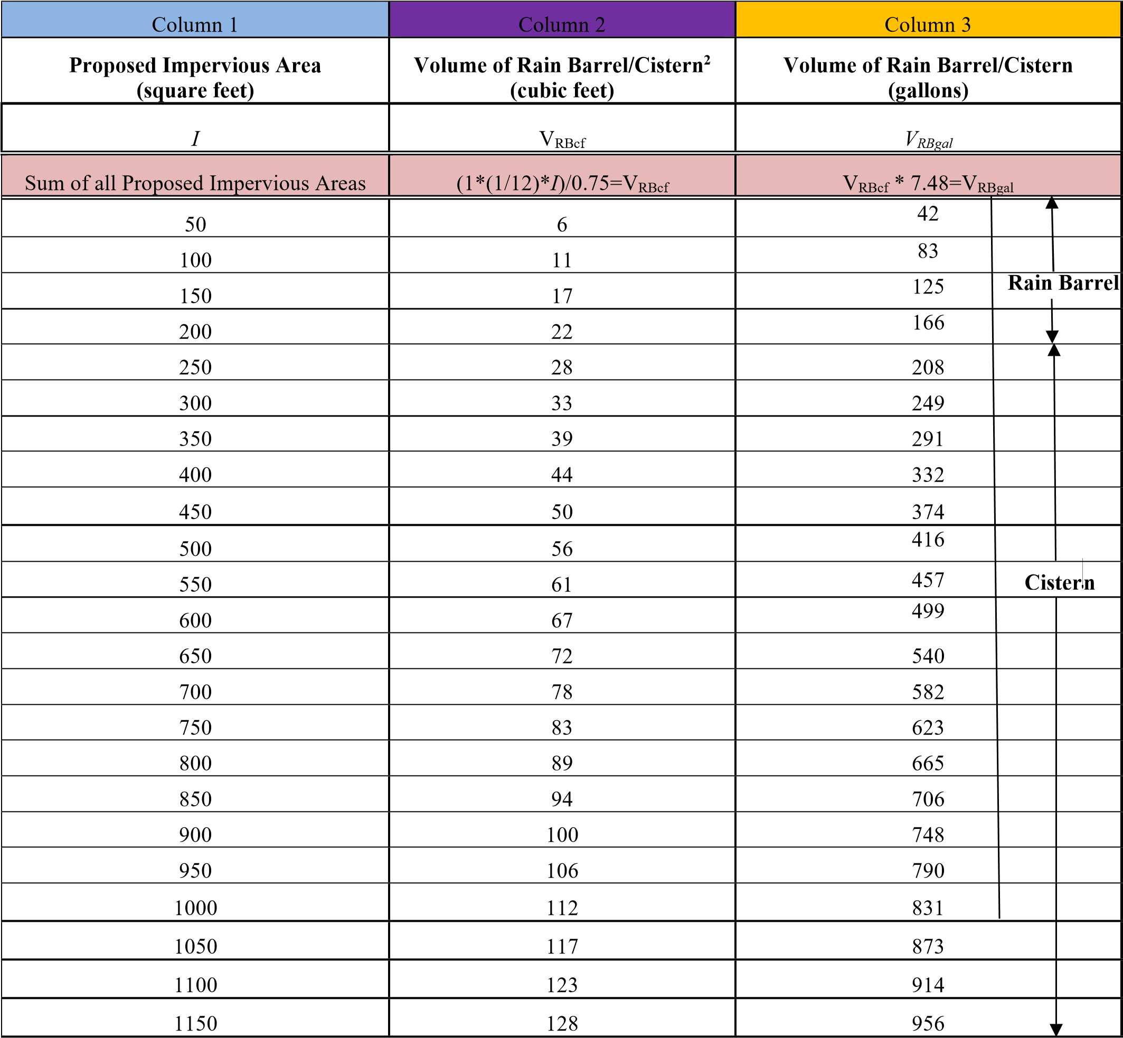

Column 1 | Column 2 | Column 3
1200 | 134 | 997
1250 | 139 | 1039
1300 | 145 | 1080
1350 | 150 | 1122
1400 | 156 | 1164
1450 | 162 | 1205
1500 | 167 | 1247
1550 | 173 | 1288
1600 | 178 | 1330
1650 | 184 | 137
1700 | 189 | 1413
1750 | 195 | 1454
1800 | 200 | 1496
1850 | 206 | 1538
1900 | 212 | 1579
1950 | 217 | 1621
2000 | 223 | 1622
2050 | 228 | 1704
2100 | 234 | 1745
2150 | 239 | 1787
2200 | 245 | 1828
2250 | 250 | 1870
2300 | 256 | 1912
2350 | 262 | 1953
2400 | 267 | 1995
2450 | 273 | 2036
2499 | 278 | 2078
Table 2: Simplified Approach - Calculating Rain Garden/Bioretention and Dry Well #1 Storage Volume and Surface Area for 1 Inch Rainfall

Column 1 | Column 2 | Column 3
Total Proposed  Impervious Area  (square feet) | Volume of Rain  Garden/Bioretention or Dry Well #1¹  (cubic feet) | Surface Area of Rain Garden/Bioretention or Dry Well #1  Acceptable Depths for Each BMP are indicated by the arrows below  (square feet)
 |  | Area  Required for a  BMP  with a  Depth(D) of 0.5' | Area  Required for a  BMP  with a  Depth(D) of 1.0' | Area  Required for a  BMP with  a  Depth(D) of 1.5' | Area  Required for a  BMP  with a  Depth(D) of 2.0' | Area  Required for a  BMP  with a  Depth(D) of 2.5' | Area  Required for a  BMP  with a  Depth(D) of 3.0' | Area  Required for a  BMP  with a  Depth(D) of 3.5' | Area  Required for a  BMP  with a  Depth(D) of 4.0'
I | V | A(sf)
Sum of all  Proposed  Impervious Areas | 1*(1/12)*I= V | V/D=A
50 | 4 | 8 | 4 | 3 | 2 | 2 | 2 | 2 | 1
100 | 8 | 16 | 8 | 6 | 4 | 4 | 3 | 3 | 2
150 | 13 | 26 | 13 | 9 | 7 | 6 | 5 | 4 | 4
200 | 17 | 34 | 17 | 12 | 9 | 7 | 6 | 5 | 5
250 | 21 | 42 | 21 | 14 | 11 | 9 | 7 | 6 | 6
300 | 25 | 50 | 25 | 17 | 13 | 10 | 9 | 8 | 7
350 | 29 | 58 | 29 | 20 | 15 | 12 | 10 | 9 | 8
400 | 33 | 66 | 33 | 22 | 17 | 14 | 11 | 10 | 9
450 | 38 | 76 | 38 | 26 | 19 | 16 | 13 | 11 | 10
500 | 42 | 84 | 42 | 28 | 21 | 17 | 14 | 12 | 11

Column 1 | Column 2 | Column 3
550 | 46 | 92 | 46 | 31 | 23 | 19 | 16 | 14 | 12
600 | 50 | 100 | 50 | 34 | 25 | 20 | 17 | 15 | 13
650 | 54 | 108 | 54 | 36 | 27 | 22 | 18 | 16 | 14
700 | 58 | 116 | 58 | 39 | 29 | 24 | 20 | 17 | 15
750 | 63 | 126 | 63 | 42 | 32 | 26 | 21 | 18 | 16
800 | 67 | 134 | 67 | 45 | 34 | 27 | 23 | 20 | 17
850 | 71 | 142 | 71 | 48 | 36 | 29 | 24 | 21 | 18
900 | 75 | 150 | 75 | 50 | 38 | 30 | 25 | 22 | 19
950 | 79 | 158 | 79 | 53 | 40 | 32 | 27 | 23 | 20
1000 | 83 | 166 | 83 | 56 | 42 | 34 | 28 | 24 | 21
1050 | 88 | 176 | 88 | 59 | 44 | 36 | 30 | 26 | 22
1100 | 92 | 184 | 92 | 62 | 46 | 37 | 31 | 27 | 23
1150 | 96 | 192 | 96 | 64 | 48 | 39 | 32 | 28 | 24
1200 | 100 | 200 | 100 | 67 | 50 | 40 | 34 | 29 | 25
1250 | 104 | 208 | 104 | 70 | 52 | 42 | 35 | 30 | 26
1300 | 108 | 216 | 108 | 72 | 54 | 44 | 36 | 31 | 27
1350 | 113 | 226 | 113 | 76 | 57 | 46 | 38 | 33 | 29
1400 | 117 | 234 | 117 | 78 | 59 | 47 | 39 | 34 | 30
1450 | 121 | 242 | 121 | 81 | 61 | 49 | 41 | 35 | 31
1500 | 125 | 250 | 125 | 84 | 63 | 50 | 42 | 36 | 32
1550 | 129 | 258 | 129 | 86 | 65 | 52 | 43 | 37 | 33
1600 | 133 | 266 | 133 | 89 | 67 | 54 | 45 | 38 | 34
1650 | 138 | 276 | 138 | 92 | 69 | 56 | 46 | 40 | 35
1700 | 142 | 284 | 142 | 95 | 71 | 57 | 48 | 41 | 36
1750 | 146 | 292 | 146 | 98 | 73 | 59 | 49 | 42 | 37
1800 | 150 | 300 | 150 | 100 | 75 | 60 | 50 | 43 | 38
1850 | 154 | 308 | 154 | 103 | 77 | 62 | 52 | 44 | 39
1900 | 158 | 316 | 158 | 106 | 79 | 64 | 53 | 46 | 40
1950 | 163 | 326 | 163 | 109 | 82 | 66 | 55 | 47 | 41
2000 | 167 | 334 | 167 | 112 | 84 | 67 | 56 | 48 | 42
Column 1 | Column 2 |  |  |  | Column 3
2050 | 171 | 342 | 171 | 114 | 86 | 69 | 57 | 49 | 43
2100 | 175 | 350 | 175 | 117 | 88 | 70 | 59 | 50 | 44
2150 | 179 | 358 | 179 | 120 | 90 | 72 | 60 | 52 | 45
2200 | 183 | 366 | 183 | 122 | 92 | 74 | 61 | 53 | 46
2250 | 188 | 376 | 188 | 126 | 94 | 76 | 63 | 54 | 47
2300 | 192 | 384 | 192 | 128 | 96 | 77 | 64 | 55 | 48
2350 | 196 | 392 | 196 | 131 | 98 | 79 | 66 | 56 | 49
2400 | 200 | 400 | 200 | 134 | 100 | 80 | 67 | 58 | 50
2450 | 204 | 408 | 204 | 136 | 102 | 82 | 68 | 59 | 51
2500 | 208 | 416 | 208 | 139 | 104 | 84 | 70 | 60 | 52

¹ It is assumed that the rain garden/bioretention or the dry well #1 are empty prior to receiving runoff (i.e. 0% full)

Table 3: Simplified Approach - Calculating Infiltration Trench and Dry Well #2 Storage Volume and Surface Area for 1 Inch of Rainfall

Column 1 | Column 2 | Column 3
Total Proposed  Impervious Area  (square feet) | Volume of Infiltration Trench or  Dry Well #2¹ (cubic feet) | Surface Area of Infiltration Trench or Dry Well #2  Acceptable Depths for Each BMP are indicated by the arrows below  (square feet)
 |  | Area  Required for a  BMP  with a  Depth(D) of 1.5' | Area  Required for a  BMP  with a  Depth(D) of 2.0' | Area  Required for a  BMP with  a  Depth(D) of 2.5' | Area  Required for a  BMP  with a  Depth(D) of 3.0' | Area  Required for a  BMP  with a  Depth(D) of 3.5' | Area  Required for a  BMP  with a  Depth(D) of 4.0' | Area  Required for a  BMP  with a  Depth(D) of 4.5' | Area  Required for a  BMP  with a  Depth(D) of 5.0'
I | V | A(sf)
Sum of all  Proposed  Impervious Areas | (1*(1/12)*I)/ (0.4)¹ =V | V/D=A
50 | 10 | 7 | 5 | 4 | 4 | 3 | 3 | 3 | 2
100 | 21 | 14 | 11 | 9 | 7 | 6 | 6 | 5 | 5
150 | 31 | 21 | 16 | 13 | 11 | 9 | 8 | 7 | 7
200 | 42 | 28 | 21 | 17 | 14 | 12 | 11 | 10 | 9
250 | 52 | 35 | 26 | 21 | 18 | 15 | 13 | 12 | 11
300 | 63 | 42 | 32 | 26 | 21 | 18 | 16 | 14 | 13
350 | 73 | 49 | 37 | 30 | 25 | 21 | 19 | 17 | 15
400 | 83 | 56 | 42 | 34 | 28 | 24 | 21 | 19 | 17
450 | 94 | 63 | 47 | 38 | 32 | 27 | 24 | 21 | 19
500 | 104 | 70 | 52 | 42 | 35 | 30 | 26 | 24 | 21
550 | 115 | 77 | 58 | 46 | 39 | 33 | 29 | 26 | 23
600 | 125 | 84 | 63 | 50 | 42 | 36 | 32 | 28 | 25
650 | 135 | 90 | 68 | 54 | 45 | 39 | 34 | 30 | 27
700 | 146 | 98 | 73 | 59 | 49 | 42 | 37 | 33 | 30
750 | 156 | 104 | 78 | 63 | 52 | 45 | 39 | 35 | 32

Column 1 | Column 2 | Column 3
800 | 167 | 112 | 84 | 67 | 56 | 48 | 42 | 38 | 34
850 | 177 | 118 | 89 | 71 | 59 | 51 | 45 | 40 | 36
900 | 188 | 126 | 94 | 76 | 63 | 54 | 47 | 42 | 38
950 | 198 | 132 | 99 | 80 | 66 | 57 | 50 | 44 | 40
1000 | 208 | 139 | 104 | 84 | 70 | 60 | 52 | 47 | 42
1050 | 219 | 146 | 110 | 88 | 73 | 63 | 55 | 49 | 44
1100 | 229 | 153 | 115 | 92 | 77 | 66 | 58 | 51 | 46
1150 | 240 | 160 | 120 | 96 | 80 | 69 | 60 | 54 | 48
1200 | 250 | 167 | 125 | 100 | 84 | 72 | 63 | 56 | 50
1250 | 260 | 174 | 130 | 104 | 87 | 75 | 65 | 58 | 52
1300 | 271 | 181 | 136 | 109 | 91 | 78 | 68 | 61 | 55
1350 | 281 | 188 | 141 | 113 | 94 | 81 | 71 | 63 | 57
1400 | 292 | 195 | 146 | 117 | 98 | 84 | 73 | 65 | 59
1450 | 302 | 202 | 151 | 121 | 101 | 87 | 76 | 68 | 61
1500 | 313 | 209 | 157 | 126 | 105 | 90 | 79 | 70 | 63
1550 | 323 | 216 | 162 | 130 | 108 | 93 | 81 | 72 | 65
1600 | 333 | 222 | 167 | 134 | 111 | 96 | 84 | 74 | 67
1650 | 344 | 230 | 172 | 138 | 115 | 99 | 86 | 77 | 69
1700 | 354 | 236 | 177 | 142 | 118 | 102 | 89 | 79 | 71
1750 | 365 | 244 | 183 | 146 | 122 | 105 | 92 | 82 | 73
1800 | 375 | 250 | 188 | 150 | 125 | 108 | 94 | 84 | 75
1850 | 385 | 257 | 193 | 154 | 129 | 110 | 97 | 86 | 77
1900 | 396 | 264 | 198 | 159 | 132 | 114 | 99 | 88 | 80
1950 | 406 | 271 | 203 | 163 | 136 | 116 | 102 | 91 | 82
2000 | 417 | 278 | 209 | 167 | 139 | 120 | 105 | 93 | 84
2050 | 427 | 285 | 214 | 171 | 143 | 122 | 107 | 95 | 86
2100 | 438 | 292 | 219 | 176 | 146 | 126 | 110 | 98 | 88
2150 | 448 | 299 | 224 | 180 | 150 | 128 | 112 | 100 | 90
2200 | 458 | 306 | 229 | 184 | 153 | 131 | 115 | 102 | 92
Column 1 | Column 2 |  |  |  | Column 3
2250 | 469 | 313 | 235 | 188 | 157 | 134 | 118 | 105 | 94
2300 | 479 | 320 | 240 | 192 | 160 | 137 | 120 | 107 | 96
2350 | 490 | 327 | 245 | 196 | 164 | 140 | 123 | 109 | 98
2400 | 500 | 334 | 250 | 200 | 167 | 143 | 125 | 112 | 100
2450 | 510 | 340 | 255 | 204 | 170 | 146 | 128 | 114 | 102
2500 | 521 | 348 | 261 | 209 | 174 | 149 | 131 | 116 | 105

¹ Assumes a percent void volume of 40%

Table-4: Simplified Approach Worksheet (AKA Simplified Stormwater Method Application)
Name of Property Owner(s): |  |  |  |  |  |  |  |  |  | Date:
Name of Applicant(s) [if different than Owner(s)]:
Contact Phone #: Email Address:
Address of Project:
Description of Project:

Met with Municipal Engineer to discuss proposed project. [insert date of meeting]
Distance from earth disturbance to nearest surface water feature (stream, pond, wetland, etc.)
(if required by the Municipality, circle one): 50 feet or less More than 50 feet
Total impervious area added since ordinance adoption (_____, 2022) = ______________________ Square Feet
 |  | Step 1: Attach Simplified SWM Site Plan (i.e. sketch plan), per Section 1, Step 1
Step 2: Determine the Impervious Area to be Managed
 |  |  | Total Proposed Impervious Area (square feet):
 |  |  | Total Earth Disturbance (square feet):
Step 3: Select the BMP(s) to be Used and Appropriate Sizing Criteria
 |  |  | Rain Barrel or Cistern
 |  |  | Proposed Impervious Surface from Column 1 in Table 1 |  | Volume from Column 3 in Table 1
 |  |  | Rain Garden/Bioretention or Dry Well #1
 |  |  | Proposed  Impervious Surface from Column 1 in Table 2 | Volume of BMP from Column 2 in Table 2 |  | Area  Dimensions of BMP - Column 3 in Table 2 |  | Depth of BMP from Column 3 in Table 2 |  |  |  | Types of Materials to be Used
 |  |  | Infiltration Trench or Dry Well #2
 |  |  | Proposed  Impervious Surface from Column 1 in Table 3 | Volume of BMP from Column 2 in Table 3 |  | Area  Dimensions of BMP - Column 3 in Table 3 |  | Depth of BMP from Column 3 in Table 3 |  |  |  | Types of Materials to be Used
Step 4: Complete, Sign & have Operation, Maintenance and Inspection Plan and Agreement Notarized and Recorded at the County Recorder of Deeds (when signed by Municipality)*
Note: For additional BMPs, use additional sheet(s).
* All Drawings and Operation, Maintenance and Inspection Plan and Agreement must be recorded at the County by the applicant. A copy of all recorded documents must be provided to the Municipality.
12/3/2021

2. Definitions

These definitions apply only to this Simplified Approach to Stormwater Management for Small Projects Handbook. The definitions included in the Municipality’s Stormwater Management Ordinance also apply. Where there are conflicts, the definitions in the Stormwater Management Ordinance prevail.

Best Management Practice (BMP) – As defined in the Municipality’s Stormwater Management Ordinance, but generally including activities, facilities, designs, measures or procedures used to manage stormwater impacts from land development and earth disturbance activities to meet stormwater quality, runoff control and groundwater recharge protection requirements. BMPs include, but are not limited to, a wide variety of practices and devices such as: infiltration facilities (dry wells and infiltration trenches), filter strips, low impact design, bioretention (rain gardens), grassed swales, and manufactured devices (cisterns and rain barrels). Structural stormwater BMPs are permanent appurtenances to the project site.

Geotextile - A fabric manufactured from synthetic fibers which provides a separation between different types of media (i.e., soil and stone), and is used to achieve specific objectives, including infiltration or filtration.

Hotspot - Areas where land use or activities generate highly contaminated runoff, with concentrations of pollutants that are higher than those that are typically found in stormwater (e.g. vehicle salvage yards, recycling facilities, vehicle fueling stations, fleet storage areas, vehicle equipment and cleaning facilities, and vehicle service and maintenance facilities).

Impervious Surface - As defined in the Municipality’s Stormwater Management Ordinance, but generally including any surface that prevents the infiltration of water into the ground. Impervious surfaces generally include, but are not limited to, streets, sidewalks, pavements, driveway areas, or roofs. The applicant should review the Municipality’s Stormwater Management Ordinance or consult with the Municipal Engineer to confirm what components of the proposed project are considered “impervious surfaces”. Decks, swimming pools, compacted soils or stone surfaces (such as for vehicle movement or parking), among other features, may be included in the Municipality’s definition of “impervious surfaces”.

Infiltration - Movement of surface water into the soil, where it is absorbed by plant roots, transpired or evaporated into the atmosphere, or percolated downward to recharge groundwater.

Low Impact Development - A land development and construction approach that uses various land planning, design practices, and technologies to simultaneously conserve and protect natural resource systems, and reduce infrastructure costs.

Percent Void Volume – The volume of void space, expressed as a percentage, of the total volume of the storage facility (void volume + volume of solid materials providing structural support for the storage facility).

Pervious Surface - Any area not defined as impervious surface.

Potable – A water supply that is either absent of contaminants or contains contaminant levels that are below a given threshold level that makes the water as suitable for drinking.

Runoff - Any part of precipitation that flows over the land surface.

Stormwater - Drainage runoff from the surface of the land resulting from precipitation, or snow or ice melt.

3. Description of BMPs

The following is a description of several types of BMPs that could be implemented. The requirements of each BMP as described below are taken directly from the PA Stormwater BMP Manual (December, 2006). Refer to the PA BMP Manual (latest version) which can be found on the PA Department of Environmental Protection’s website.

Rain Barrels/Cisterns
Rain Barrels are large containers that collect drainage from roof leaders and temporarily store water to be released to lawns, gardens, and other landscaped areas after the rainfall has ended. Rain Barrels are typically between 50 to 200 gallons in size. The stored water can also be used as a non-potable water supply. Cisterns are larger than rain barrels having volumes of 200 gallons or more, and can be placed either on the surface or underground. Figures 1 and 2 show examples of rain barrels and cisterns, respectively, that could be used to manage stormwater from a project. Rain barrels and cisterns are manufactured in a variety of shapes and sizes. All of these facilities must make provisions for the following items:
- There must be a means to release the water stored in the container between storm events in order for the necessary storage volume to be available for the next storm.
- Stormwater must be kept from entering other potable systems, and pipes and storage units must be clearly marked “Do Not Drink”.
- An overflow outlet should be placed a few inches below the top of the storage container with an overflow pipe to divert flow away from structures once the storage containers are filled.
- Use screens to filter debris, and covers (lids) placed over the containers to prevent insects and debris from entering the storage chamber.
- Make sure cisterns are watertight and do not leak.
- Rain barrels are typically assumed to be 25% full to calculate volume since they are not always emptied before each storm. The tables contained in this Handbook were developed to account for the 25% increase in the required storage of a rain barrel or a cistern.

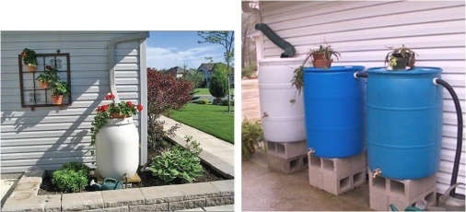

Source (picture on left): http://www.rfcity.org/Eng/Stormwater/YourProperty/YourProperty.htm
Source (picture on right): :http://www.floridata.com/tracks/transplantedgardener/Rainbarrels.cfm

Figure 1: Rain Barrels

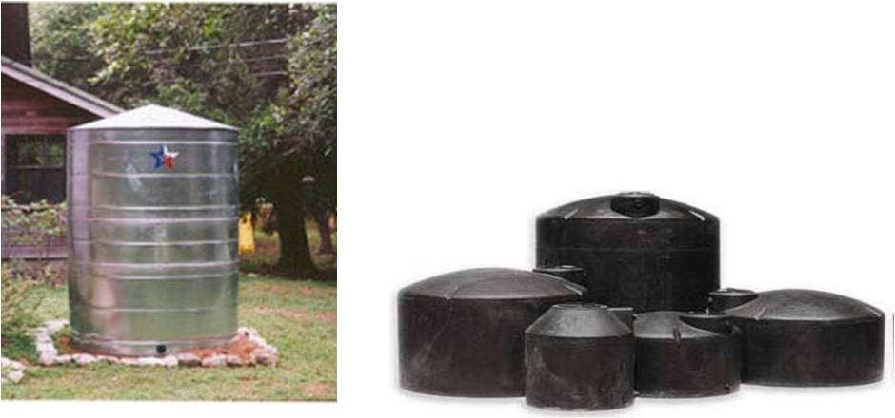
Source (for both pictures): Pennsylvania Stormwater BMP Manual (PADEP, 2006)

Figure 2: Cisterns

Infiltration Trench
An infiltration trench is a long, narrow, rock-filled trench, with or without a perforated pipe placed within the rock to distribute water evenly along the trench, that receives stormwater runoff, and has no outlet. Runoff is stored in the void space between the stones and in the pipe, and infiltrates through the bottom of the trench into the underlying soil matrix. Figure 3 shows a typical cross-section of an infiltration trench configuration. Infiltration trenches shall incorporate or make provisions for the following elements:

- These facilities should be located a minimum of ten (10) feet (or as otherwise required by the Municipality) from the building foundation to avoid foundation seepage problems, and are not recommended if their installation would create a risk of flooding other structures constructed at or below grade.
- Perforated pipe placed within the rock is to be set level.
- The width is limited to between 3 to 8 feet, and the depth ranges from 2 to 5 feet. Given the variability of local groundwater and bedrock formations, a shallow bed with wider footprint is generally recommended. Should the applicant run into a limiting factor (ground water or bedrock) during construction, consultation with the Municipal Engineer is required.
- Trench should be wrapped in nonwoven geotextile (top, sides, and bottom).
- There should be a positive overflow that allows stormwater that cannot be stored or infiltrated to be discharged into a nearby vegetated area.
- Roof downspouts may be connected to infiltration trenches, but should contain a cleanout to collect sediment and debris before entering the infiltration area.
- Infiltration testing is recommended to ensure soil is capable of infiltrating stormwater.
- It is recommended that there be a 2 foot clearance above the regularly occurring seasonal high water table, and have a minimum depth to bedrock of 2 feet.
- The infiltration trench should be at least 50 feet from individual water supply wells, 100 feet from community or municipal water supply wells, and 50 feet from any septic system component. It should not be located near stormwater Hotspots (refer to B.2 Definitions).
- The infiltration trench should be located so that it presents no threat to sub-surface structures such as building foundations and basements.
- Protect infiltration areas from compaction by heavy equipment during and after construction.
- Infiltration trenches should be constructed after all earth disturbance associated with a given project or site is stabilized to avoid clogging.
- The ratio of the drainage area which stormwater runoff is collected from to the area of the footprint (bottom area) of the infiltration portion of the facility should be as small as possible with a ratio of less than 5:1 preferred.

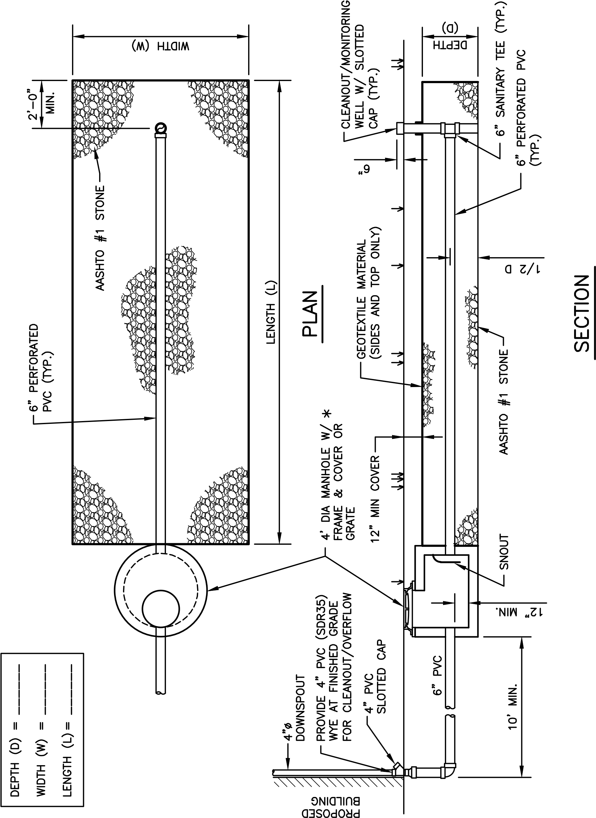

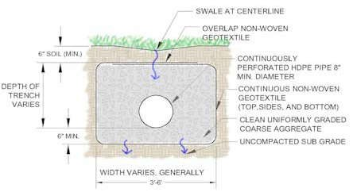

Source: Pennsylvania Stormwater BMP Manual (PADEP, 2006)

Figure 3: Cross-Section of Typical Infiltration Trench

12/3/2021 21

Rain Garden/Bioretention Area
A Rain Garden (Bioretention Area) is an excavated depression area on the surface of the land in which native vegetation is planted to filter and use stormwater runoff. Runoff ponds on top of the surface of the rain garden and then infiltrates into an enhanced soil/planting mix below the surface where plants can use the water to grow. Bioretention improves water quality, with the vegetation planted in the facility filtering the water, and the root systems encouraging or promoting infiltration. Figure 4 shows a cross-section of a typical rain garden. Key elements of a rain garden include:

- Recommended ponding depths not exceeding 1 foot.
- Native vegetation that can tolerate dry and wet weather.
- An overflow area where, if the bioretention area were to overflow, the overflow would flow over pervious surfaces (i.e. grass, meadow), and would not cause harm to property, or;
- An overflow, such as a domed riser, to allow excess flow from large storms to travel to other infiltration areas, pervious areas, or connected storm systems designed to receive the excess runoff.
- For most areas, slopes should be limited to 3:1, maximum; however, where space is limited, 2:1 side slopes may be acceptable with approval from the municipal engineer.
- The soil/planting mix depth should not be less than 1.5 feet deep and typically consist of a mixture of topsoil, sand and compost (i.e. mulch). The topsoil, sand and compost should be uniformly mixed by volume in a 50%, 30%, 20% mixture, respectively.

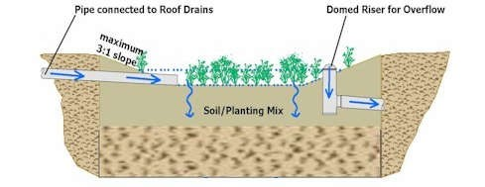

Source: Pennsylvania Stormwater BMP Manual (PADEP, 2006)

Figure 4: Cross-Section of Typical Rain Garden/Bioretention Area

12/3/2021 22

Dry Wells
A dry well, also referred to as a seepage pit, is a subsurface storage facility that temporarily stores and infiltrates runoff from the roofs of buildings or other impervious surfaces. A dry well can be either a structural prefabricated chamber (Dry Well #1) or an excavated pit filled with stone fill (Dry Well #2). Dry Wells discharge the stored runoff via infiltration into the surrounding or underlying soils. Figure 5 shows a typical prefabricated dry well and a typical dry well configuration with stone fill. The following elements shall be incorporated into all dry well designs:

- These facilities should be located a minimum of ten (10) feet (or as otherwise required by the Municipality) from the building foundation to avoid foundation seepage problems, and are not recommended if their installation would create a risk of flooding other structures constructed at or below grade.
- Dry well should be constructed after all earth disturbance associated with a given project or site is stabilized to avoid clogging.
- During construction, compaction of the subgrade soil in the bottom of the dry well should be avoided, and construction should be performed only with light machinery.
- For Dry Well #2 designs, the depth of dry well should be between 1.5 feet to 4 feet. Gravel fill should consist of uniformly graded stone with an average diameter of between one and one half and two (1.5 –2.0) inches with the gravel fill wrapped in a nonwoven geotextile to separate the stone fill from the surrounding soil.
- At least 1 foot of soil must be placed over the top of the dry well.
- Dry wells should be inspected at least four (4) times annually as well as after large storm events.
- Dry wells should have overflow pipes to allow high volumes of runoff to overflow the facility and flow into a connected infiltration area, pervious area, or other connected storm sewer designed to receive the excess runoff.
- Every dry well must have at least one monitoring well to assist in the inspection of the dry well to determine how much water is retained within the well during dry weather periods.
- Infiltration testing is recommended to ensure the underlying soil is capable of infiltrating the needed volume of stormwater.

12/3/2021 23

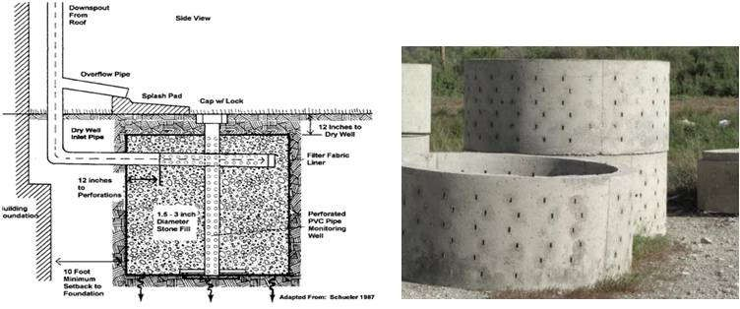

Monitoring Well

Source (for picture on left): http://www.seagrant.sunysb.edu/pages/BMPsForMarinas.htm
Source (for picture on right): http://www.copelandconcreteinc.net/1800652.html

Figure 5: Typical Dry Well Configuration filled with Stone Fill (DRY WELL #2) (Left) and Structural Prefabricated Chamber (DRY WELL #1) (Right)
12/3/2021 24

4. Example

Simplified Approach to Stormwater Management for a Residential Garage and Driveway addition

Joe Homeowner wants to build a 400 square foot two car garage, and a 540 square foot (30’ long x 18’ wide) impervious driveway that is graded so that the stormwater runoff drains to the grassy area along one edge of the driveway. (An annotated copy of Table 1 is provided below as Table 5 and an annotated copy of Table 3 is provided below as Table 6, and outlines the steps of this example) and a completed Table 4 is provided as Table 7.

STEP 1 – Make a sketch of the site plan as shown in Figure 6.

STEP 2 - Determine the total area of all proposed impervious surfaces to drain to each BMP:

Garage Roof (Front) | 10 ft. x 20 ft. | = | 200 sq. ft
Garage Roof (Rear) | 10 ft. x 20 ft. | = | 200 sq. ft.
Driveway | 30 ft. x 18 ft. | = | 540 sq. ft.
 |  |  | -------------
Total Proposed Impervious Surface |  |  | 940 sq. ft.
Total Proposed Earth Disturbance Area |  |  | 2,500 sq. ft. (estimated)

Note: If the driveway used pervious pavement (i.e. paving blocks), then the total impervious area would only be 400 square feet, and no stormwater management practices would need to control runoff from the project.

STEP 3 – Select the BMP(s) to be Used and Appropriate Sizing Criteria

Select a BMP or combination of BMPs from Section 3 to be used to satisfy the volume requirement. Determine the length, width, depth and other requirements for the BMPs in Section 3. A BMP needs to be placed to catch runoff from the back of the garage, and a BMP needs to be placed to capture runoff from the front of the garage and the driveway. Figure 6 shows the direction the runoff flows and the locations where the BMPs are to be placed.

Joe Homeowner would like to use a rain barrel (BMP #1) to capture the runoff from the rear of the garage and an infiltration trench (BMP #2) to capture runoff from the front of the garage and the driveway.

BMP #1 (Rain Barrel/Cistern) – Steps 3A and 3B

STEP 3A - Select the proposed impervious area value for BMP #1, the rain barrel or cistern, in Column 1 that is closest to, but not less than 200 in Table 1:

The value in Column 1 that is closest to but is not less than 200 is 200.
STEP 3B - Determine the volume that BMP #1 must be to satisfy the volume requirements using Columns 2 and 3 in Table 1:

12/3/2021 25

The volume in gallons of the rain barrel/cistern to be used as BMP #1, assuming the rain barrel/cistern is 25% full, is determined by finding the value in Column 3 for the same row that corresponds to the impervious area value determined in Step 1. Therefore, the volume of BMP #1, the rain barrel/cistern must be ≥ 166 gallons. Depending on the size of the rain barrel(s), a combination of rain barrels could be used in succession as shown in Figure 1, or a cistern could be used.

BMP #2 (Infiltration Trench) - Steps 3A through 3C

STEP 3A - Select the proposed impervious area value for BMP #2, the infiltration trench, using Column 1 in Table 6:

Find the row in Column 1 that is closest to but not less than 740 (200 from the front of the garage + 540 from the driveway). Therefore, the value selected is 750.

STEP 3B - Determine the volume that BMP #2, the infiltration trench must be to satisfy the volume requirements using Column 2 in Table 6:

The volume of the infiltration trench to be used as BMP #2, assuming a percent void volume of 40%, is determined by finding the value Column 2 that is in the same row as 750 square feet from Column 1 as described in Step 2. Therefore, the volume of BMP #2 must be 156 cubic feet.

STEP 3C - Utilizing the value from Column 2 determined above, and the surface area that the proposed BMP will occupy, determine the depth needed using Column 3 in Table 6:

Joe Homeowner would like to place the infiltration trench along the edge of the driveway so it would have a length of 20 feet. The smallest width that can be used, as stated in the infiltration trench requirements in Section 3, is 3 feet. Therefore, the area of the infiltration trench is:

20 feet * 3 feet = 60 square feet

To find the minimum depth of the trench move toward the right side of the table from 156 cubic feet in Column 2 to Column 3, and find the column with a value of as close to but not more than 60 square feet, which is 52 square feet. Then obtain the minimum depth of the facility by reading the depth from the column heading at the top of the table. Therefore, the depth of the trench would need to be 3 feet.

Selected BMPs:
BMP #1: Rain barrel(s) that provides for at least 166 gallons, and BMP #2: A 20’ long x 3’ wide x 3’ deep infiltration trench

12/3/2021 26

Table 5: Example – Calculating Storage Volume for Rain Barrel/Cistern

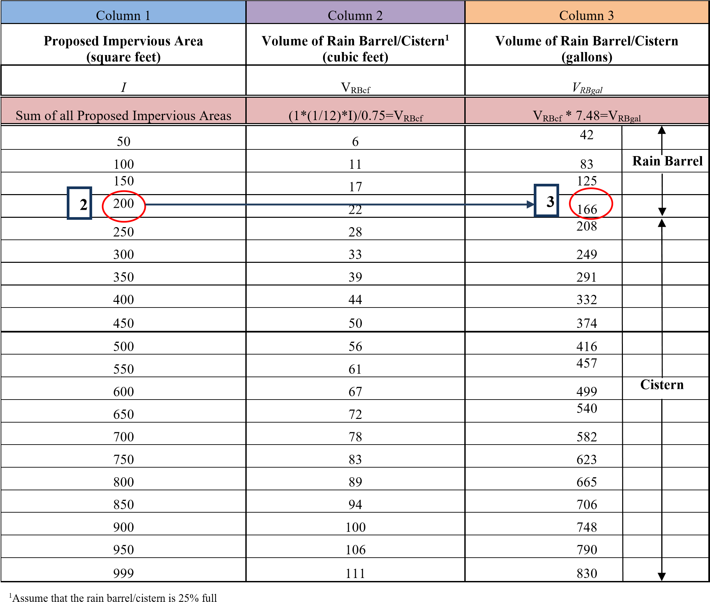

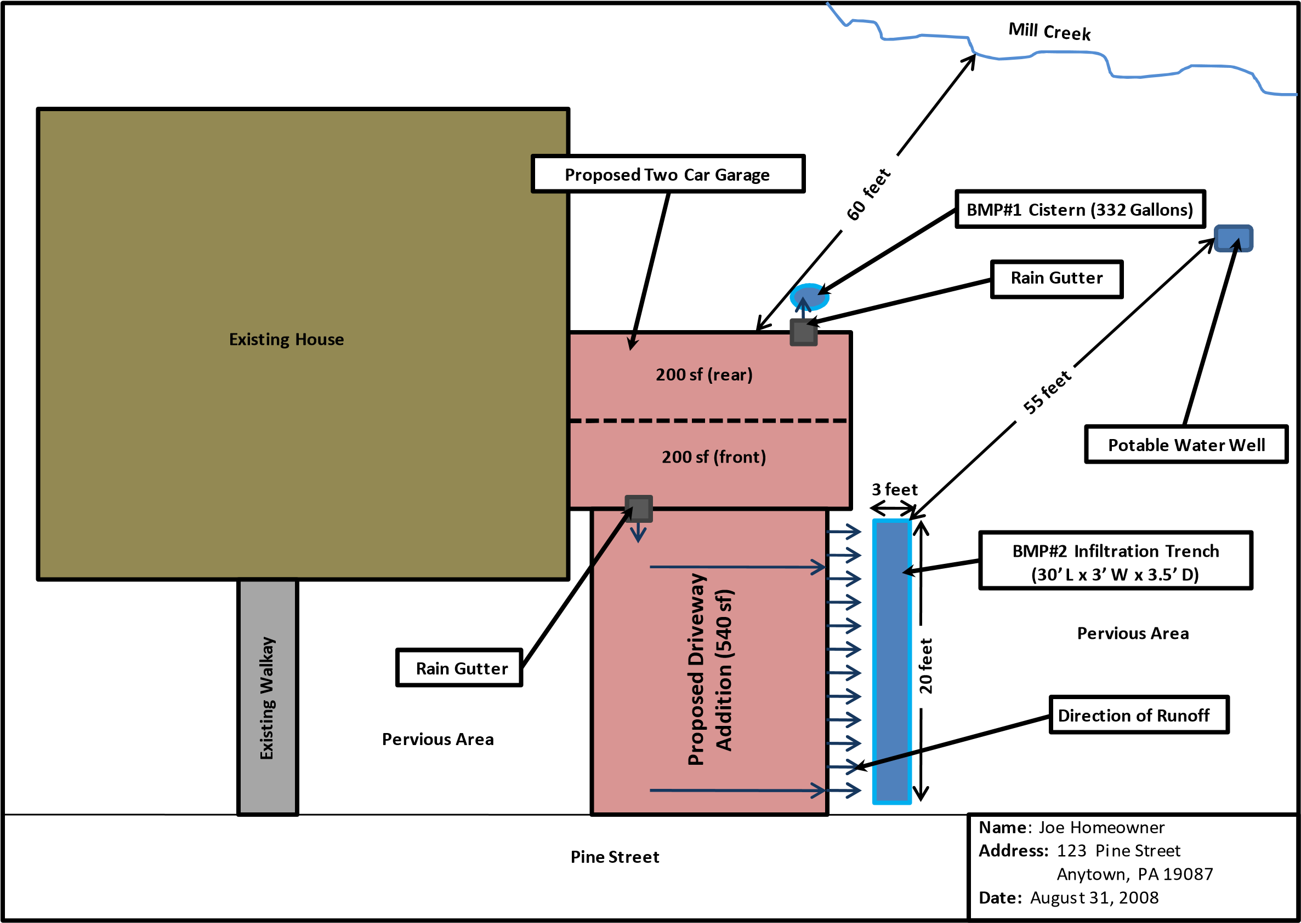

Figure 6: Example of Simplified Stormwater Management Site Plan for Joe Homeowner
Table 6: Example – Calculating Storage Volume Surface Area and Depth for Infiltration Trench
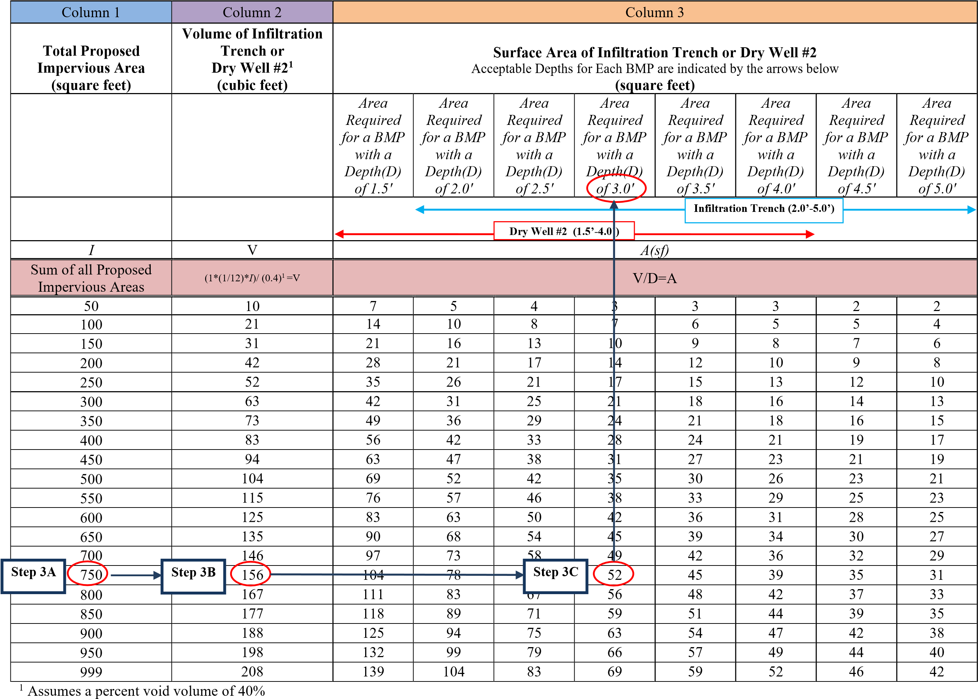

Table 7: Simplified Approach Worksheet – Example for Joe Homeowner
Name of Property Owner(s): Joe Homeowner Date: 8/26/12
Name of Applicant(s) [if different than Owner(s)]: N/A
Contact Phone #: 610-555-1234 Email Address: joe@homeowner.com
Address of Project: 123 Pine St., Anytown, PA 19355
Description of Project: Add a 2-car garage and driveway
Met with Municipal Engineer to discuss proposed project. [date of meeting 6/1/12]
Distance from earth disturbance to nearest surface water feature (stream, pond, wetland, etc.)
(if required by the Municipality, circle one): 50 feet or less More than 50 feet

x Step 1: Attach Simplified SWM Site Plan (i.e. sketch plan), per Section .1, Step 1

Step 2: Determine the Impervious Area to be Managed
Total Proposed Impervious Area (square feet): 940 sq. feet
Total Earth Disturbance (square feet): ~ 2,500 sq. feet

Step 3: Select the BMP(s) to be Used and Appropriate Sizing Criteria
Rain Barrel or Cistern
Proposed Impervious Volume from Column 3
Surface from Column 1 in Table 1 in Table 1
200 sq. feet 166 gallons

Rain Garden/Bioretention or Dry Well #1
Proposed Volume of BMP Area Depth of BMP Types of
Impervious Surface from Column 2 in Dimensions of from Column 3 Materials to
from Column 1 in Table 2 BMP - Column 3 in Table 2 be Used
Table 2 in Table 2
N/A

Infiltration Trench or Dry Well #2
Proposed Volume of BMP Area Depth of BMP Types of
Impervious Surface from Column 2 in Dimensions of from Column 3 Materials to from Column 1 in Table 3 BMP - Column 3 in Table 3 be Used
Table 3 in Table 3
740 sq. feet 156 cubic feet 20 ft by 3 ft 3 ft Infiltration
trench, uniformly graded aggregate, 8” HDPE pipe, geotextile, grass planted on top.
x Step 4: Complete, Sign & have Operation, Maintenance and Inspection Agreement Notarized and Recorded at the County Recorder of Deeds (when signed by the Municipality) Note: For additional BMPs, use additional sheet(s).
12/3/2021 30

5. Simplified Approach Operation, Maintenance and Inspection Plan and Agreement

It is the property owner’s responsibility to properly maintain BMPs. It is also the property owner’s responsibility to inform any future buyers of the function, operation, and maintenance needed for any BMPs on the property prior to the purchase of the property. The accompanying sample “Simplified Approach Operation, Maintenance and Inspection Plan and Agreement” (see accompanying appendix) outlines the maintenance required for each type of BMP, the responsibilities of the property owner, and the rights of the Municipality in regards to inspection and enforcement of the maintenance requirements.

The “Simplified Approach Operation, Maintenance and Inspection Plan and Agreement” must be signed, notarized and submitted to the Municipality. Following the signature by the Municipality, the property owner must have the Agreement recorded at the County Recorder of Deeds, so that the Agreement will be applicable to future property owners.

12/3/2021 31

Appendix A.3
Simplified Approach – Stormwater Best Management Practices Operation, Maintenance, and Inspection Plan and Agreement

SAMPLE AGREEMENT

REVISED
ARRO Consulting, Inc.
December 3, 2021

SIMPLIFIED APPROACH
STORMWATER BEST MANAGEMENT PRACTICES
OPERATION, MAINTENANCE, AND INSPECTION PLAN AND AGREEMENT

THIS AGREEMENT, made and entered into this ____________ day of _________, 20___, by and between
____________________________________, (hereinafter the “Landowner”), and Marietta Borough, Lancaster County, Pennsylvania, (hereinafter “Municipality”).
WITNESSETH
WHEREAS, the Landowner is the owner of certain real property by virtue of a deed of conveyance recorded in the land records of Lancaster County, Pennsylvania, at Deed Book ___________ and Page ______,
(hereinafter “Property”); and
WHEREAS, the Landowner recognizes that the stormwater management best management practices or BMPs (hereinafter referred to as “BMP” or “BMP(s)”) located on the Property at
_________________________________________________________________________________________
__________________________________ (address of Property where BMP is located) must be inspected and
maintained; and
WHEREAS, the Municipality and the Landowner, for itself and for its administrators, executors,
successors, heirs, and assigns, agree that the health, safety, and welfare of the residents of the Municipality and
the protection and maintenance of water quality require that on-site BMP(s) be constructed and maintained on
the Property; and
WHEREAS, for the purposes of this Agreement, the following definitions shall apply:
BMP – “Best Management Practice;” activities, facilities, designs, measures or procedures used to manage stormwater impacts from land development, to protect and maintain water quality and ground water recharge and to otherwise meet the purposes of the Municipality’s Stormwater Management Ordinance, including, but not limited to infiltration trenches, dry wells, bioretention, rain gardens, permeable paving, rain barrels and cisterns, etc. The BMP(s) are permanent appurtenances to the Property; and

Conveyance – As specifically identified in the Simplified Stormwater Management Site Plan (herein
after “Plan”), a man-made, existing or proposed facility, structure or channel used for the transportation or transmission of stormwater from one place to another, including pipes, drainage ditches, channels and swales (vegetated and other), gutters, and like facilities or features. The conveyances identified in the Plan are permanent appurtenances to the Property; and
WHEREAS, the Municipality requires that the BMP(s) and conveyances as shown on Plan and in accordance with the sizing calculations found on the Simplified Method Worksheet (herein after “Worksheet”) be constructed by the Landowner; the BMP(s) shall further be maintained by the Landowner, its administrators, executors, successors, heirs, and assigns in accordance with the associated operation and maintenance requirements included herein. The Plan and Worksheet are attached hereto and incorporated herein together as Exhibit “A” hereto; and
WHEREAS, the Municipality requires that stormwater management BMP(s) be constructed and adequately inspected, operated and maintained by the Landowner, its administrators, executors, successors, heirs, and assigns, in accordance with the following maintenance requirements:
NOTE TO EDITOR:
Retain the type of BMP(s) from the following list that applies to this Property and delete any of the following BMP(s) listed below that do not apply. You may also add a BMP not listed and provide its maintenance requirement, if needed.

- Infiltration Trenches
  - At least twice a year and after significant rainfall events the Landowner is to inspect the infiltration trench and remove any accumulated debris, sediment and invasive vegetation.
  - Vegetation along the surface of an infiltration trench is to be maintained in good condition, and any bare spots are to be revegetated as soon as possible.
  - Vehicles are not to be parked or driven on an infiltration trench, and care is to be taken to avoid excessive compaction by mowers.
  - Any debris, such as leaves blocking flow from reaching an infiltration trench, is to be routinely removed.

- Bioretention/Rain Garden
  - Any debris, such as leaves blocking flow from reaching a bioretention/rain garden, is to be routinely removed.
  - Pruning and weeding are required as needed including removal of invasive species, especially while vegetation is being established for a bioretention/rain garden.
  - Mulch cover is to be maintained in a bioretention/rain garden, re-spread and replaced as needed to prevent erosion, reduce weed growth and assist with plant survival, without restricting the infiltration of stormwater.
  - At least twice a year the Landowner is to inspect the bioretention/rain garden for sediment buildup, ground cover and vegetative conditions and make any repairs as needed.
  - Watering is required as needed, including during periods of extended dry weather and drought.
  - Trees and shrubs in a bioretention/rain garden are to be inspected at least twice per year by the Landowner to evaluate their health. If they are in poor health they are to be replaced.

- Dry Wells
  - Dry wells are to be inspected by the landowner at least four (4) times a year and after significant rainfalls, and debris, trash, sediment, and any other waste material need to be removed and disposed of at suitable disposal or recycling sites and in compliance with local, state, and federal waste regulations.
  - For dry wells, gutters are to be regularly cleaned out and ensure that proper connections are maintained to facilitate the effectiveness of the dry well.
  - The filter screen for downspouts or roof gutters which intercepts roof runoff and conveys it to the dry well must be cleaned and replaced as necessary.
  - Dry wells that are damaged are to be fixed or replaced within two (2) weeks of being damaged.
  - If an intermediate sump box exists in conjunction with a dry well, it must be cleaned out at least once per year.

- Rain Barrels and Cisterns
  - Rain Barrels and Cisterns are to be cleared of debris routinely at least every three (3) months and after significant storms to allow stormwater from gutters to enter them.
  - Gutters that directly convey rain water to dry wells, rain barrels, and cisterns are to be routinely cleared of trash and debris at least every three (3) months and after significant rainfall events.
  - Rain Barrels and cisterns should be routinely emptied to allow for storage of additional rain water.
  - Overflow outlets from rain barrels and cisterns must be kept free and clear of debris.
  - Rain Barrels and cisterns that are damaged are to be fixed or replaced within two (2) weeks of being damaged.

NOW, THEREFORE, in consideration of the foregoing promises, the mutual covenants contained
herein, and the following terms and conditions, the parties hereto, intending to be legally bound hereby, agree as follows:
- The foregoing recitals to this Agreement are incorporated as terms of this Agreement and obligations of the Landowner as if fully set forth in the body of this Agreement.
- The Landowner shall construct the BMP(s) in accordance with the specifications identified in the Plan and Worksheet.
- The Landowner shall inspect, operate and maintain the BMP(s) as shown on the Plan in good working order acceptable to the Municipality and in accordance with the specific inspection and maintenance requirements outlined in this Agreement.
- The Landowner hereby grants permission to the Municipality, its authorized agents and employees, to enter upon the Property from the public right-of-way or roadway, at reasonable times and upon presentation of proper identification, to inspect the BMP(s) whenever it deems necessary for compliance with this Agreement and the Municipality’s Stormwater Ordinance. Whenever possible, the Municipality shall notify the Landowner prior to entering the Property.
- The Landowner acknowledges that, per the Municipality’s Stormwater Ordinance, it is unlawful, without written approval of the Municipality, to:
  - Modify, remove, fill, landscape, alter or impair the effectiveness of any BMP or conveyance that is constructed as part of the Plan;
  - Place any structure, fill, landscaping, additional vegetation, yard waste, brush cuttings, or other waste or debris into a BMP or conveyance that would limit or alter the functioning of the BMP or conveyance;
  - Allow the BMP or conveyance to exist in a condition which does not conform to the Plan or this
Agreement; and
  - Dispose of, discharge, place or otherwise allow pollutants including, but not limited to, deicers, pool additives, household chemicals and automotive fluids to directly or indirectly enter any BMP or conveyance.
- In the event the Landowner fails to operate and maintain the BMP(s) as shown on the Plan in good working order acceptable to the Municipality the Landowner shall be in violation of this Agreement and the Landowner agrees that the Municipality or its representatives may, in addition to and not in derogation or diminution of any remedies available to it under the Stormwater Ordinance or other statutes, codes, rules or regulations, or this Agreement, enter upon the Property and take whatever action is deemed necessary to maintain said BMP(s). It is expressly understood and agreed that the Municipality is under no obligation to maintain or repair said facilities, and in no event shall this Agreement be construed to impose any such obligation on the Municipality.
- In the event the Municipality, pursuant to this Agreement, performs work of any nature, or expends any funds in performance of said work for labor, use of equipment, supplies, materials, and the like, the Landowner shall reimburse the Municipality for all expenses (direct and indirect) incurred within 30 days of delivery of an invoice from the Municipality. Failure of the Landowner to make prompt payment to the Municipality may result in enforcement proceedings, which may include the filing of a lien against the Property, which filing is expressly authorized by the Landowner.
- The intent and purpose of this Agreement is to ensure the proper maintenance of the onsite BMP(s) by the Landowner; provided, however, that this Agreement shall not be deemed to create or effect any additional liability of any party for damage alleged to result from or be caused by stormwater runoff.
- The Landowner, its executors, administrators, assigns, heirs, and other successors in interests, hereby release and shall release the Municipality, its employees, agents and designated representatives from all damages, accidents, casualties, occurrences or claims which might arise or be asserted against the Municipality and/or its said employees, agents or representatives, arising out of the construction, presence, existence, or maintenance of the BMP(s) either by the Landowner or Municipality. In the event that a claim is asserted or threatened against the Municipality, its employees, agents or designated representatives, the Municipality shall notify the Landowner and the Landowner shall defend, at his own expense, any claim, suit, action or proceeding, or threatened claim, suit, action or proceeding against the Municipality or, at the request of the
Municipality, pay the cost, including attorneys’ fees, of defense of the same undertaken on behalf of the Municipality. If any judgment or claims against the Municipality, its employees, agents or designated representatives shall be allowed, the Landowner shall pay all damages, judgments or claims and any costs and expenses incurred by the Municipality, including attorneys fees, regarding said damages, judgment or claims.
- The Municipality may enforce this Agreement in accordance with its Stormwater Ordinance, at law or in equity, against the Landowner for breach of this Agreement. Remedies may include fines, penalties, damages or such equitable relief as the parties may agree upon or as may be determined by a Court of competent jurisdiction. Recovery by the Municipality shall include its reasonable attorneys fees and costs incurred in seeking relief under this Agreement.
- Failure or delay in enforcing any provision of this Agreement shall not constitute a waiver by the Municipality of its rights of enforcement hereunder.
- The Landowner shall inform future buyers of the Property about the function of, operation, inspection and maintenance requirements of the BMP(s) prior to the purchase of the Property by said future buyer, and upon purchase of the Property the future buyer assumes all responsibilities as Landowner and must comply with all components of this Agreement.
- This Agreement shall inure to the benefit of and be binding upon, the Municipality and the Landowner, as well as their heirs, administrators, executors, assigns and successors in interest.

This Agreement shall be recorded at the Office of the Recorder of Deeds of the County of Lancaster,
Pennsylvania, and shall constitute a covenant running with the Property and/or equitable servitude, in perpetuity.

ATTEST:

WITNESS the following signatures and seals:

(SEAL) For the Municipality:

(SEAL) For the Landowner:

ATTEST:

_____________________________ (City, Borough, Township)
County of Lancaster, Pennsylvania
I, _______________________________________, a Notary Public in and for the County and State aforesaid, whose commission expires on the __________ day of __________________, 20__, do hereby certify that
________________________________________ whose name(s) is/are signed to the foregoing Agreement bearing date of the ___________ day of ___________________, 20__, has acknowledged the same before me
in my said County and State.
GIVEN UNDER MY HAND THIS _____________ day of ___________, 20__.
________________________________ ____________________________________
NOTARY PUBLIC (SEAL)

ORDINANCE APPENDIX B

RUNOFF COEFFICIENTS
AND
CURVE NUMBERS

Chapter 2 Estimating Runoff Technical Release 55
Urban Hydrology for Small Watersheds
Table 2-2a
Runoff curve numbers for urban areas
1
/
 |  | Curve numbers for
------------------------------------------- Cover description -----------------------------------------  Average percent |  | -----------hydrologic soil group -------------
Cover type and hydrologic condition impervious area ^{2/} |  | A B C D
Fully developed urban areas (vegetation established)  Open space (lawns, parks, golf courses, cemeteries, etc.) ^{3/}:  Poor condition (grass cover < 50%) .......................................... |  |  | 68 | 79 | 86 | 89
Fair condition (grass cover 50% to 75%) .................................. |  |  | 49 | 69 | 79 | 84
Good condition (grass cover > 75%)......................................... |  |  | 39 | 61 | 74 | 80
Impervious areas:  Paved parking lots, roofs, driveways, etc.  (excluding right-of-way)............................................................. |  |  | 98 | 98 | 98 | 98
Streets and roads:  Paved; curbs and storm sewers (excluding  right-of-way) ................................................................................ |  |  | 98 | 98 | 98 | 98
Paved; open ditches (including right-of-way).......................... |  |  | 83 | 89 | 92 | 93
Gravel (including right-of-way) ................................................. |  |  | 76 | 85 | 89 | 91
Dirt (including right-of-way)...................................................... |  |  | 72 | 82 | 87 | 89
Western desert urban areas:  Natural desert landscaping (pervious areas only) ^{4/} ..................... |  |  | 63 | 77 | 85 | 88
Artificial desert landscaping (impervious weed barrier, desert shrub with 1- to 2-inch sand or gravel mulch and basin borders) ...................................................................... |  |  | 96 | 96 | 96 | 96
Urban districts:  Commercial and business ................................................................. | 85 |  | 89 | 92 | 94 | 95
Industrial ............................................................................................. | 72 |  | 81 | 88 | 91 | 93
Residential districts by average lot size:  1/8 acre or less (town houses).......................................................... | 65 |  | 77 | 85 | 90 | 92
1/4 acre ................................................................................................ | 38 |  | 61 | 75 | 83 | 87
1/3 acre ................................................................................................ | 30 |  | 57 | 72 | 81 | 86
1/2 acre ................................................................................................ | 25 |  | 54 | 70 | 80 | 85
1 acre ................................................................................................... | 20 |  | 51 | 68 | 79 | 84
2 acres.................................................................................................. | 12 |  | 46 | 65 | 77 | 82
Developing urban areas  Newly graded areas  (pervious areas only, no vegetation) 5/................................................................  Idle lands (CN’s are determined using cover types similar to those in table 2-2c). |  |  | 77 | 86 | 91 | 94
- Average runoff condition, and I_{a} = 0.2S.
- The average percent impervious area shown was used to develop the composite CN’s. Other assumptions are as follows: impervious areas are directly connected to the drainage system, impervious areas have a CN of 98, and pervious areas are considered equivalent to open space in good hydrologic condition. CN’s for other combinations of conditions may be computed using figure 2-3 or 2-4.
- CN’s shown are equivalent to those of pasture. Composite CN’s may be computed for other combinations of open space cover type.
- Composite CN’s for natural desert landscaping should be computed using figures 2-3 or 2-4 based on the impervious area percentage (CN = 98) and the pervious area CN. The pervious area CN’s are assumed equivalent to desert shrub in poor hydrologic condition.
- Composite CN’s to use for the design of temporary measures during grading and construction should be computed using figure 2-3 or 2-4 based on the degree of development (impervious area percentage) and the CN’s for the newly graded pervious areas.
(210-VI-TR-55, Second Ed., June 1986) 2–5
Chapter 2 Estimating Runoff

Technical Release 55
Urban Hydrology for Small Watersheds

Table 2-2b
Runoff curve numbers for cultivated agricultural lands
1
/
Curve numbers for
 |  | Hydrologic
Cover type | Treatment ^{2/} | condition ^{3/} | A | B | C | D
Fallow | Bare soil | — | 77 | 86 | 91 | 94
 | Crop residue cover (CR) | Poor | 76 | 85 | 90 | 93
 |  | Good | 74 | 83 | 88 | 90
Row crops | Straight row (SR) | Poor | 72 | 81 | 88 | 91
 |  | Good | 67 | 78 | 85 | 89
 | SR + CR | Poor | 71 | 80 | 87 | 90
 |  | Good | 64 | 75 | 82 | 85
 | Contoured (C) | Poor | 70 | 79 | 84 | 88
 |  | Good | 65 | 75 | 82 | 86
 | C + CR | Poor | 69 | 78 | 83 | 87
 |  | Good | 64 | 74 | 81 | 85
 | Contoured & terraced (C&T) | Poor | 66 | 74 | 80 | 82
 |  | Good | 62 | 71 | 78 | 81
 | C&T+ CR | Poor | 65 | 73 | 79 | 81
 |  | Good | 61 | 70 | 77 | 80
Small grain | SR | Poor | 65 | 76 | 84 | 88
 |  | Good | 63 | 75 | 83 | 87
 | SR + CR | Poor | 64 | 75 | 83 | 86
 |  | Good | 60 | 72 | 80 | 84
 | C | Poor | 63 | 74 | 82 | 85
 |  | Good | 61 | 73 | 81 | 84
 | C + CR | Poor | 62 | 73 | 81 | 84
 |  | Good | 60 | 72 | 80 | 83
 | C&T | Poor | 61 | 72 | 79 | 82
 |  | Good | 59 | 70 | 78 | 81
 | C&T+ CR | Poor | 60 | 71 | 78 | 81
 |  | Good | 58 | 69 | 77 | 80
Close-seeded | SR | Poor | 66 | 77 | 85 | 89
or broadcast |  | Good | 58 | 72 | 81 | 85
legumes or | C | Poor | 64 | 75 | 83 | 85
rotation |  | Good | 55 | 69 | 78 | 83
meadow | C&T | Poor | 63 | 73 | 80 | 83
 |  | Good | 51 | 67 | 76 | 80
------------------------------------------ Cover description --------------------------------------------- ------------- hydrologic soil group ----------------

- Average runoff condition, and I_{a}=0.2S
- Crop residue cover applies only if residue is on at least 5% of the surface throughout the year.
- Hydraulic condition is based on combination factors that affect infiltration and runoff, including (a) density and canopy of vegetative areas, (b) amount of year-round cover, (c) amount of grass or close-seeded legumes, (d) percent of residue cover on the land surface (good ≥ 20%), and (e) degree of surface roughness.
Poor: Factors impair infiltration and tend to increase runoff.
Good: Factors encourage average and better than average infiltration and tend to decrease runoff.
2–6 (210-VI-TR-55, Second Ed., June 1986)
Chapter 2 Estimating Runoff Technical Release 55
Urban Hydrology for Small Watersheds
Table 2-2c
Runoff curve numbers for other agricultural lands
1
/
Curve numbers for
--------------------------------------- Cover description -------------------------------------- ------------ hydrologic soil group ---------------
Hydrologic
Cover type condition A B C D
Pasture, grassland, or range—continuous | Poor | 68 | 79 | 86 | 89
forage for grazing. ^{2/} | Fair | 49 | 69 | 79 | 84
 | Good | 39 | 61 | 74 | 80
Meadow—continuous grass, protected from | — | 30 | 58 | 71 | 78
grazing and generally mowed for hay.  Brush—brush-weed-grass mixture with brush | Poor | 48 | 67 | 77 | 83
the major element. ^{3/} | Fair | 35 | 56 | 70 | 77
 | Good | 30 4/ | 48 | 65 | 73
Woods—grass combination (orchard | Poor | 57 | 73 | 82 | 86
or tree farm). ^{5/} | Fair | 43 | 65 | 76 | 82
 | Good | 32 | 58 | 72 | 79
Woods. ^{6/} | Poor | 45 | 66 | 77 | 83
 | Fair | 36 | 60 | 73 | 79
 | Good | 30 4/ | 55 | 70 | 77
Farmsteads—buildings, lanes, driveways, and surrounding lots. | — | 59 | 74 | 82 | 86
¹ Average runoff condition, and I_{a} = 0.2S.
2 | Poor: | <50%) ground cover or heavily grazed with no mulch.
 | Fair: | 50 to 75% ground cover and not heavily grazed.
 | Good: | > 75% ground cover and lightly or only occasionally grazed.
3 | Poor: | <50% ground cover.
 | Fair: | 50 to 75% ground cover.
 | Good: | >75% ground cover.
- Actual curve number is less than 30; use CN = 30 for runoff computations.
- CN’s shown were computed for areas with 50% woods and 50% grass (pasture) cover. Other combinations of conditions may be computedfrom the CN’s for woods and pasture.
- Poor: Forest litter, small trees, and brush are destroyed by heavy grazing or regular burning.
Fair: Woods are grazed but not burned, and some forest litter covers the soil.
Good: Woods are protected from grazing, and litter and brush adequately cover the soil.
(210-VI-TR-55, Second Ed., June 1986) 2–7
TABLE F-2

RATIONAL RUNOFF COEFFICIENTS

 | HYDROLOGIC SOIL GROUP
LAND USE DESCRIPTION | A | B | C | D
Cultivated land : without conservation treatment | .49 | .67 | .81 | .88
: with conservation treatment | .27 | .43 | .61 | .67
Pasture or range land: poor condition | .38 | .63 | .78 | .84
: good condition | ---* | .25 | .51 | .65
Meadow: good condition | ---* | ---* | .44 | .61
Woods: thin stand, poor cover, no mulch | ---* | .34 | .59 | .70
: good cover | ---* | ---* | .45 | .59
Open spaces, lawns, parks, golf courses, cemeteries
Good condition: grass cover on 75% or more of the area | ---* | .25 | .51 | .65
Fair condition: grass cover on 50% to 75% of the area | ---* | .45 | .63 | .74
Commercial and business areas (85% impervious) | .84 | .90 | .93 | .96
Industrial districts (72% impervious) | .67 | .81 | .88 | .92
Residential:
Average lot size Average % impervious
1/8 acre or less 65 | .59 | .76 | .86 | .90
1/4 acre 38 | .25 | .49 | .67 | .78
1/3 acre 30 | ---* | .49 | .67 | .78
1/2 acre 25 | ---* | .45 | .65 | .76
1 acre 20 | ---* | .41 | .63 | .74
Paved parking lots, roofs, driveways, etc. | .99 | .99 | .99 | .99
Streets and roads:
Paved with curbs and storm sewers | .99 | .99 | .99 | .99
Gravel | .57 | .76 | .84 | .88
Dirt | .49 | .69 | .80 | .84
Notes: Values are based on SCS definitions and are average values.
Values indicated by ---* should be determined by the design engineer based on site characteristics.

Source : New Jersey Department of Environmental Protection, Technical Manual for Stream Encroachment, August 1984
F-3

APPENDIX C

OPERATION AND MAINTENANCE (O&M) AGREEMENT
STORMWATER MANAGEMENT BEST MANAGEMENT PRACTICES (SWM BMPs)

THIS AGREEMENT, made and entered into this day of , 20 , by and between -
_______________________________ (hereinafter the “Landowner”), and Marietta Borough, Lancaster County,
Pennsylvania (hereinafter “Municipality”);

WITNESSETH

WHEREAS, the Landowner is the owner of certain real property as recorded by deed in the land records of Lancaster County, Pennsylvania, Deed Book at page ,
(hereinafter “Property”).

WHEREAS, the Landowner is proceeding to build and develop the Property; and

WHEREAS, the SWM BMP Operation and Maintenance (O&M) Plan approved by the Municipality (hereinafter referred to as the “O&M Plan”) for the property identified herein, which is attached hereto as Appendix A and made part hereof, as approved by the Municipality, provides for management of stormwater within the confines of the Property through the use of BMPs; and

WHEREAS, the Municipality, and the Landowner, his successors and assigns, agree that the health, safety, and welfare of the residents of the Municipality and the protection and maintenance of water quality require that on-site SWM BMPs be constructed and maintained on the Property; and

WHEREAS, the Municipality requires, through the implementation of the SWM Site Plan, that SWM BMPs as required by said SWM Site Plan and the Municipal Stormwater Management Ordinance be constructed and adequately operated and maintained by the Landowner, successors, and assigns.

NOW, THEREFORE, in consideration of the foregoing promises, the mutual covenants contained
herein, and the following terms and conditions, the parties hereto agree as follows:

- The Landowner shall construct the BMPs in accordance with the plans and specifications identified in the SWM Site Plan.

- The Landowner shall operate and maintain the BMPs as shown on the SWM Site Plan in good working order in accordance with the specific operation and maintenance requirements noted on the approved O&M Plan.

- The Landowner hereby grants permission to the Municipality, its authorized agents and employees, to enter upon the property, at reasonable times and upon presentation of proper credentials, to inspect the BMPs whenever necessary. Whenever possible, the Municipality shall notify the Landowner prior to entering the property.

- In the event the Landowner fails to operate and maintain the BMPs per paragraph 2, the Municipality or its representatives may enter upon the Property and take whatever action is deemed necessary to maintain said BMP(s). It is expressly understood and agreed that the Municipality is under no obligation to maintain or repair said facilities, and in no event shall this Agreement be construed to impose any such obligation on the Municipality.

- In the event the Municipality, pursuant to this Agreement, performs work of any nature, or expends any funds in performance of said work for labor, use of equipment, supplies, materials, and the like, the Landowner shall reimburse the Municipality for all expenses (direct and indirect) incurred within 10 days of receipt of invoice from the Municipality.

- The intent and purpose of this Agreement is to ensure the proper maintenance of the on-site BMPs by the Landowner; provided, however, that this Agreement shall not be deemed to create any additional liability of any party for damage alleged to result from or be caused by stormwater runoff.

- The Landowner, its executors, administrators, assigns, and other successors in interests, shall release the Municipality from all damages, accidents, casualties, occurrences, or claims which might arise or be asserted against said employees and representatives from the construction, presence, existence, or maintenance of the BMP(s) by the Landowner or Municipality.

- The Municipality intends to inspect the BMPs at a minimum of once every three years to ensure their continued functioning.

This Agreement shall be recorded at the Office of the Recorder of Deeds of Lancaster
County, Pennsylvania, and shall constitute a covenant running with the Property and/or equitable servitude, and shall be binding on the Landowner, his administrators, executors, assigns, heirs, and any other successors in interests, in perpetuity.

ATTEST:

WITNESS the following signatures and seals:
(SEAL) For the Municipality:

For the Landowner:

ATTEST:
(City, Borough, Township)
County of , Pennsylvania
I, , a Notary Public in and for the county and state aforesaid, whose commission expires on the day of , 20 , do hereby certify that whose name(s) is/are signed to the foregoing Agreement bearing date of the day , 20 , has acknowledged the same before me in my said county and state.

GIVEN UNDER MY HAND THIS day of , 20 .

NOTARY PUBLIC (SEAL)

ORDINANCE APPENDIX D
CONSERVATION DESIGN AND
LOW IMPACT DEVELOPMENT

SITE DESIGN

CONSERVATION DESIGN &
LOW IMPACT DEVELOPMENT SITE DESIGN

INTRODUCTION
Traditional approaches to land development often radically alter natural hydrologic conditions by constructing collection and conveyance systems that are designed to remove runoff from a site as quickly as possible and capture it in a detention basin. This approach has often led to the degradation of water quality, reduced groundwater recharge, and increased volumes of stormwater runoff, as well as the imposition of expenditures to detain and manage concentrated runoff downstream. Fortunately, the study of hydrology (the way rainfall interacts with slopes, soils, and vegetation) offers a number of alternative approaches that respect the natural environment and ultimately save money. The accompanying ordinance encourages the use of Conservation Design (CD), Low Impact Development (LID), and green infrastructure to preserve, restore and maintain pre-development hydrology on sites with planned land disturbance and development activity. The site design practices and recommendations included in this appendix provide a framework to assist developers, municipal planning commission members, and others involved in local land use planning with designing and implementing development that minimizes the impacts of stormwater runoff to local streams.
Conventionally designed development often divides a parcel into buildable lots, streets, and parking areas, while only keeping traditionally undevelopable areas (wetlands, floodplains, steep slopes) as open space. Existing site hydrology and natural features are often an afterthought in locating and designing stormwater systems. In contrast, Conservation Design and Low Impact Development practices strive to minimize landscape and natural feature disturbance to maintain a site’s natural drainage patterns and flow conditions.
CD is a holistic site design process that aims to protect and maintain a site’s unique natural, historic, and cultural features. CD emphasizes the protection of key land and environmental resources to maintain site hydrology; preserves and/or enhances significant concentrations of natural resources, open space, wildlife habitat, biodiversity corridors, and greenways (interconnected open space); incorporates unique natural, scenic, and historic site features into the configuration of the development; preserves the integral characteristics of the site as viewed from adjacent roads; and ensures flexibility in development design to meet community needs for complementary and aesthetically pleasing development.

LID consists of site design approaches and small-scale stormwater management practices that promote the use of natural systems for infiltration, evapotranspiration (returning moisture to the atmosphere through vegetation), and the harvest and reuse of rainwater. LID addresses the root cause of water quality impairment by managing stormwater as close to the point of generation as possible.
Together, CD and LID offer unique opportunities to balance the “carrying capacity” of the land, the human demands on the land (including land economics), and the design constraints and opportunities of a site, which together allow for a dynamic interaction between people and the natural world. The goal is to produce a design that balances the demands of human use (scale, pattern, autonomy, privacy, views, etc.)
with the requirements for a sustainable landscape (reduction in land fragmentation and use conflicts, preservation of watershed hydrology, protection of wildlife corridors and species diversity, conservation of
natural resources, etc.). CD and LID are integrated development processes that respect natural site conditions and attempt to replicate and/or improve the natural hydrology of a site. The abundance of Lancaster County’s streams and headwater areas, agricultural land (consisting of prime agricultural soils), uniqueaquatic and terrestrial habitat, and scenic and historic resources, argue for design approaches responsive toconservation principles.
This appendix provides information on the principles, processes, and common practices of CD and LID to assist designers and planners to achieve site designs that best maintain pre-construction stormwater runoff conditions, protect site amenities, and preserve natural resources. Components of this appendix include:
- Implementation Challenges
- Design Principles and Techniques;
- Design Process;
- Design Practices;
- Benefits of Conservation Design; • Conclusion; and • References.

IMPLEMENTATION CHALLENGES
Various techniques exist to accomplish the purposes of CD and LID (see the list of Design Practices starting on Page 12). However, many municipal codes currently prevent creative site design and engineering by requiring mechanical “by the numbers” development of sites. Restrictive zoning, subjective economic concerns, jurisdictional preferences, and personal tastes determine how a site is developed and how stormwater will be managed. These can pose significant impediments to the use of CD and LID. Such issues, left unaddressed, will “fail to comprehensively maintain predevelopment ecological functions at sites and fail to prevent development impacts to overall watershed ecological health” (Low Impact Development, Prince George’s County, Maryland). Several examples of practices that may be limited by municipal zoning or subdivision and land development ordinances (SALDO) are presented in the Design Practices section to assist municipalities, developers, and landowners to understand how to improve the development design process to allow or require CD and LID practices.
Dialogue between developers, municipalities, and planners should be encouraged early in the design process to evaluate all potential site design options. Discussions on proposed site layouts often do not occur until after the submission of preliminary/final developments plans. At this point, substantial time and expense have already gone into the development of these plans, resulting in the reduced preference to make substantial changes or re-designs. Thus, discussions of potential site considerations between landowners, developers, municipalities, and planners early in the design process is critical to ensuring CD and LID practices are incorporated. While the
Municipalities Planning Code prevents municipalities from mandating the submission of sketch plans unless they waive preliminary or final plan requirements, voluntary submission of these plans should be encouraged. Other options also exist; for example, municipalities could mandate the sketch plan but permit a one-step preliminary/final plan submission. Moreover, this site design process emphasizes the importance of dialogue. Remaining open minded to alternative site designs, including flexibility of area and bulk standards, building types, lot sizes, and even construction standards, among others, may achieve multiple benefits, not the least of which is the protection of site hydrology and improved management of stormwater.
One of the greatest challenges to reducing the impact of development is to control the volume of stormwater runoff generated from a site. Typically, a development’s increase in impervious surface contributes to reduced infiltration, evapotranspiration, and attenuation of stormwater runoff. This can result in reduced groundwater levels and lower stream baseflow during periods of dry weather and higher stream flows during and after precipitation events (which can result in increased occurrences of flooding and the erosion and destabilization of downstream streambanks). CD and LID techniques strive to prevent these problems by encouraging land development site designs that minimize post-development runoff rates and volumes and minimize needs for artificial conveyance and storage facilities. This process attempts to incorporate the desired land development into the natural hydrologic landscape in a manner that maintains and utilizes existing site hydrology features and functions to minimize generation of new stormwater runoff, thus avoiding the cumulative environmental impacts often associated with land development and reducing the need for and size of constructed stormwater facilities.
Site design practices include preserving natural drainage features, minimizing impervious surface area, reducing the hydraulic connectivity of impervious surfaces, and protecting natural depression storage. Applying this site design process helps maintain site hydrology and manage stormwater by:
- minimizing the generation of stormwater runoff (achieved by designing to the land, considering site drainage patterns and infiltration characteristics, reducing grading and compaction, and considering scale and placement of buildings); managing stormwater as close to the point of generation as possible (by disconnecting impervious surfaces, rather than collecting storm flows from all such surfaces, and distributing such flows to landscaped-based BMPs);
- providing open and vegetated channel conveyance (as needed to treat water quality, reduce velocity and infiltrate); and
- managing remaining conveyed stormwater in common open space (as needed to disperse low velocity storm flows, treat water quality, infiltrate, and release).
A well-designed site will contain a mix of all these features.
In some communities, the use of CD and LID will require a paradigm shift in how we think about and regulate development; community education, be that of residents, developers, engineers, or community officials, will be important if we are to achieve the multiple benefits offered through the use of these alternative design principles and practices.

DESIGN PRINCIPLES AND TECHNIQUES
CD and LID place significant emphasis on maintaining, mimicking, or improving the natural hydrology of land undergoing development. A site’s natural hydrology refers to the drainage patterns and infiltration characteristics existing on a site. With CD and LID, effort is placed on development design that minimizes the generation of stormwater runoff. This can be achieved by designing to the land, i.e., giving consideration to site drainage patterns and site infiltration characteristics, reducing grading and compaction, and carefully considering the placement and scale of streets and buildings. Consideration of the natural drainage patterns of a site and the capacity of the site to infiltrate water are central to the concept of managing stormwater on-site.
Where stormwater is generated, the next step involves managing such storm flows as close to the source of generation as possible. This is achieved by disconnecting impervious surfaces and distributing storm flows to green infrastructure. Disconnection allows for management near the source of generation rather than the traditional approach of conveying all storm flows to a central “catch and release” facility (expensive to build and expensive to maintain). Where distributed management practices common to LID are insufficient to accommodate storm flows, CD encourages the use of open channel conveyance systems, such as vegetated channels, bioswales, and wet swales, that further manage storm flows in common open space. This multi-management approach (or four-step management process) - minimizing the generation of stormwater, landscape-based management near the point of generation, open channel conveyance, and management in common open space - is a clear advantage of CD (see Figure 1).
It should also be noted that CD is quite effective on sites with limited infiltration capability, principally, because the four-step management process builds redundancies into runoff management, seeking to achieve disconnection, using LID, providing open channel conveyance, and making use of common open space where other tools and techniques are insufficient on their own.
Figure 1

Conservation Design Principles
Maintaining Site Hydrology and Managing Stormwater
Step 1 - Minimize Generation of Stormwater Runoff through Development Design: Achieved by Designing to the Land & Optimizing the
Cumulative Benefits of the Site’s Natural Hydrologic Features
■ Consider Natural Drainage Patterns and Infiltration Characteristics
■ Reduce Grading and Compaction by Utilizing Natural Topography
■ Consider Placement and Scale of Streets and Buildings
■ Minimize Land Disturbance - both Surface and Subsurface
■ Minimize Cumulative Area to be Covered by Impervious and Compacted Surfaces
Step 2 - Manage Stormwater as Close to the Point of Generation as Possible using Distributed LID Practices
■ Take Advantage of the Natural Hydrologic Landscape to Achieve Runoff Controls
■ Disconnect Impervious Surfaces
■ Distribute Storm Flows to Green Infrastructure
Step 3 - Utilize Open Channel Conveyance (as needed)
Step 4 - Management in Common Open Space (or as conveyed to other green infrastructure practices)
■ Integrate Management Facilities into the Natural Environment
■ Incorporate Natural Site Features into the Design
■ Create Site Amenities that can be Enjoyed by Residents and Provide a Community Aesthetic
No single approach is appropriate for all sites; rather, CD is a process by which to assess the appropriateness of different techniques (LID or otherwise) for different sites. The key to making CD and LID work is a willingness on the part of all involved to be flexible in how a particular site is developed. With this in mind, CD makes it possible to achieve multiple objectives, both in terms of site design (controlling peak flows, reducing total volume, and enhancing water quality), as well as those related to community (protecting natural resources, preserving habitat, interconnecting open space, providing
greenways, and achieving better designed communities). (See Figure 2)
Figure 2

Common Objectives Of Conservation Design
Conservation Design practices are intended to protect environmental resources,
preserve open space, and manage stormwater by respecting natural drainage patterns and infiltration characteristics.
CommonObjectives

Site Design Objectives
Maintain Natural Drainage Patterns
Preserve Water Budget and Natural
Infiltration
Minimize Grading - Design to the Site
(Minimum Disturbance, Minimum Maintenance)
Reduce Need for Traditional Structural
Stormwater Management Facilities
(incorporate the use of Green Infrastructure)
Reduce Impervious Cover
Preserve Natural Features & Habitat (Contiguous Open Space)
Provide Open Space Linkages with
Adjacent Parcels
Community Objectives
Community Commons/Greens
Lots that Front or Back to Open Space
“Neighborhoods” within Neighborhoods
Options for a Variety of
Housing Types/Lot Sizes
Incorporate Unique Site Features into the Design (Natural/Scenic/Historic)
Preserve Characteristics of Site as Viewed from Adjoining Roads
Provide Trail Systems and/or
Alternative Transportation Options

CD and LID involve identifying and prioritizing natural resources and natural and constructed hydrologic features and incorporating such features into the overall site design to take advantage of their efficiencies in hydrologic performance, their cost efficiencies of reducing the need for or size of constructed stormwater facilities, and their aesthetic amenities.
Techniques to apply Figure 1 design principles are presented in Table 1.

Table 1 - Site Design Process Principles and Techniques
Conservation Design Principles | Select Design Techniques
Development Design that  Minimizes the Generation of  Stormwater Runoff: Achieved by Designing to the Land & Optimizing the Cumulative  Benefits of the Site’s Natural Hydrologic Features | - Maintain the natural soil structure and vegetative cover that are often critical components of maintaining the hydrologic functions of natural infiltration, bioretention, flow attenuation, evapotranspiration, and pollutant removal. Strive to achieve multiple stormwater objectives (i.e., maintain hydrologic regime including both peak rate and total volume control, water quality control, and temperature control.  - Protect, or improve, natural resources to reduce the needs for environmental mitigation, future environmental restoration, and cumulative flow and water quality impacts of unnecessary disturbances within the watershed system.  - Minimize the disturbance of natural surface and groundwater drainage features and patterns, discharge points and flow characteristics, natural infiltration and evapotranspiration patterns and characteristics, natural stream channel stability, and floodplain conveyance, etc.  - Minimize the size of individual impervious surfaces.  - Separate large impervious surfaces into smaller components.  - Avoid unnecessary impervious surfaces.  - Utilize porous materials where suited in lieu of impervious materials.  - Prioritize on-site hydrologic features (i.e., for protection, improvement, utilization, or alteration) and natural site drainage patterns and infiltration characteristics and consider them for the cornerstones of the conceptual site design. Prevent rather than minimize.  - Reduce grading and compaction by applying selective grading design methods to provide final grading patterns that preserve existing topography where it most benefits natural hydrologic functions and where needed; this results in graded areas that evenly distribute runoff and minimize concentrated runoff flows.  - Consider the scale and placement of buildings and other infrastructure to minimize impact to natural hydrologic features.  - Incorporate unique natural, scenic, and historic site features into the configuration of the development, and ensure flexibility in development design to meet community needs for complementary and aesthetically pleasing development.

Conservation Design Principles | Select Design Techniques
Managing Stormwater as  Close to the Point of  Generation as Possible using Distributed LID Practices | - Incorporate natural hydrologic features that have been selected for their available capacity and function into the overall system of site runoff controls (protect their hydrologic and natural ecosystem functions without directing additional stormwater to them).  - Disconnect runoff from one impervious surface to another.  - Incorporate LID (or similar) green infrastructure and distribute storm flows to:  - Reduce runoff;  - Manage stormwater at or as close to the point of generation as possible;  - Disconnect discharges from streets and municipal storm sewer systems; and  - Select and design BMPs to give first priority to nonstructural and vegetated (landscape-based) BMPs, second priority to surface structural BMPs, third priority to subsurface structural BMPs, and design subsurface BMPs as shallow as possible.
Open Channel Conveyance (as needed) | - Convey concentrated flows by means of innovative pervious vegetated channels rather than piped systems  - Provide open channel conveyance, as needed, to:  o Treat water quality; o Reduce runoff velocity; and o Promote infiltration and evapotranspiration of runoff.
Management in Common  Open Space (or as conveyed to other green infrastructure  practices) | - Rely on natural processes within the soil mantle and the plant community to the maximum extent practicable.  - Manage remaining conveyed stormwater from small storms in common open space areas to achieve multiple objectives:  o Disperse storm flows and reduce velocity; o Treat water quality; and o Promote infiltration and evapotranspiration of runoff.  - Provide for appropriate conveyance to retention or detention storage facilities as needed for flows from large storm events (as needed).  - Maintain open space functions consistent with common area uses (passive recreation, on-site sewage management, scenic vistas, etc). Management practices should be integrated into the natural environment and be site amenities.

The concepts presented in Figures 1 and 2, and further described in Table 1, are graphically presented below in Figures 3.1, 3.2. 3.3, 3.4, 3.5, and 3.6.
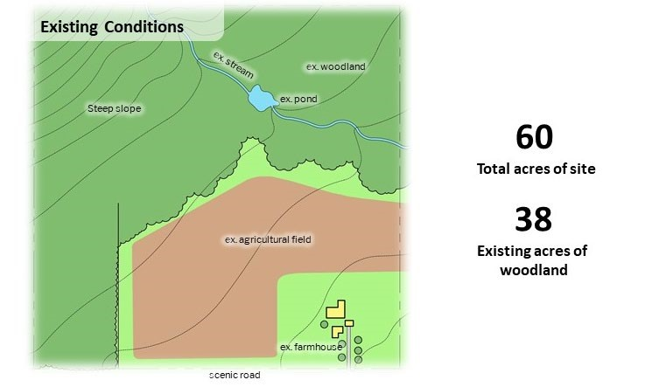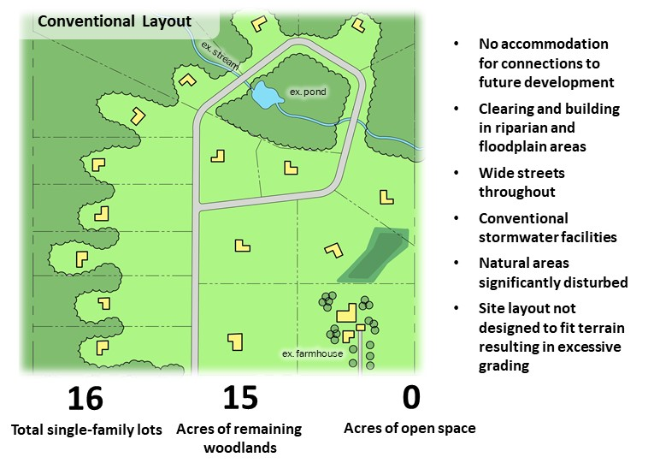

Figure 3.1: Existing conditions on a 60-acre, majority wooded parcel

Figure 3.2: Example of how the above parcel may be developed using conventional layout methods

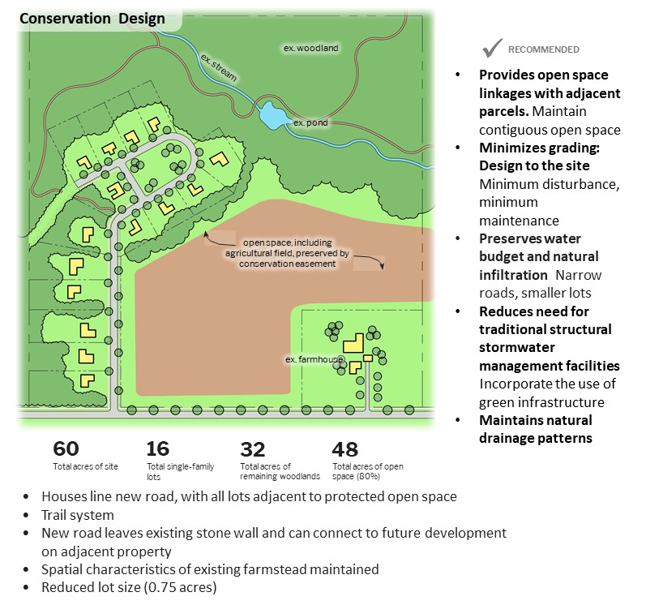

Figure 3.3: Example of a single-family development on the same parcel using
the principles of Conservation Design and Low Impact Development

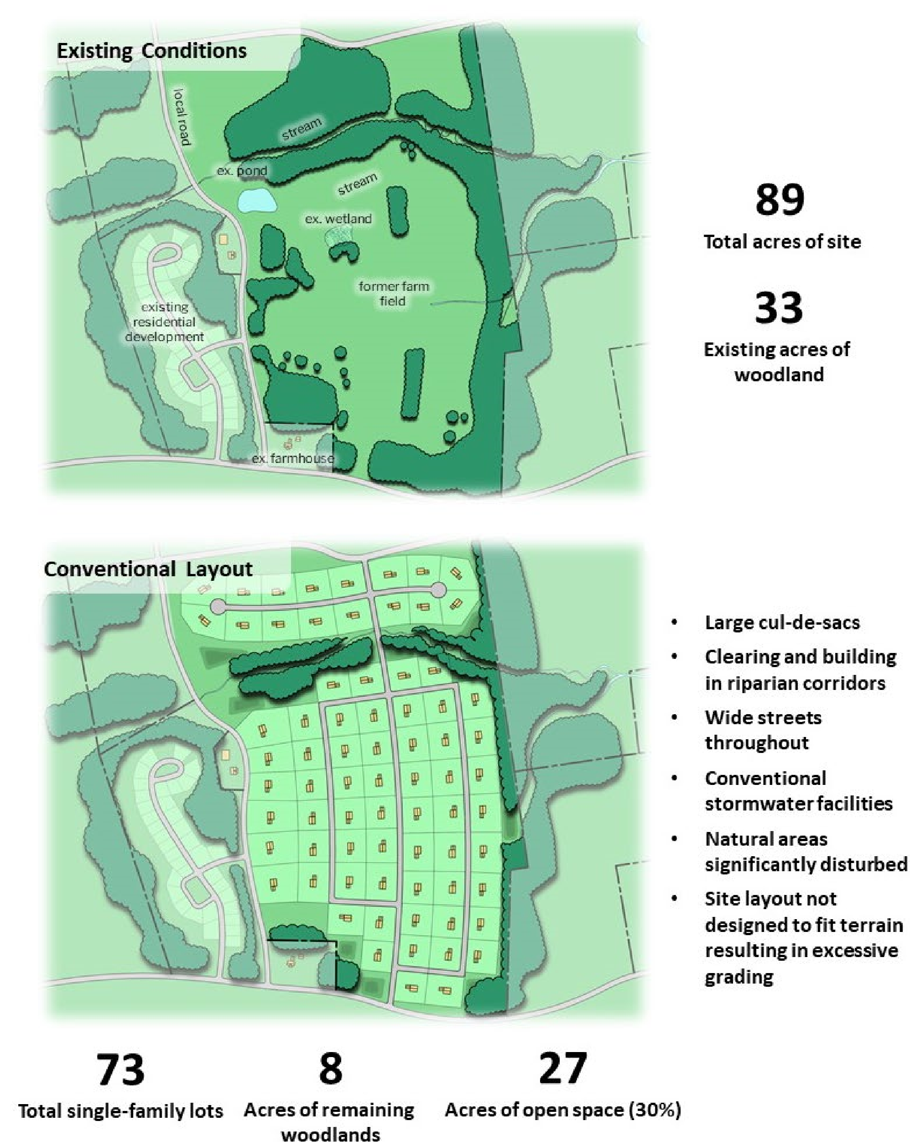

Figure 3.4: Example of how a larger parcel with a mix of open meadows, woodlands, scattered fence rows, and stream corridors may be developed using conventional layout methods.
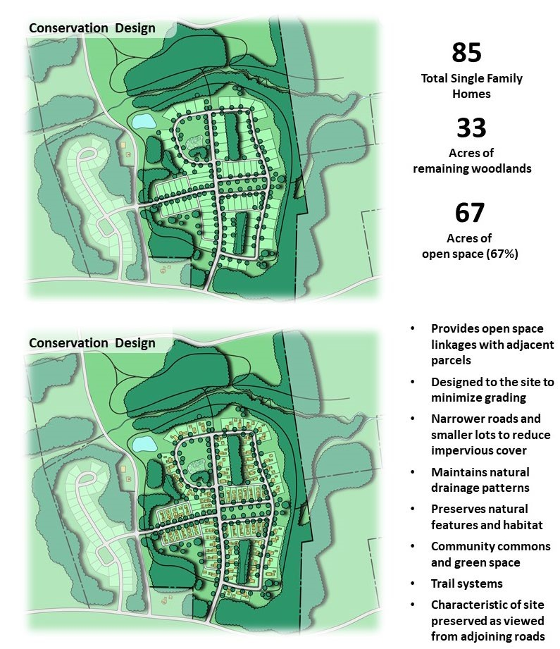

Figure 3.5: Example of single-family development on the same parcel using the principles of Conservation Design and Low Impact Development.
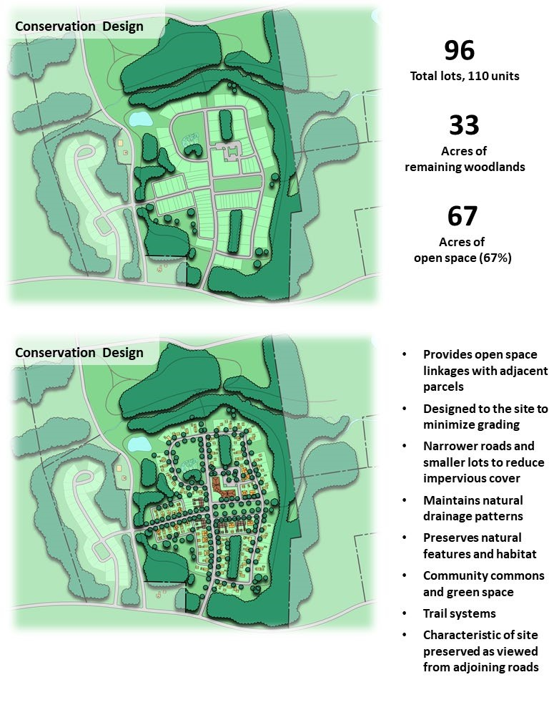

Note: While the Conservation Design graphics shown
above optimize unit types
and lot sizes (and thus allow greater density), it is recognized that that this type
of mixed use may not be appropriate in some zoning districts. However,
Conservation Design works equally well where housing diversity is not
appr
opriate.

Figure 3.6: Example of higher density mixed use site design on the same parcel using the principles of Conservation Design and Low Impact Development.

DESIGN PROCESS
The first step in applying CD is to identify, delineate and assess the functions of all existing natural resources and natural and constructed hydrologic features that: are located within the project site; will receive discharge from the project site; or may be impacted by runoff or disturbance from the proposed land development project. These include:
- Streams, waterways, springs, wetlands, vernal pools, and water bodies;
- Drainage patterns, conveyances, and discharge points;
- Natural infiltration areas and patterns;
- Areas of natural vegetation or woodlands that provide significant evapotranspiration, pollutant removal, bank stabilization, flow attenuation, or riparian buffer functions;
- Floodplains; and
- Other features that contribute to the overall hydrologic function and value of the site and its receiving streams.
Once this inventory and assessment are completed, these identified resources and features are then prioritized for their ability to provide hydrologic function and performance for managing runoff from the proposed site improvements. Specifically, they should be prioritized as follows:
- Those to be incorporated into the site design in a manner that provides for their protection from any disturbance or impact from the proposed land development;
- Those to be protected from further disturbance or impact and for which the proposed land development will provide improvement to existing conditions;
- Those that can be incorporated into and utilized as components of the overall site design in a manner that protects or improves their existing conditions while utilizing their hydrologic function (i.e., for infiltration, evapotranspiration, or reducing pollutant loads, runoff volume or peak discharge rates, etc.) to reduce the need for or size of constructed BMPs; and • Those that may be considered for alteration, disturbance, or removal.
These prioritizations are then applied as the basis on which to begin the site design lay-out, grading, construction, and permanent ground cover designs to achieve the CD Principles outlined above.
Evaluating a Site Using Conservation Design Principles
The following is a suggested series of steps that landowners, developers, and municipalities can take to
achieve CD goals and work together in a more effective manner. While this approach places significant emphasis on the initial phases of project design, it will strengthen support for the plan and substantially reduce the time needed for preliminary and final plan review and approval.
As stated above, the sketch plan process encouraged herein cannot be mandated by municipalities in Pennsylvania under Act 247 (Municipalities Planning Code) unless requirements for either the preliminary plan or final plan are waived. Some municipalities are doing just this by requiring sketch plans and preliminary/final plan submissions while others “strongly encourage” sketch plans in their subdivision/land development ordinances.

1. Determine Development Goals
- Define what is driving the decision to develop the property.
- Consider the site context - regional, local and site characteristics of land ownership, visual patterns, cultural patterns, roadways, vegetation, wildlife habitat, topography, etc. Consider possibilities for linking other landscapes, stream corridors, critical farmland and distinctive woodland patterns; identify or establish wildlife or recreational trail corridors, etc. Consider the natural hydrology of the site - how water flows over the land (the natural drainage patterns), where vegetation intercepts water, etc.
Note: Further consideration of these issues is suggested after a resource inventory and site analysis are performed.
- Clearly define the goals to work towards - these are the design goals for the project.
Goals could be economic and/or personal/family related, as well as visual, ecological, agricultural, historical, and educational.
- Consider the project’s time schedule and that of the municipal review process.

2. Conduct an Inventory of Existing Resources - Examine the Natural/Scenic/Historic Resources and Land Use Patterns
- Determine the site context (defined above)
- Evaluate current and past land use (agriculture, wooded lot, vacant, brownfield, etc.)
- Assess wind patterns and micro-climate
- Delineate steep slopes and general topography
- Identify existing vegetative cover conditions according to general cover type, and label specimen trees and the canopy line of existing woodlands.
- Map hydrologic features and drainage patterns (wetlands, floodplains, streams, drainage swales,
etc.)
- Identify scenic viewsheds (interior and exterior)
- Consider potential historic and cultural resources
- Assess soil patterns (hydric soils, prime agricultural soils, infiltration⁻capable soils, etc.) and vegetation patterns (landscape texture and patterns)
- Consider local zoning regulations
- Review the site for obvious land fragmentation (agricultural, natural habitat, human use, viewsheds)
- Determine the presence of endangered/threatened species and unusual habitats, critical natural areas, etc.
Other design considerations include solar exposure (seasonal changes), light patterns (shadows), sense of space (enclosed, open, mysterious) and sense of scale.

3. Undertake a Site Analysis
- Compare/overlay/combine the natural/scenic/historic resource and land use pattern information to create a general understanding of the site's opportunities and constraints, particularly as they relate to the design goals. Some initial constraints could present opportunities. Particular emphasis should be placed on site contours and existing site hydrology, e.g., drainage patterns, infiltration capability of soils, etc.
- Prepare a site analysis map that outlines the most important opportunities and constraints. The site analysis should identify both the traditionally unbuildable areas (wet, flood- prone, or steep) and the most outstanding aspects of the remaining land (such as scenic vistas, natural meadows, hedgerows, mature woodlands, historic buildings or other structures, stone walls, etc.). It is important to note that CD places significant emphasis on soils (particularly the manner in which water moves across and through them). Disturbance of soils, disturbance of vegetation, and compaction all affect the ability of a site to manage stormwater. For example, while it is imperative that good draining soils be preserved to the maximum extent possible, areas of poor permeability that contain robust vegetation may function quite satisfactorily (a well-developed root zone in conjunction with established vegetation can significantly improve poor soil infiltration and permeability). Conversely, even good soils, if substantially disturbed and compacted, can become far less permeable.
Note: Although reliance on published soils data is acceptable for site analyses and conceptual planning purposes, detailed planning must include soil field sampling.

4. Create Conceptual Designs or Sketch Plans
- Use the site analysis to create conceptual designs. Consider the principles and objectives of Conservation Design as the basis for initially conceptualizing layouts (Note: some municipalities will have a similar design process codified in their subdivision and land development ordinance referred to as the 4-step design process). List opportunities and constraints of each design element. This component involves four steps:
  - Delineate conservation areas (based on the findings of the site analysis) and potential development areas. Designing to the site, rather than grading to achieve a standardized product, is preferable because it accomplishes the goals of minimum disturbance/minimum maintenance (i.e., respecting the site’s natural hydrology,
minimizing grading and earth disturbance, etc.); such an approach can also substantially reduce construction costs. Additional emphasis should be given to the site’s existing hydrology, such as drainage patterns, the location of natural swales and conveyances, and the infiltration capability of soils.
This step requires careful integration of stormwater management and CD concepts into the design of the site. Engineering stormwater solutions after a design has been selected fails to consider a key component of CD, i.e., design as an integral best management practice. For example, it is better to prevent runoff than to attempt to mitigate it once it is created. Approaches to the site design that can reduce the generation of stormwater from the outset are the most effective approach to stormwater management.
  - Locate desired/permitted structures (housing units, buildings, etc.) on the property (as they relate to Step 1 and the design goals). Again, Conservation Design principles should be carefully considered here. Will compact development allow for a reduction in road length? Is it possible to interconnect open space, thus permitting stormwater management close to the source of generation and creating biodiversity corridors, etc. (multiple objectives)? Can structures be located so that a majority back or front to open space?
  - Connect buildings or house sites with streets (logical alignment) and trails (where appropriate). Consider ways to reduce impervious cover (one-way streets where appropriate, planted islands in cul-de-sacs, etc.).
  - Draw in lot lines for the house sites or buildings, where needed.
- Meet with municipal officials and review plans -- what is liked, not liked, and why.
- Identify a direction for engineering and final design.

5. Formulate A Final Design (or Sketch Plan) as the Basis for an Engineered Site Plan
- Synthesize discussion of conceptual designs (sketch plans) and finalize design.
- Develop legal instruments necessary to realize plan objectives, e.g., conservation easements, deed restrictions, homeowners association, estate planning, etc. (Note: these concepts are considered throughout the design process).

6. Obtain Approvals (Follow-up)
- Obtain municipal and County buy-in of master sketch plan, and
- Proceed to Final Engineered Plan approvals.

DESIGN PRACTICES
Numerous practices and strategies can be considered where their aim is to sustain and utilize the benefits of existing site hydrology and minimize the generation of new stormwater runoff. Careful consideration of site topography and implementation of a combination of the design practices described herein may reduce the cost associated with implementing stormwater control measures. Following are brief descriptions of various practices that can be used to achieve the principles of CD and LID.
Site Layout Practices
The following site layout practices are but a few of the methods by which CD and LID can be implemented. Although municipal codes can reflect such practices, they are less functions of regimented codes and procedures than about understanding and recognizing the benefits and values that existing resources can contribute to the desired outcomes of the land development project. In many circumstances, communication among design engineers, land planning and environmental professionals, knowledgeable developers, community representatives, and regulatory authorities can promote a beneficial collective understanding about the most effective path forward to achieve optimum planning outcomes.
Preserving Natural Drainage Features. Protecting natural drainage features, particularly vegetated drainage swales and channels, is desirable because of their ability to infiltrate and attenuate flows and to filter pollutants. Unfortunately, some common land development practices encourage just the opposite pattern -- streets and adjacent storm sewers typically are located in the natural headwater valleys and swales, thereby replacing natural drainage functions with an impervious system. As a result, runoff and pollutants generated from impervious surfaces flow directly into storm sewers with no opportunity for attenuation, infiltration, or filtration. Designing developments to fit site topography retains much of the natural drainage function. In addition, designing with the land minimizes the amount of site grading, reduces the amount of compaction that can alter site infiltration characteristics, and can result in cost savings to the developer.
Protecting Natural Depression Storage Areas. Depressional storage areas have no surface outlet or drain very slowly following a storm event. They can be commonly seen as ponded areas in fields during the wet season or after large storm events. Some development practices eliminate these depressions by filling or draining, thereby eliminating their ability to reduce surface runoff volumes and trap pollutants. The volume and release-rate characteristics of depressions should be protected in the design of the development site to assist in reducing runoff volumes and reducing runoff rates. Designing around the depression or incorporating its storage as additional capacity in required detention facilities, treats this area as a site amenity rather than a detriment.
Avoiding Introduction of Impervious Areas. Reduction of impervious cover is one of the greatest benefits of CD. The combined benefits of setting aside more than half of the buildable land as open space, coupled with the resulting shorter road lengths, result in less impervious cover and less compacted soil. Building footprints, sidewalks, driveways, and other features producing impervious surfaces should be evaluated to minimize impacts on runoff. Designing a site to reduce the overall length and area of roads not only reduces total impervious cover, but also lowers municipal road maintenance and snow removal costs. In many instances, municipalities have the ability to reduce impervious cover by providing incentives or opportunities in their zoning and subdivision/ land development ordinances to reduce road width, reduce or modify cul-de-sac dimensions, reduce or modify curbing requirements, and reduce or modify sidewalk requirements. For example, curbing contributes to impervious cover and channels storm flows to inlets, thus further concentrating runoff. An alternative is to consider bioswales and/or infiltration trenches that can treat and attenuate flows coming off roadways. Where curbs are desirable, simply providing curb breaks or openings of 6-12 inches every 2-4 feet can disconnect flows and reduce concentration of runoff. Cul-de-sacs can be replaced with “hammerheads’ or be designed with planted islands to reduce impervious cover (both of which can be designed to allow sufficient turning radius for emergency vehicles). In fact, planted islands in cul-de-sacs can be designed to intercept road runoff and contribute to infiltration.
Disconnecting Impervious Surfaces. Impervious surfaces are significantly less of a problem if they are not directly connected to an impervious conveyance system (such as storm sewer). Two basic ways to reduce hydraulic connectivity are routing roof runoff over lawns and reducing the use of storm sewers. Site grading should promote increasing travel time of stormwater runoff from these sources and should help reduce concentration of runoff to a single point within the project site. Along roadways, where feasible, low velocity runoff (i.e., 1-to-2-year storms) can be infiltrated in grass swales.
Routing Roof Runoff Over Lawns. Roof runoff can be easily routed over lawns in most site designs. The practice discourages direct connections of downspouts to “driveway-to-street-to- storm sewers” or parking lots. The practice also discourages sloping driveways and parking lots to the street. Crowning the driveway, to run off to the lawn, uses the lawn as a filter strip.
Reducing Street Widths. Street widths can be reduced by either eliminating on-street parking (where conditions warrant) and/or by designing roads to meet actual demand. Designers should consult with municipal officials and staff to select the narrowest practical street width for the design conditions (speed, curvature, housing density, need for on-street parking, etc.). For example, permitting one-way streets for small loop roads can reduce overall road width. Reduced street widths also can lower maintenance needs and costs. Municipalities should review their ordinances to ensure that their street requirements are not over or under designed. Although there are some situations, such as with higher density development, where on-street parking may be needed, the amount of on-street parking, and hence overall street width, should be gaged to need. For further information, see the Multi-modal Circulation Handbook prepared by the YCPC (or consult other smart street publications). Narrower neighborhood streets should be considered and encouraged under select conditions.
Reducing or Modifying Sidewalk Requirements. A sidewalk on one side of the street may suffice in low-traffic neighborhoods. The lost sidewalk could be replaced with bicycle/recreational trails that follow back-of-lot lines as an alternative to reduced sidewalks, where appropriate. Where used, consideration should be given to constructing trails with pervious materials.
Reducing or Modifying Parking Requirements. Parking standards, particularly for nonresidential development, can be excessive. Reducing spaces to match actual demand makes sense and can significantly reduce impervious cover. In addition to or in lieu of reductions, alternatives such as shared or reserve parking should be considered. Where appropriate, stall size should also be considered and modified as needed.
Reducing Building Setbacks. Reducing building setbacks (from streets) reduces the size of impervious areas of driveways and entry walks and is most readily accomplished along low-traffic streets where traffic noise is not a problem.
Minimum Disturbance/ Minimum Maintenance. Reducing site disturbance and grading can go a long way towards reducing runoff. Sensitive site design conducive to the natural features of the site, including natural site contours, can reduce the amount of land disturbed during actual development. Often referred to as “fingerprinting,” this approach identifies the limits of disturbance, which are flagged in the field. As is often the case, development sites need some grading in order to achieve development objectives. In these cases, there are often opportunities to make grading part of the solution, rather than part of the problem. Careful grading can capitalize on natural site functions to achieve stormwater management objectives. For example, grading that does occur can be incorporated into terracing or berming near existing vegetation to aid in infiltration, stormwater management and pollutant filtering.
Constructing Compact Developments using Conservation Design Principles: Lower impact, compact CD can reduce the amount of impervious area for a given number of lots. Reductions in overall infrastructure, including reduced street length, width, curbing, and parking, among others, can contribute to a reduction in development and long-term maintenance costs. Reduced site disturbance and preservation of open space help buffer sensitive natural areas and retain more of a site’s natural hydrology. Development can be designed so that areas of high infiltration soils are reserved as stormwater infiltration areas. Construction activity can be focused onto less sensitive areas without affecting the gross density of development. One impediment to the use of smaller lots is where lot area impervious cover standards (as opposed to total impervious cover standards) make it difficult to locate houses, driveways, pools, septic, etc., on small lots. Where this issue arises, municipalities may want to consider reductions in, or waivers to, lot area impervious cover standards where it can be shown that total impervious cover standards can be met and a stormwater management report indicates that the coverage proposed can be managed appropriately on the site.
LID Practices and Stormwater Control Measures
Stormwater Control Measures (SCMs) are intended to supplement natural hydrology site design techniques where needed. Structural in nature, such practices include bioretention facilities, rain gardens, swales, and other engineered stormwater BMPs. Listed here are techniques intended to help manage stormwater predominantly at or near the source, rather than traditional techniques that largely release runoff over an extended period of time to adjacent properties and streams. This list, in no way exhaustive, gives examples of a few of the most common practices. It should be noted that LID aims to mimic the predevelopment site hydrology by using site design techniques that store, infiltrate, evaporate, and detain runoff. Use of these techniques helps to reduce off-site runoff and ensure adequate groundwater recharge. Since every aspect of site development affects the hydrologic response of a site, LID control techniques focus mainly on site hydrology. LID strives to conserve existing site resources, minimize site impacts, maintain (and even extend) the time of concentration of runoff, utilize distributed management practices, and prevent pollution.
Bioretention. This type of BMP combines open space with stormwater treatment. Soil and plants, rather than sand filters, treat and store runoff. Infiltration and evapotranspiration are achieved, often coupled with an underdrain to collect water not infiltrated or used in the root zone.
Rain Gardens. Typically, rain gardens are shallow depression areas containing a mix of water tolerant native plant species. The intent is to capture runoff for storage and use in the root zone of plants. Intended largely as a way of managing stormwater through evapotranspiration (ET), rain gardens often function as infiltration facilities as well.
Vegetated Open Channel Conveyances. By reducing the use of storm sewers to drain streets, parking lots, and back yards, the potential for accelerating runoff from development can be greatly reduced. This practice requires greater use of natural or vegetated drainage swales and may not be practical for some development sites, especially if there are concerns for areas that do not drain in a “reasonable” time. The practice requires educating local citizens, who may expect runoff to disappear shortly after a rainfall event.
Permeable Paving Materials. These materials include permeable interlocking concrete paving blocks or porous bituminous concrete, among others. Such materials should be considered as alternatives to conventional pavement surfaces, especially for low use surfaces such as driveways, overflow parking lots, and emergency access roads. Surfaces for which seal coats may be applied should refrain from using permeable paving materials. Note: ongoing maintenance is required for some surfaces to minimize potential for clogging.
Residents and municipal officials of communities that utilize LID and other green technology practices often need to be informed of the benefits of such facilities. LID practices can offer enhanced stormwater control in a more naturalized setting, reduce maintenance needs and costs, provide more attractive management options, and provide opportunities for wildlife habitat. Descriptions of the benefits of such practices should be included in homeowners association documents (and conveyed to homeowners in other ways) and signage should be used to convey helpful information about the function and value of such practices.

BENEFITS OF CONSERVATION DESIGN
Studies over the past 25 years have shown that development planned according to CD principles yields significant benefits to homeowners, developers, municipalities, and local communities. Homeowners see tremendous value in the preservation of open space and the protection of natural features, even if it does not exist on their lots (National Association of Home Builders, 1991; DVRPC, 2011). Developers experience reduced construction costs and enjoy the improved marketability. Municipalities see a reduced demand for new municipal parks and receive additional revenue from improved property values. Areas preserved as open space allow for passive and active recreational opportunities and help to preserve the unique character of the site. Common open spaces also help to foster social cohesion by providing residents with opportunities to get outside and interact with neighbors without having to drive. Ultimately, communities designed using CD planning principles are more desirable places to live, work, and play.
Given the improved sense of place and community, dollar appreciation of conservation subdivisions outpaces conventional development by upwards of 12% (The Conservation Fund, 2001). In Indiana, the use of conservation subdivision design added $20,000 in worth to each lot without decreasing the total number of lots (ConservationTools.org). Even more compact development (quarter-acre lots) sells for more than half-acre and larger lots where open space exists. Over a 20-year period, the conservation development homes built on quarter-acre lots sold for an average $17,000 more than their counterparts built on half-acre lots (Northeastern Illinois Planning Commission, 2003).
Developers see value through reduced development costs and increased unit values. In Texas, respect for the natural terrain and existing resources allowed the developer of an 80-lot development to reduce grading costs by 83% ($250,000) compared to a conventionally-engineered plan (Growing Greening, ConservationTools.org). CD subdivisions typically cost upwards of $7,400 less per lot to build (Environmental Law and Policy Center, 2011). Examples of cost savings to developers include:
- Reduced Site preparation costs o Elimination of mass re-grading o Decrease in erosion and sediment control measures
- Reduced Infrastructure costs
o Reduced need for storm water basins o Reduced roadway lengths o Reduced drainage pipe installations
- Increased value of units o Located adjacent to open space o Positioned to coexist with natural resource areas
Conventional development places tremendous burdens on infrastructure and typically does not pay for itself in services provided. CD and compact development reduce the costs of infrastructure and construction, preserve open space, increase the inherent value of units over conventional development, pose greater opportunities for cost efficient housing, and offer greater protection to the environment and our waterways. And while costs to develop go down, value to homeowners and municipalities goes up.
It should also be noted that there is a distinct climate benefit to be gained from the principles of conservation design, among them: providing open land for stormwater infiltration, landscape restoration, wildlife habitat, heat mitigation, and storm resilience, among others. The tools and techniques described herein offer important techniques by which to implement climate action plans published at the local, county and state levels (see also the Pennsylvania Department of Conservation and Natural Resources Climate Change Adaptation and Mitigation Plan).

CONCLUSION
The use of Conservation Design (CD), Low Impact Development (LID), and green infrastructure offers municipalities and developers opportunities to protect and enhance the hydrology of development sites, as well as address other environmental and social issues related to development. In conclusion, development designed using these principles results in a more desirable place to live.
As noted above, land development sites can be evaluated through a consensus-driven stakeholder process that seeks to determine development goals, conduct a resource inventory, undertake a site analysis, create conceptual designs (sketch plans), formulate final designs, and obtain government buy-in and approval. Flexibility by all parties allows each site to be evaluated for its unique resources and potential. Solutions emerge from early and on-going engagement among all stakeholders in a project.

REFERENCES
Appreciating Clusters, Builder Magazine, National Association of Home Builders, 1991.
Better Models for Development in Virginia, The Conservation Fund, 2001.
Conservation Design for Stormwater Management, Delaware Department of Natural Resources and Environmental Control and the Brandywine Conservancy, September 1997.
Conservation Design Resource Manual, Northeastern Illinois Planning Commission and Chicago Wilderness, 2003
Conservation Design: Techniques for Preserving Natural Hydrologic Functions, White Paper prepared for New Castle County, Delaware Drainage Code, John M. Gaadt, AICP, September 2007.
Conservation Design Resource Manual, Northeastern Illinois Planning Commission and Chicago Wilderness, 2003
Growing Greener: Conservation By Design guide at ConservationTools.org.
Guidelines for Counties and Municipalities to Protect Ecological Features of State Resource Areas,
Environmental Resources Management, Inc, Gaadt Perspectives, LLC, Kramer and Associates, Delaware Office of State Planning Coordination, Delaware Department of Natural Resources and Environmental Control, March 2008.
Guidance on MS4 Ordinance Provisions, Document Number 392-0300-003, by the Pennsylvania Department of Environmental Protection.
Impervious Surface Coverage - The Emergence of a Key Environmental Indicator, American Planning Association Journal, Spring, 1996.
Land Use Tools to Protect Groundwater: Conservation Design, Environmental Law and Policy Center, 2011
Low Impact Development Center, http://www.lowimpactdevelopment.org/.
Metro, Portland Metropolitan Planning Body, “Green Streets, Innovative Solutions for Stormwater and Stream Crossings,” First Edition, June 2002.
PA Department of Environmental Protection, Best Management Practices Manual, 2006.
Prince George’s County Department of Environmental Resources and Maryland Department of Natural Resources, Low Impact Development, Prince George’s County, MD, undated.
Rural By Design, Planning for Town and Country, Second edition, Randall Arendt, 2015.
Return on Environment: The Economic Value of Protected Open Space in Southeastern Pennsylvania, January 2011, DVRPC.
Sustainable Technologies Evaluation Program, https://wiki.sustainabletechnologies.ca/wiki/Main Page

The typical volume of a rain barrel is between 50-200 gallons, so more than one rain barrel may be needed. Larger volumes may require a cistern. ²It is assumed that the rain barrel/cistern is 25% full prior to receiving runoff.

