2022 Marietta Summer Playground
Under the direction of GEARS, the Borough of Marietta will again offer a 2022 Youth Summer Playground Program. Energetic and enthusiastic playground leaders will guide participants in active games, board games, sports, tournaments, arts & crafts and much more! Schedule of weekly activities will be posted. Check out this exciting program designed to fill your child’s summer with fun!
We will be following all CDC and PA Department of Health COVID Guidelines.
Who: Children ages 6-14
What: Eight weeks of organized FUN!
When: Mon-Fri, June 13-August 5 (No July 4)
Time: 9 am-12 noon
Where: War Memorial Park (East Walnut Street)
Fee: FREE for residents of Marietta Borough
$90 for Non-Residents, + $50 per additional sibling (Max fee of $140 per family)
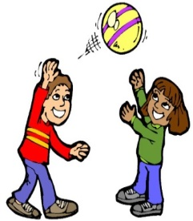
Note to Parents: The Summer Playground Program is designed to provide activities for children and is not a substitute for childcare. Attendance is not mandatory or enforced. Be sure to inform your child of your expectations regarding attendance. Pre-registration is required.
To Register:
- Phone-in (717-426-4143) Fax-in (717-426-1427)
- Mail-in (Borough Office, 111 East Market Street, Marietta 17547)

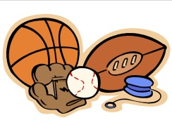
Borough of Marietta
2022 Youth Summer Playground Registration Form

Name: (only one name per form)
(First) (Last)

Address: Twp. /Boro
(Street) (Town) (Zip Code)

Telephone #: Email Address

Age: (As of June 13) Birth Date: Gender Grade (as of Sept. 2022)

Please list any medical conditions or allergies:

Please indicate if your child is allowed to walk home: _________________________________________________________________________________________

Parent/Guardian Signature:

Name and number of person to contact in case of emergency during the playground:

Name:_______________________________________________________________________ Telephone #:
Liability Waiver & Release: As a condition of participation in any GEARS program, sports league, class, recreation or fitness activity, I agree as a participant or parent/guardian of a participant in the program, to assume all risks and hazards of engaging in a GEARS activity or facility, including assuming all risks for personal injury, death and property damage.
I agree to hold harmless GEARS, its staff, instructors, volunteers, officials, sponsors, partners or representatives from liability for any losses, damages or injuries that may occur as a result of my participation in these activities regardless of cause. I further agree that there is risk associated in regard to the COVID-19 pandemic and possible exposure as a participant.
I understand that by participating in a GEARS activity, I consent to photo and/or video images taken by GEARS staff during this activity to be used in any GEARS publications, reports and websites.
Acknowledgement of Understanding: I have read the above and understand the terms and conditions set forth in the liability waiver and release.

